|  |  |
| --- | --- |
|  | **MINISTRY OF EDUCATION AND TRAINING** |

|  |
| --- |
| **FPT UNIVERSITY** |
| Capstone Project Document |
| Sales Management System for Major Education |

|  |  |
| --- | --- |
| **GSP21SE12** | |
| **Group Members** | Pham Thi Ngoc Ha – SE130460 *(Leader)*  Le Gia Nguyen – SE63042 *(Team member)*  Nguyen Hoang Gia – SE63203 *(Team member)*  ~~Vu Thien Phu – SE63268~~ *~~(Team member)~~* ~~(dropped)~~ |
| **Supervisor** | Mr. Lai Duc Hung *(Instructor)* |
| **Ext Supervisor** | Mr. Pham Duy Tien *(Customer Representative)* |
| **Capstone Project code** | SMSME |

- Ho Chi Minh City, 01/2021 -

**Table of Contents**

Acknowledgement 9

Definition and Acronyms 9

I. Project Introduction 10

1. Overview 10

2. Product Background 10

3. Existing Systems 10

4. Business Opportunity 10

5. Software Product Vision 10

6. Project Scope & Limitations 10

II. Project Management Plan 10

1. Overview 10

2. Management Approach 15

3. Master Schedule 16

4. Project Organization 17

5. Project Communication 18

6. Configuration Management 19

III. Software Requirement Specification 20

1. Overall Description 20

2. User Requirements 23

3. Functional Requirements 90

4. Non-Functional Requirements 94

5. Other Requirements 95

IV. Software Design Description 97

1. Overall Description 97

2. System Architecture Design 97

3. System Detailed Design 100

4. Class Specifications 112

5. Data & Database Design 119

V. Software Testing Documentation 124

1. Overall Description 124

2. Test Plan 125

3. Test Cases 127

4. Test Reports 127

VI. Release Package & User Guides 128

1. Deliverable Package 128

2. Installation Guides 128

3. User Manual 129

４．ユーザーマニュアル 145

VII. Appendix 158

1. Glossary [Optional] 158

2. References [Optional] 158

3. Others [Optional] 158

**List Tables**

Table 1. Definition and Acronyms 9

Table 2. Project Team - Supervisor 10

Table 3. Project Team - Team Members 10

Table 4. Work Breakdown Structure & Estimation 12

Table 5. Project Objectives 14

Table 6. Project Risks 15

Table 7. Training Plan 16

Table 8. Master Schedule 16

Table 9. Roles & Responsibilities 18

Table 10. Communication Plan 18

Table 11. FU Contacts 18

Table 12. Customer Contacts 19

Table 13. Tools & Infrastructures 19

Table 14. Business Rules 22

Table 15. System Actors 24

Table 16. Use Cases List 26

Table 17. <<Unauthorized User>> Login 27

Table 18. <<Unauthorized User>> Forget password 29

Table 19. <<Authorized User>> View profile 31

Table 20. <<Authorized User>> Edit profile 32

Table 21. <<Authorized User>> Change avatar 34

Table 22. <<Authorized User>> Logout 34

Table 23. <<Authorized User>> View notifications 35

Table 24. <<Administrator>> Create new accounts 38

Table 25. <<Administrator>> Search accounts 39

Table 26. <<Administrator>> View list of accounts 40

Table 27. <<Administrator>> View account’s details 41

Table 28. <<Administrator>> Edit account’s information 42

Table 29. <<Administrator>> Create new schools 46

Table 30. <<Administrator>> Search schools 47

Table 31. <<Administrator>> View list of schools 48

Table 32. <<Administrator>> View school’s details 49

Table 33. <<Administrator>> Edit school’s information 50

Table 34. <<Salesman>> Search target schools 52

Table 35. <<Salesman>> View list of target schools 54

Table 36. <<Salesman>> View target school’s details 56

Table 37. <<Salesman>> Edit school’s information 58

Table 38. <<Salesman>> Create contracts 59

Table 39. <<Salesman>> View my contracts 60

Table 40. <<Salesman>> View contract’s details 61

Table 41. <<Salesman>> Edit my contracts 62

Table 42. <<Salesman>> Create reports 64

Table 43. <<Salesman>> Search reports 66

Table 44. <<Salesman>> View all reports 67

Table 45. <<Salesman>> View report’s details 68

Table 46. <<Salesman>> Edit reports 70

Table 47 <<Salesman>> Remove reports 71

Table 48. <<Salesman>> Create personal activities 73

Table 49. <<Salesman>> Search other’s workplan 74

Table 50. <<Salesman>> View workplan 75

Table 51. <<Salesman>> View personal activity’s details 76

Table 52. <<Salesman>> Edit personal activities 78

Table 53. <<Salesman>> Remove personal activities 80

Table 41. <<Sales Supervisor>> Create target schools 82

Table 55. <<Sales Supervisor>> Edit target schools 83

Table 56. <<Sales Supervisor>> Assign salesmen to target schools 85

Table 57. <<Sales Supervisor>> Remove target schools 86

Table 58. <<Sales Supervisor>> Comment on Salesmen’s reports 88

Table 59. <<Sales Manager>> View all contracts 90

Table 60. Screen Details 91

Table 61. Screen Authorization 92

Table 62. Non-Screen Functions 92

Table 63. Entities List 94

Table 64. Appendix1 - Messages List 96

Table 65. Overall Architecture Data Dictionary 97

Table 66. Package Diagram Specifications 100

Table 67. Class User Specification - Attributes 113

Table 68. Class User Specification - Methods 113

Table 69. Class PersonalActivity Specification - Attributes 114

Table 70. Class PersonalActivity Specification - Methods 114

Table 71. Class Role Specification - Attributes 114

Table 72. Class Role Specification - Methods 114

Table 73. Class Auditable Specification - Attributes 114

Table 74. Class Auditable Specification - Methods 114

Table 75. Class TargetSchool Specification - Attributes 115

Table 76. Class TargetSchool Specification - Methods 115

Table 77. Class Report Specification - Attributes 115

Table 78. Class Report Specification - Methods 115

Table 79. Class School Specification - Attributes 116

Table 80. Class School Specification - Methods 116

Table 81. Class District Specification - Attributes 116

Table 82. Class District Specification - Methods 117

Table 83. Class SchoolStatus Specification - Attributes 117

Table 84. Class SchoolStatus Specification - Methods 117

Table 85. Class TargetSchoolPurpose Specification - Attributes 117

Table 86. Class TargetSchoolPurpose Specification - Methods 117

Table 87. Enum Class EducationalLevel Specification 117

Table 88. Enum Class SchoolScale Specification 118

Table 89. Enum Class SchoolType Specification 118

Table 90. Description for table "school" 120

Table 91. Description for table "district" 120

Table 92. Description for table "school_status" 120

Table 93. Description for table "target_school" 121

Table 94. Description for table "report" 121

Table 95. Description for table "target_school_purpose" 121

Table 96. Description for table "user" 122

Table 97. Description for table "role" 122

Table 98. Description for table "personal_activity" 123

Table 99. Description for table "contract" 123

Table 100. Data File Design 123

Table 101. Testing Levels 124

Table 102. Testing Types 125

Table 103. Test Stages 125

Table 104. Human Resources 125

Table 105. Environment 126

Table 106. Test Milestones 127

Table 107. Deliverables 127

Table 108. Test Cases 127

Table 109. Test Reports 127

Table 110. Source codes & documents 128

Table 111. <Installation guides> Hardware requirements for Web App 129

Table 112. <Installation guides> Hardware requirements for API service 129

Table 113. <Installation guides> Hardware requirements for Database 129

Table 114. <User Manual> Hardware requirements for Web App 130

Table 115. <User Manual> Hardware requirements for API Services 130

Table 116. <User Manual> Hardware requirements for Database 130

Table 117. 「システム要件」 Web アプリの場合 145

Table 118. 「システム要件」 API サービスの場合 145

Table 119. 「システム要件」 Database の場合 146

**List Figures**

Figure 1. Major Features 12

Figure 2. SCRUM Framework 17

Figure 3. Team & Structures 19

Figure 4. System Context Diagram 22

Figure 5. Use case Overview 25

Figure 6. <<Unauthorized User>> Overview Use Case 28

Figure 7. <<Unauthorized User>> Login 28

Figure 8. <<Unauthorized User>> Forget password 30

Figure 9. <<Authorized User>> Overview Use Case 32

Figure 10. <<Authorized User>> View profile 32

Figure 11. <<Authorized User>> Edit profile 33

Figure 12. <<Authorized User>> Change avatar 35

Figure 13. <<Authorized User>> Logout 36

Figure 14. <<Authorized User>> View notifications 36

Figure 15. <<Administrator>> Overview Use Case 38

Figure 16. <<Administrator>> Create new accounts 38

Figure 17. <<Administrator>> Search accounts 40

Figure 18. <<Administrator>> View list of accounts 41

Figure 19. <<Administrator>> View account’s details 42

Figure 20. <<Administrator>> Edit account’s information 43

Figure 21. <<Administrator>> Create new schools 45

Figure 22. <<Administrator>> Search schools 48

Figure 23. <<Administrator>> View list of schools 49

Figure 24. <<Administrator>> View school’s details 50

Figure 25. <<Administrator>> Edit school’s information 51

Figure 26. <<Salesman>> Overview Use Case 53

Figure 27. <<Salesman>> Search target schools 53

Figure 28. <<Salesman>> View list of target schools 55

Figure 29. <<Salesman>> View target school’s details 56

Figure 30. <<Salesman>> Edit school’s information 58

Figure 31 <<Salesman>> Create contracts 60

Figure 32. <<Salesman>> View my contracts 61

Figure 33. <<Salesman>> View contract’s details 62

Figure 34. <<Salesman>> Edit my contracts 63

Figure 35. <<Salesman>> Create reports 65

Figure 36. <<Salesman>> Search reports 66

Figure 37. <<Salesman>> View all reports 68

Figure 38. <<Salesman>> View report’s details 69

Figure 39. <<Salesman>> Edit reports 70

Figure 40. <<Salesman>> Remove reports 72

Figure 41. <<Salesman>> Create personal activities 73

Figure 42. <<Salesman>> Search other’s workplan 75

Figure 43. <<Salesman>> View workplan 76

Figure 44. <<Salesman>> View personal activity’s details 77

Figure 45. <<Salesman>> Edit personal activities 78

Figure 46. <<Salesman>> Remove personal activities 80

Figure 47. <<Sales Supervisor>> Overview Use Case 82

Figure 48. <<Sales Supervisor>> Create target schools 82

Figure 49. <<Sales Supervisor>> Edit target schools 84

Figure 50. <<Sales Supervisor>> Assign salesmen to target schools 86

Figure 51. <<Sales Supervisor>> Remove target schools 87

Figure 52. <<Sales Supervisor>> Comment on Salesmen’s reports 88

Figure 53. <<Sales Manager>> Overview Use Case 91

Figure 54. <<Sales Manager>> View all contracts 91

Figure 55. Screen Flow 92

Figure 56. Entity Relationship Diagram 95

Figure 57. System Architecture 99

Figure 58. Package Diagram 100

Figure 59. Class Diagram 102

Figure 60. Assign Salesmen to Target schools 103

Figure 61. Create contract 104

Figure 62. Create new accounts 105

Figure 63. Edit school’s information 106

Figure 64. Remove personal activities 107

Figure 65. View target school details 108

Figure 66. Create target schools 109

Figure 67. Assign salesmen to target schools 110

Figure 68. Update target school's details 111

Figure 69. Remove a target school 112

Figure 70. Create reports 113

Figure 71. Update report 114

Figure 72. Database Diagram 122

Figure 73 Prototype model 126

Figure 74. List of Accounts 133

Figure 75. Account’s details 134

Figure 76. List of Schools 135

Figure 77. School’s details 136

Figure 78 Target Schools list 137

Figure 79 Profile 138

Figure 80 Add New Daily Activity 139

Figure 81 Add New Monthly Activity 140

Figure 82 Add New Weekly Activity 141

Figure 83 Drag Location Card to Add new 141

Figure 84 Add New Activity By Draging Location Card 142

Figure 85 Add New Yearly Activity 142

Figure 86 Day view 143

Figure 87 Monthly view 143

Figure 88 Quick Add Form 143

Figure 89 Quick Details 144

Figure 90 Edit By Drag Activity 144

Figure 91 Dashboards 145

Figure 92 Login 146

Figure 93 Log out 146

Figure 94アカウントリスト 149

Figure 95アカウント詳細 150

Figure 96スクールリスト 151

Figure 97スクールの詳細 152

Figure 98ターゲットスクールリスト 153

Figure 99プロフィール 154

Figure 100デイビュー 155

Figure 101月表示 155

Figure 102 クイック追加 155

Figure 103 活動の詳細 156

Figure 104 詳細追加 156

Figure 105 ドラッグして編集 157

Figure 106ダッシュボード 158

Figure 107ログイン 159

Figure 108ログアウト 159

# Acknowledgement

*[Fill team’s acknowledgement here…]*

# Definition and Acronyms

|  |  |
| --- | --- |
| **Acronym** | **Definition** |
| API | Application Program Interface |
| AWS | Amazon Web Services |
| BA | Business Analysis |
| BR | Business Rule |
| ERD | Entity Relationship Diagram |
| GUI | Graphical User Interface |
| MOU | Memorandum of understanding |
| MSG | Message |
| PM | Project Manager |
| SDD | Software Design Description |
| SPMP | Software Project Management Plan |
| SRS | Software Requirement Specification |
| UAT | User Acceptance Test |
| UC | Use Case |

Table 1. Definition and Acronyms

# I. Project Introduction

## 1. Overview

### 1.1 Project Information

* Project name: Sales Management System for Major Education
* Project code: SMSME
* Group name: GSP21SE12
* Software type: Web Application

### 1.2 Project Team

#### Supervisor

|  |  |  |  |
| --- | --- | --- | --- |
| **Full Name** | **Email** | **Phone Number** | **Title** |
| Lai Duc Hung | HungLD5@fe.edu.vn | 0976.710.580 | Instructor |

Table 2. Project Team - Supervisor

#### Team Members

|  |  |  |  |
| --- | --- | --- | --- |
| **Full Name** | **Email** | **Mobile** | **Role** |
| Pham Thi Ngoc Ha | HaPTNSE130460@fpt.edu.vn | 0946.753.053 | Leader |
| Le Gia Nguyen | NguyenLGSE63042@fpt.edu.vn | 0984.272.299 | Member |
| Nguyen Hoang Gia | GiaNHSE63203@fpt.edu.vn | 0799.651.670 | Member |
| ~~Vu Thien Phu (dropped)~~ | ~~PhuVTSE63268@fpt.edu.vn~~ | ~~0946.056.921~~ | ~~Member~~ |

Table 3. Project Team - Team Members

## 2. Product Background

Major Education is an educational organization that collaborates with primary schools, secondary schools or high schools in Ho Chi Minh City, in the fields of English, STEM or Abacus Master. All schools in Ho Chi Minh City are considered as Major Education’s customers/partners. Every school year (from May to September), salesmen from Major Education go to the target schools to introduce and sales their programs.

Currently, the Sales Department of Major Education processes all their works manually, from reports collecting, work-plan planning, salesmen managing and target schools managing, based on free software such as Microsoft Excel, Google Sheet and shared files via Google Drive cloud.

Therefore, they expect a software that can help them, for both salesmen and sales managers, to automate the existing manual workflow. Simultaneously, through this application, sales managers will be able to see the overall picture of the company's business process, to know how many schools are cooperating as well as the school’s state.

## 3. Existing Systems

Nowadays, there are a variety of applications that provide CRM (Customer Relationship Management) solutions for businesses. Major Education suggests our team refer to those softwares to visualize the concept and main features of the future product.

### 3.1 CRMViet

CRMViet is a system that provides comprehensive solutions related to CRM for small and medium-sized enterprises (SME) in Vietnam.

*Link:*

* Web application: <https://crmviet.vn/>.
* Mobile application:
  + Android: <https://play.google.com/store/apps/details?id=vn.altalab.app.crmvietpack>.
  + iOS: <https://apps.apple.com/us/app/crmviet/id1197961185>.

*System analysis:*

1. Roles:

* Administrator
* Manager
* Staff
* … (customized roles depends on each company)

1. Platforms:

* Web app
* Mobile app

1. Main features:

* Manage customers
* Support sales and marketing automation
* Manage workflow, tasks, job reminders,…
* Integrated multi-channel
* …

1. Pros:

* A complete and powerful application
* Fulfill all needs of the Major’s Sales Department

1. Cons:

* Many redundant features
* Price is expensive

### 3.2 GetFly

GetFly is a system that provides comprehensive solutions related to CRM for small and medium-sized enterprises (SME) in Vietnam.

*Link:*

* Web application: <https://getfly.vn/>.
* Mobile application:
  + Android: <https://play.google.com/store/apps/details?id=com.getflyvn.crm>.
  + iOS: <https://apps.apple.com/us/app/getflyvn/id1490060413>.

*System analysis:*

1. Roles:

* Administrator
* Manager
* Staff
* … (customized roles depends on each company)

1. Platforms:

* Web app
* Mobile app

1. Main features:

* Manage customers
* Support marketing automation (via SMS, email, or social network)
* Manage departments, sales team,…
* Manage workflow, tasks, KPIs,…
* Integrate modules extension
* …

1. Pros:

* A complete and powerful application
* User-friendly UI
* Fulfill all needs of the Major’s Sales Department

1. Cons:

* Overpowered, many redundant features
* Require monthly payment

### 3.3 EasyEdu

EasyEdu is a system to manage all activities of many departments in an educational organization, especially for language centers. EasyEdu provides solutions for managing finances, expenses, marketing, human resources, class attendance reports, CRM,…

*Link:*

* Web application: <https://easyedu.vn/>.
* Mobile application:
  + Android:

Teacher: <https://play.google.com/store/apps/details?id=com.easyedu.manager&hl=vi>.

Parent/Student: <https://play.google.com/store/apps/details?id=com.easyedu.customer&hl=vi> .

* + iOS:

Teacher: <https://apps.apple.com/vn/app/easy-manager/id1495280190?l=vi>.

Parent/Student: <https://apps.apple.com/vn/app/easy-edu/id1472824752?l=vi> .

*System analysis:*

1. Roles:

* Administrator
* Staff
* Teacher
* Parent/Student

1. Platforms:

* Web app (for all roles)
* Mobile app (one for Teacher and one for Parent/Student)

1. Main features:

* Manage finances, expenses, marketing campaigns, SMS/chats…
* Manage human resources, departments, agencies,…
* Manage customer relationship
* Manage courses, classes, attendances,…
* Manage tasks, schedules,…
* Provide an online learning platform

1. Pros:

* A complete and powerful application
* Good UI

1. Cons:

* Overpowered and too complicated for what the customer (Sales Department of Major Education) really need
* Is a B2C system (one side is the language center, one side is parent/student)
* Require payment (monthly or annually)

## 4. Business Opportunity

Although the current CRM applications in the market can partially meet the requirements of the business, Major Education still has to pay for many redundant features, which they rarely or would not use. That is why Major Education requests this Sales Management System to specify for their business model. The model of software that we are building is only used for staffs in the Sales Department of Major Education and is not public commercially to the current market. As this Sales Management Software would innovate and improve the effectiveness of Major Education’s manual workflow, so it would save employees’ time and effort to complete their daily tasks as usual.

However, in fact, due to the time and developer team’s experience limitation, we could not covered for the whole Major Education’s sales process yet some features would be upgraded in the next versions of this software.

## 5. Software Product Vision

The target users that SMSME aims to are salesmen and sales managers of the Sales Department of Major Education.

For salesmen, this software would help them manage their work-plan as well as their tasks easier and more visually, submit daily reports more directly and they can also monitor other salesmen’s works.

For sales managers, they would not have to collect and analyze all salesmen’s reports manually. Now they can supervise salesmen or search for reports more easily. Moreover, they can see the overall picture of the company's business process, including what schools are lead customers, who are the most effective salesmen,…

## 6. Project Scope & Limitations

### 6.1 Major Features

There are four roles in this system, which includes the following major features:

FE-01: Administrator can manage user accounts (view, create, edit, remove).

FE-02: Administrator can manage all schools (view, create, edit, remove).

FE-03: Sales Manager and Sales Supervisor can manage target schools (create, edit, remove, assign).

FE-04: Sales Manager, Sales Supervisor and Salesman can view all target schools.

FE-05: Salesman can manage own daily reports (create, edit, remove) and view all reports.

FE-06: Sales Manager and Sales Supervisor can comment on the reports.

FE-07: Sales Manager, Sales Supervisor and Salesman can manage own work-plan (create, edit, remove personal activities) and view work-plan of each other.

FE-08: Salesman can update school’s representative’s information.

FE-09: Salesman can create and view contracts which is belong with the target schools they are assigned.

FE-10: Sales Manager can view all contracts of all target schools.

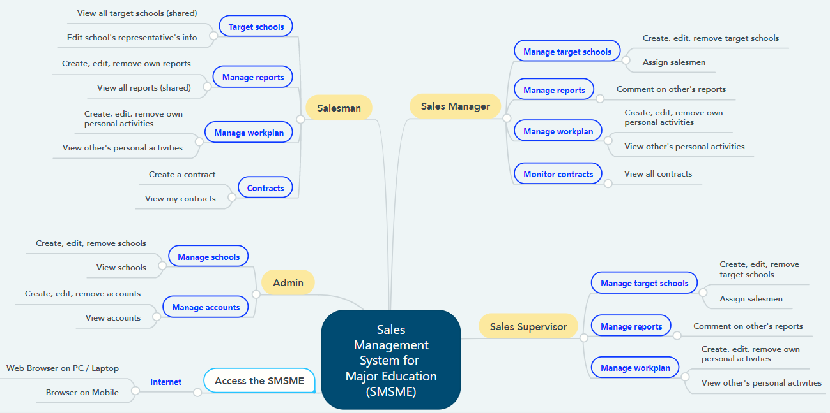

Figure 1. Major Features

### 6.2 Limitations & Exclusions

LI-1: The SMSME has not supported versions for Mobile application yet. SMSME now is a responsive Web application.

LI-2: The SMSME does not support communication channel with customers.

LI-3: The SMSME has not supported feature “Manage Salesmen” or “Manage team” yet.

LI-4: The SMSME shall be used only for the Sales Department of the Major Education.

# II. Project Management Plan

## 1. Overview

### 1.1 WBS & Estimation

|  |  |  |  |
| --- | --- | --- | --- |
| **#** | **WBS Item** | **Complexity** | **Est. Effort**  **(man-days)** |
| ***1*** | ***Initiating*** |  | ***14*** |
| 1.1 | Meet customers at Viet Anh School (Major Education) | Simple | 1 |
| 1.2 | Gain requirements | Medium | 3 |
| 1.3 | Write “Current System Description” | Medium | 4 |
| 1.4 | Confirm “Current System Description” with customers | Simple | 1 |
| 1.5 | Write Report 1 (Introduction) | Medium | 4 |
| 1.6 | Collect stakeholders’ contact information | Simple | 1 |
| ***2*** | ***Planning*** |  | ***17*** |
| 2.1 | Discuss project scope with development team | Simple | 3 |
| 2.2 | Estimate time to finish the project | Simple | 1 |
| 2.3 | Discuss project’s limitations and risks | Simple | 2 |
| 2.4 | Discuss model to use for project management | Simple | 2 |
| 2.5 | Create project plan & work breakdown structure (WBS) | Simple | 3 |
| 2.6 | Assign roles in this project for each team member | Medium | 1 |
| 2.7 | Write Report 2 (Project Management) | Medium | 5 |
| ***3*** | ***Executing*** |  | ***294*** |
| **3.1** | **Analysis** |  | **41** |
| 3.1.1 | Analyse users’ requirements:   * Identify stakeholders * Identify user roles in this system * Identify needs and activities of each role | Complex | 9 |
| 3.1.2 | Analyse materials that Major provided   * Analyse Major current working process (7 steps) * Analyse Excel files (including sample data of target schools, assignment, daily reports,…) | Medium | 4 |
| 3.1.3 | Research business definitions | Simple | 2 |
| 3.1.4 | Use free trial of CRM applications (CRMViet, EasyEdu,…) | Simple | 3 |
| 3.1.5 | Create Use case Diagram | Complex | 8 |
| 3.1.6 | Write Report 3 (Software Requirement Specification – SRS) | Complex | 15 |
| **3.2** | **Designing** |  | **34** |
| 3.2.1 | Create Entity Relationship Diagram (ERD) | Medium | 6 |
| 3.2.2 | Create Database Diagram | Simple | 3 |
| 3.2.3 | Create Class Diagram | Medium | 4 |
| 3.2.4 | Create Architecture Diagram | Medium | 3 |
| 3.2.5 | Standardize provided Excel files | Simple | 3 |
| 3.2.6 | Write Report 4 (Software Design Document – SDD) | Complex | 15 |
| **3.3** | **Prototyping** |  | **27** |
| 3.3.1 | Draw draft major screens on paper | Simple | 6 |
| 3.3.2 | Create prototype for role Admin | Simple | 3 |
| 3.3.3 | Create prototype for role Salesman | Medium | 9 |
| 3.3.4 | Create prototype for role Sales Supervisor | Medium | 6 |
| 3.3.5 | Create prototype for role Sales Manager | Medium | 3 |
| **3.4** | **Implementing** |  | **153** |
| 3.4.1 | Install coding environment (Eclipse, Visual Studio Code) | Simple | 2 |
| 3.4.2 | Identify coding conventions (Front-end & Back-end) | Medium | 2 |
| 3.4.3 | Implement “Admin” module – Iteration 1 |  |  |
| 3.4.3.1 | Update SRS and SDD (Iteration 1) | Medium | 9 |
| 3.4.3.2 | Create test plan and test cases (Iteration 1) | Medium | 6 |
| 3.4.3.3 | Code and perform unit test (Iteration 1) | Complex | 9 |
| 3.4.3.4 | Deploy package 1 | Simple | 3 |
| 3.4.4 | Implement “Salesman” module – Iteration 2 |  |  |
| 3.4.4.1 | Update SRS and SDD (Iteration 2) | Medium | 12 |
| 3.4.4.2 | Create test plan and test cases (Iteration 2) | Medium | 6 |
| 3.4.4.3 | Code and perform unit test (Iteration 2) | Complex | 15 |
| 3.4.4.4 | Execute integration test and system test (Iteration 2) | Medium | 6 |
| 3.4.4.5 | Deploy package 2 | Simple | 1 |
| 3.4.5 | Implement “Sales Supervisor” module – Iteration 3 |  |  |
| 3.4.5.1 | Update SRS and SDD (Iteration 3) | Medium | 12 |
| 3.4.5.2 | Create test plan and test cases (Iteration 3) | Medium | 6 |
| 3.4.5.3 | Code and perform unit test (Iteration 3) | Complex | 15 |
| 3.4.5.4 | Execute integration test and system test (Iteration 3) | Medium | 9 |
| 3.4.5.5 | Deploy package 3 | Simple | 1 |
| 3.4.6 | Implement “Sales Manager” module – Iteration 4 |  |  |
| 3.4.6.1 | Update SRS and SDD (Iteration 4) | Medium | 12 |
| 3.4.6.2 | Create test plan and test cases (Iteration 4) | Medium | 6 |
| 3.4.6.3 | Code and perform unit test (Iteration 4) | Complex | 9 |
| 3.4.6.4 | Execute integration test and system test (Iteration 4) | Medium | 9 |
| 3.4.6.5 | Deploy package 4 (product version Alpha) | Simple | 3 |
| **3.5** | **Testing** |  | **30** |
| 3.5.1 | Fix bugs and retest | Medium | 12 |
| 3.5.2 | Get feedback from customers after acceptance test | Medium | 8 |
| 3.5.3 | Deploy full package (product version Beta) | Simple | 4 |
| 3.5.4 | Write Report 5 (Testing) | Medium | 6 |
| **3.6** | **Support** |  | **9** |
| 3.6.1 | Write Report 6 (User Guides) | Medium | 6 |
| 3.6.2 | Train customers (end-users) how to use this application | Simple | 3 |
| ***4*** | ***Monitoring and Controlling*** |  | ***9*** |
| 4.1 | Evaluate project’s code quality | Complex | Cannot estimate due to SCRUM model |
| 4.2 | Refractor/Optimize code (optional) | Complex |
| 4.3 | Tracking project’s progress, scope and risks | Medium |
| 4.4 | Write Report 7 (Final Project Report) | Complex | 9 |
| ***5*** | ***Closing*** |  | ***18*** |
| 5.1 | Create final presentation | Simple | 6 |
| 5.2 | Practice Thesis presentation | Medium | 9 |
| 5.3 | Present at Capstone Project Defense | Complex | 3 |
| ***Total Estimated Effort (man-days)*** | | | ***352*** |

*Table 4. Work Breakdown Structure & Estimation*

### 1.2 Project Objectives

To create an utility, practical and friendly sales management application for Sales Department of Major Education.

|  |  |  |  |  |
| --- | --- | --- | --- | --- |
| **#** | **Quality Stage** | **No. of Defects** | **% of Defect** | **Notes** |
| 1 | Initiating | 2 | 8.7% | * Gain sufficient and useful information for requirement analysis in the next stage. * All team members must understand clearly customer’s situation and demands. |
| 2 | Planning | 1 | 4.3% | Project plan must be attainable, time-bound and specific. |
| 3 | Analysis | 4 | 17.4% | Confirm SRS (functional requirements, non-functional requirements, business rules) with the customers before moving to “Implementing” stage. |
| 4 | Designing | 4 | 17.4% | * Design Use Cases Diagram, ERD and Database based on result of stage 3 (Analysis). * Review carefully with the Instructor before moving to the next stages. |
| 5 | Prototyping | 3 | 13.2% | Design and confirm with customers all screens of all roles before move to “Implementing” stage. |
| 6 | Implementing | 4 | 17.4% | * Strictly follow the general coding convention. * All team members need to update code regularly. |
| 7 | Testing | 2 | 8.7% | * Each developer applys unit test before merge code with each other. * Both Front-end code and Back-end code need to be tested carefully before deploying to the Server. * Have Acceptance test (-test) in the customet-side, in real business environment. |
| 8 | Support | 1 | 4.3% | Project team needs to provide User Guide documents, and also spend time in real business environment to support to the customers at the beginning of the deployment. |
| 9 | Monitoring & Controlling | 1 | 4.3% | * Not only Team Leader needs to track the progress of other team members. * Using version control to keep track of the changes in stages “Designing”, “Prototyping” and “Implementing”. * Applying SCRUM model. |
| 10 | Closing | 1 | 4.3% | All team members need to join slide designing and prepare thoroughly for the final presentation. |
| ***Total*** | | ***23*** | ***100%*** |  |

*Table 5. Project Objectives*

### 1.3 Project Risks

|  |  |  |  |  |
| --- | --- | --- | --- | --- |
| **#** | **Risk Description** | **Impact** | **Possibility** | **Response Plans** |
| **I** | **Requirement risks** | | | |
| 1 | Development team misunderstands or unclears customer requirements | High | High | Meet customers regularly to confirm our thoughts or do not hesitate to ask customers via Zalo group chat. |
| 2 | Customers do not clear about their requirements | High | Medium | Create prototypes or suggest our solutions to customers and confirm with them what features they want to use. |
| 3 | Unexpected scope change | Medium | Low | If new feature is justifiable and time remaining is enough, development team will implement that feature.  If not, team need to deal with customers to implement that feature in the next version. |
| **II** | **Techical risks** | | | |
| 4 | Lack of technical knowledge or poor coding skills | High | Medium | * Enhance self-research. * Exchange knowledge with other team members or other teams. |
| 5 | Poor code quality | Medium | Medium | Strictly follow code convention, carry out acceptance test to ensure quality source code. |
| **III** | **Human risks** | | | |
| 6 | Restricted in direct meeting and communication due to Covid-19 | High | High | * Team can use online meeting platforms (Google Meet, Zoom,…) or send resources via email. * Team can deploy live demo on Ngrok for customers using. |
| 7 | Conflicts between team members | High | High | Team need a meeting, all members share uncomfortable things. |
| 8 | Over deadline | High | High | * Each member has to report their working progress daily. * Team members need to support each other to finish tasks in time. |
| 9 | Lack of real experiences | Low | High | Ask instructor or customer Exchange knowledge with other team members or other teams. |

*Table 6. Project Risks*

## 2. Management Approach

The project management model our team chose to manage and implement in this project is Agile methodology, for more specific, is SCRUM framework.

### 2.1 Project Process

We chose Scrum framework because of the following reasons:

* As we are making real product for a real company, we need to satisfy the customers first by early deliverables.
* Scrum requires regular meeting and communication, so development team will closely follow user’s requirements, reduce deviation.
* Scrum welcome changes, even during the developing process.
* Scrum allows us to divide work into small sprints, which will deliver module package each sprint, so we can easily manage bugs, fix bugs faster and reduce risks.

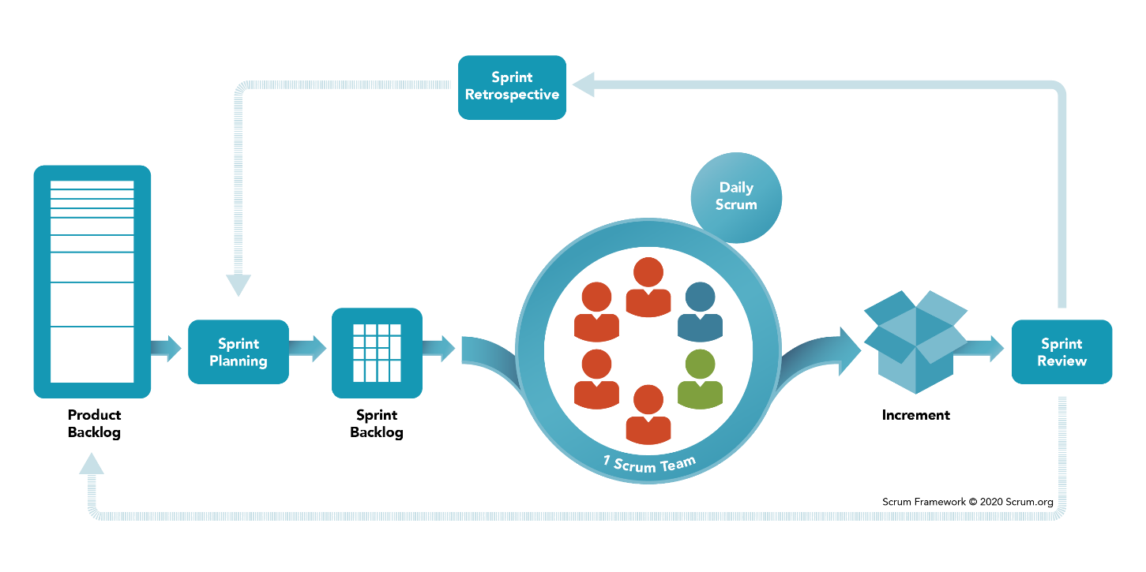

Figure 2. SCRUM Framework

*Reference:* [*https://www.scrum.org/resources/what-is-scrum*](https://www.scrum.org/resources/what-is-scrum)

### 2.2 Quality Management

To enhance the quality, the team have to:

* Follow all code conventions and ensure clean code.
* Refer to and study similar working applications in the market.
* Ensure all team members clearly understand user requirements and prototype.

### 2.3 Training Plan

|  |  |  |  |
| --- | --- | --- | --- |
| Training Area | Participants | When, Duration | Waiver Criteria |
| Java Spring Boot | All team members | Week 3rd | Mandatory |
| HTML, CSS, Javascript (ES6) | All team members | Week 1st | Mandatory |
| SCSS | All team members | Week 1st | Optional |
| ReactJS | All team members | Week 3rd | Mandatory |
| UML 2.0 conventions | All team members | Week 2nd | Mandatory |
| Git, Github | All team members | Week 1st | Mandatory |

*Table 7. Training Plan*

## 3. Master Schedule

|  |  |  |  |
| --- | --- | --- | --- |
| **#** | **Deliverable** | **Due Date** | **Deliverable Scope** |
| 1 | Project Introduction (Report 1) | Week 2 |  |
| 2 | Project Plan (Report 2) | Week 2 | Work Breakdown Structure (WBS) |
| 3 | SRS (Report 3) | Week 4 | Use case Diagram and Specification, non functional requirements, screen flow and description |
| 4 | Design (Report 4) | Week 6 | Architecture Diagram, Detailed Design, ERD, Database Diagram, Prototypes |
| 5 | Code Package 1: module “Admin” (Front-end) | Week 8 | Codes & Unit test cases |
| 6 | Code Package 2: module “Salesman” (Front-end) | Week 10 | Codes & Unit test, System test cases |
| 7 | Code Package 3: module “Sales Supervisor”  (Front-end) | Week 12 | Codes & Unit test, System test test cases |
| 8 | Code Package 4: module “Sales Manager”  (Front-end) | Week 12 | Codes & Unit test, System test test cases |
| 9 | Code Package 1  (Back-end) | Week 8 | Codes & Unit test cases |
| 10 | Code Package 2  (Back-end) | Week 10 | Codes & Unit test, System test test cases |
| 11 | UAT Package | Week 14 | Code, System test reports |
| 12 | Final Package | Week 15 | Final codes & documents, User guides |

Table 8. Master Schedule

## 4. Project Organization

### 4.1 Team & Structures

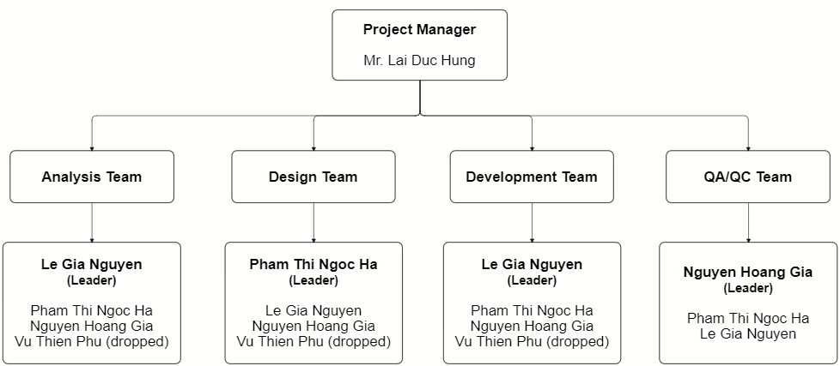

Figure 3. Team & Structures

### 4.2 Roles & Responsibilities

|  |  |
| --- | --- |
| **Role** | **Responsibility** |
| Project Manager | * Be a bridge between Major Education and FPTU development team in the initial stage of the project. * Give guidance, review deliverables during project time. |
| Analysis Leader | * Communicate with the customers to get requirements. * Analyse customer’s requirements and business then explain to team members. * Generate use cases and diagrams in Software Design Description (SDD). * Review and adjust project’s documents made by analysis members. |
| Analysis Member | * Communicate with customers to get requirements. * Analyse customer’s requirements and business. * Draw software diagrams (use cases diagram, ERD,…) and write documents (SRS, SDD). |
| Design Leader | * Design prototypes for website layouts. * Assign tasks for team members. |
| Design Member | * Design prototypes for tasks assigned by the Design Leader. * Review draft prototypes of Design Leader. * Review prototypes of each other. |
| Technical Leader | * Study and decide architecture and technologies using in the project. * Assign tasks for development team members. * Track the work progress of the project. * Review member's code and fix errors. |
| Developer | * Implement code for tasks assigned by the Technical Leader. * Implement unit test. |
| Test Leader | * Write test cases and test plan for the project. * Assign tasks for team members. * Review test results of team members and make test strategy. * Implement the system test. * Collect and analyse customer’s comments at phase UAT. |
| Test Member | Write test cases and test modules as tasks assigned by the Test Leader. |

*Table 9. Roles & Responsibilities*

## 5. Project Communication

### 5.1 Communication Plan

|  |  |  |  |  |
| --- | --- | --- | --- | --- |
| **Communication Item** | **Who/ Target** | **Purpose** | **When, Frequency** | **Type, Tool, Method(s)** |
| First meeting | Project supervisor, Project team, Major team (customers) | Introduce the project | Once | Meeting |
| Weekly meeting | Project supervisor, Project team | Review project status | Weekly | Meeting |
| Meeting minute reports | Project supervisor, Project team | Inform supervisor and team members about weekly meeting contents | Weekly | Document file  Submit via email |

*Table 10. Communication Plan*

### 5.2 External Interface

#### FU Contacts

|  |  |  |  |
| --- | --- | --- | --- |
| Function | Contact Person  (name, position) | Contact address  (email, telephone) | Responsibility |
| Supervisor | **Lai Duc Hung**  Instructor | [HungLD5@fe.edu.vn](mailto:HungLD5@fe.edu.vn)  0976.710.580 | - Provide document templates. - Give instruction to project team. - Review deliverables. - Supervise project status. |

*Table 11. FU Contacts*

#### Customer Contacts

|  |  |  |  |
| --- | --- | --- | --- |
| Function | Contact Person  (name, position) | Contact address  (email, telephone) | Responsibility |
| Customer Representor | **Pham Duy Tien** Sales Supervisor | [duytien@truongvietanh.com](mailto:duytien@truongvietanh.com)  0963.281.235 | - Give and describe requirements.  - Review deliverables of the development team. |
| Coordinator | **Tran Thi Xuan Tuyen**  Account Manager | [xuantuyen@truongvietanh.com](mailto:xuantuyen@truongvietanh.com)  0938.137.949 | Introduce project and related person in charge of this project |
| Supporter | **Le Quy Mai Huyen**  Vice president | huyen@truongvietanh.com  0984.388.988 | Support to connect between Major team and development team. |

*Table 12. Customer Contacts*

## 6. Configuration Management

### 6.1 Tools & Infrastructures

|  |  |
| --- | --- |
| **Programming languages** | Java (Java EE 11), Javascript (ES6) |
| **Framework** | Spring Boot |
| **Library** | ReactJS, Syncfusion |
| **API** | RESTful API, Postman, Swagger |
| **DBMS** | MySQL |
| **IDEs/Editors** | Eclipse, Visual Studio Code |
| **UML tools** | StarUML, LucidChart, draw.io, Cacoo |
| **Version Control** | git (GitHub) |
| **Deployment server** | Amazon Web Services (EC2, RDS) |
| **Cloud Services** | Firebase Storage (store images) Firebase Realtime Database (store notifications) |
| **Project management tool** | Jira |

*Table 13. Tools & Infrastructures*

### 6.2 Document Management

We create a shared GitHub account only used only for this project, all team members can access to this account.

In this account, we create a repository for storing all materials related to documents, including 7 reports, requirements analysis, Major’s files, UML diagrams of SDD and weekly meeting minutes.

Link: <https://github.com/salesmgt/documentation>.

### 6.3 Source Code Management

In the shared GitHub account mentioned in part 6.2, we create one repository for prototype, one for front-end codes and one for back-end codes.

Link: <https://github.com/salesmgt/prototype>.

# III. Software Requirement Specification

## 1. Overall Description

### 1.1 Product Overview

The Sales Management System for Major Education is a new software system that replaces the current manual working processes of the Sales Department of Major Education.

The working processes includes managing target schools and their related materials (daily reports, contracts / MOUs – *Memorandum of understanding*), collecting daily reports, and planning work-plan.

The system context diagram below demonstrates the human components (actors) that interacted with SMSME for release 1.0.

The SMSME is expected to automate the existing manual workflow of Major Education and increase the working productivity of Major’s staffs by giving motivation between them.

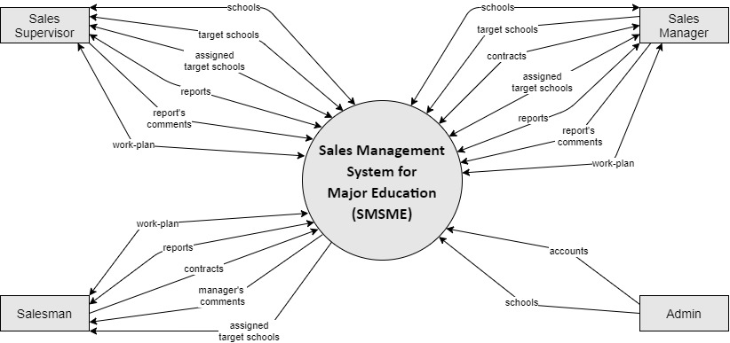

Figure 4. System Context Diagram

### 1.2 Business Rules

|  |  |
| --- | --- |
| **ID** | **Rule Definition** |
| BR-01 | This system is only used for Sales Department of the Major Education.  Public users shall not use this system. |
| BR-02 | Users shall not register an account. Only Administrators (Admin) can create new accounts for users. |
| BR-03 | Users shall reset their forgotten password.  When users send request to reset their forgotten password, the system automatically generates a verification code and sends that code to user’s email. |
| BR-04 | Admin shall create new accounts for users but not including the password.  Password is automatically generated by the system and sent to user’s email. |
| BR-05 | Users (all roles) can view and edit their profile, including email, phone number, address, avatar and password.  Users shall not edit username, full name, birthday, gender and working status (“active”/ “inactive”) (also shall not view “working status”). |
| BR-06 | When an employee quits his/her job or moves to another department, Admin shall changes his/her “working status” from “active” to “inactive”. |
| BR-07 | Users whose “working status” is “inactive” shall not log into the system. |
| BR-08 | Admin shall edit user’s phone number, gender, birthday, roles, and working status.  Admin shall not edit username and email of the existed accounts. |
| BR-09 | Admin manage the raw data of all accounts and schools in the system.  Admin shall not create or edit fields related to business process of the sales. |
| BR-10 | Only Admin shall create new schools.  Sales Managers and Sales Supervisors can view list of all schools and their details but shall not create. |
| BR-11 | Sales Managers and Sales Supervisors shall create lists of target schools.  The initial list of target schools has not had PIC yet.  The initial list of target schools is required to have purpose. |
| BR-12 | Sales Managers and Sales Supervisors can modify (create, remove, edit or assign) lists of target schools. |
| BR-13 | Sales Managers and Sales Supervisors shall not modify (create, remove, edit or assign) lists of target schools in the past. |
| BR-14 | Sales Managers and Sales Supervisors shall assign or unassigned Salesmen to target schools.  The assigned person is called “PIC” (person in charge). |
| BR-15 | Each target school shall be assigned to only one PIC at a time.  A target school can be assigned many times to different PIC. |
| BR-16 | An assigned target school can be unassigned. |
| BR-17 | If Sales Managers want to change the PIC of a target school, they need to unassign the current PIC first before assigning a new PIC. |
| BR-18 | Sales Managers and Sales Supervisors shall not remove target schools which have been assigning or having reports or being in the contract’s duration. |
| BR-19 | Only Sales Managers and Sales Supervisors can view list of all target schools.  Salesmen can only view list of their own assigned schools. |
| BR-20 | Business trips to each target school have different purposes, depends on the school status (for example: “Leads”, “Customer”, “Ngưng hợp tác”). |
| BR-21 | Salesmen shall visit their assigned schools. After every business trip to the target schools, Salesmen shall submit a daily report. |
| BR-22 | Salesmen shall successfully meet school’s representatives (principals) of at least 3 new target schools every working day. |
| BR-23 | Salesmen shall not create reports for a date in the past or the future.  The reported date is the current date. |
| BR-24 | List of all reports is shared, so any Salesmen, Sales Managers or Sales Supervisors can view it. |
| BR-25 | Sales Managers and Sales Supervisors can comment on other Salesmen’s, Sales Supervisors’ or Sales Managers’ reports, and shall not comment on their own reports. |
| BR-26 | When Sales Managers comment on reports, notifications shall be sent to the corresponding users. |
| BR-27 | Sales Managers and Sales Supervisors shall only edit or remove comments in the current school year. |
| BR-28 | The users can only edit or remove their own reports and in the current school year. |
| BR-29 | The users shall not edit or remove the reports which were commented. |
| BR-30 | After a business trip to the target schools, if the users collect some information that is different from the existed school’s details, the users can only edit data related to the school’s representative. The other school’s data, user needs to inform to the Admin to edit them. |
| BR-31 | A target school may has one or multiple contracts.  \**Note*:  In the context of the Major Education, the word “contract” refers to “MOU (Memorandum of understanding)[1]” between the Major Education and their target shools, not the final contract as usual. |
| BR-32 | The PIC shall only create, edit and view the contracts (MOUs) of their assigned schools. |
| BR-33 | When PIC create new contracts, notifications shall be sent to the Sales Managers. |
| BR-34 | Only Sales Managers shall view all contracts of all target schools in the list.  However, Sales Managers shall not edit the contracts (MOUs) of schools which they are not in charge of. |
| BR-35 | Each Salesman, Sales Manager and Sales Supervisor has his/her own work-plan.  Salesmen can search to view work-plan of other Salesmen but shall not view work-plan of Sales Sales Supervisors or Sales Managers.  Sales Manager and Sales Supervisor can view work-plan of all users.  An item in work-plan is called “personal activity”. |
| BR-36 | The users shall not modify (create, edit or remove personal activities) work-plan of the others. |
| BR-37 | A personal activity has three statuses: “pending” (not started yet or in progress), “completed” and “failed”.  When the users create a personal activity, the default status shall be “pending”. |
| BR-38 | Any personal activity has endtime.  When the current time reaches endtime, if users have not marked that personal activity as completed, the default status shall be changed into “failed”; otherwise, the status shall be “completed”. |
| BR-39 | Sales Managers and Sales Supervisors supervise Salesmen via daily reports and work-plan. |
| BR-40 | Sales Managers and Sales Supervisor may play a role as a Salesman, so they have full features of the Salesmen. |

Table 14. Business Rules

## 2. User Requirements

### 2.1 Overview

#### Use Case Diagram

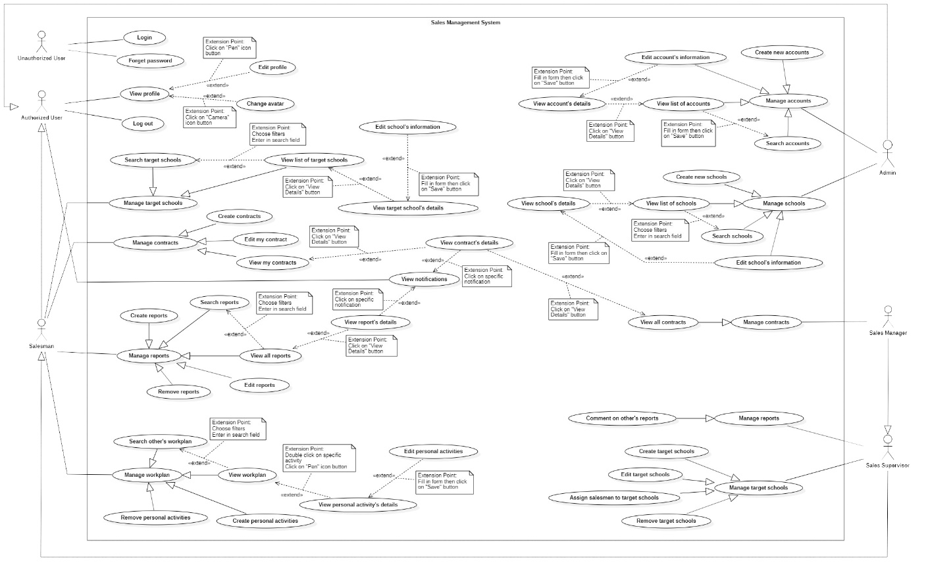

Figure 5. Use case Overview

#### System Actors

|  |  |  |
| --- | --- | --- |
| **#** | **Actor** | **Description** |
| 1 | Unauthorized User | The people who have not logged into the system yet. |
| 2 | Authorized User | The people who have logged into the system with the account (Administrator, Salesman, Sales Manager).  All functions of this user are general functions that a normal user can do without considering the role. |
| 3 | Administrator | The Administrators manage data of all accounts and all schools in the system. |
| 4 | Salesman | * The Salesman has business trips to target schools for many purposes, including introducing and selling Major Education’s programs to target schools for cooperation. * Salesman shall create contract and view his/her own assigned target schools’ contracts. |
| 5 | Sales Manager | * Sales Manager manages target schools, Salesmen and supervises salesmen’s reports and work-plans. * Sales Manager also plays a role as Salesman, including business trips. * Sales Manager is not allow to view contracts of others’. |
| 6 | Sales Supervisor | * Sales Supervisor manages target schools, Salesmen and supervises salesmen’s reports and work-plans. * Sales Supervisor also plays a role as Salesman, including business trips. * Sales Supervisor shall view all contracts of all target schools. |

Table 15. System Actors

#### Use Cases List

|  |  |  |  |
| --- | --- | --- | --- |
| **ID** | **Use Case** | **Primary Actors** | **Secondary Actors** |
| UC-01 | Login | Unauthorized User |  |
| UC-02 | Forget password | Unauthorized User |  |
| UC-03 | View Profile | Authorized User,  Salesman,  Sales Supervisor,  Sales Manager,  Administrator |  |
| UC-04 | Edit Profile | Authorized User,  Salesman,  Sales Supervisor,  Sales Manager,  Administrator |  |
| UC-05 | Change avatar | Authorized User,  Salesman,  Sales Supervisor,  Sales Manager,  Administrator |  |
| UC-06 | Log out | Authorized User,  Salesman,  Sales Supervisor,  Sales Manager,  Administrator |  |
| UC-07 | View notifications | Authorized User,  Salesman,  Sales Supervisor,  Sales Manager,  Administrator |  |
|  | ***Manage accounts*** | | |
| UC-08 | Create new accounts | Administrator |  |
| UC-09 | Search accounts | Administrator |  |
| UC-10 | View list of accounts | Administrator |  |
| UC-11 | View account’s details | Administrator |  |
| UC-12 | Edit account’s information | Administrator |  |
|  | ***Manage schools*** | | |
| UC-13 | Create new schools | Administrator |  |
| UC-14 | Search schools | Administrator |  |
| UC-15 | View list of schools | Administrator |  |
| UC-16 | View school’s details | Administrator |  |
| UC-17 | Edit school’s information | Administrator |  |
|  | ***Manage target schools*** |  |  |
| UC-18 | Search targetschools | Salesman,  Sales Supervisor,  Sales Manager |  |
| UC-19 | View list of targetschools | Salesman,  Sales Supervisor,  Sales Manager |  |
| UC-20 | View targetschool’s details | Salesman,  Sales Supervisor,  Sales Manager |  |
| UC-21 | Edit school’s information | Salesman,  Sales Supervisor,  Sales Manager |  |
|  | ***Manage contracts*** | | |
| UC-22 | Create contracts | Salesman,  Sales Supervisor,  Sales Manager |  |
| UC-23 | View my contracts | Salesman,  Sales Supervisor,  Sales Manager |  |
| UC-24 | View contract’s details | Salesman,  Sales Supervisor,  Sales Manager |  |
| UC-25 | Edit my contracts | Salesman,  Sales Supervisor,  Sales Manager |  |
|  | ***Manage reports*** | | |
| UC-26 | Create reports | Salesman,  Sales Supervisor,  Sales Manager |  |
| UC-27 | Search reports | Salesman,  Sales Supervisor,  Sales Manager |  |
| UC-28 | View all reports | Salesman,  Sales Supervisor,  Sales Manager |  |
| UC-29 | View report’s details | Salesman,  Sales Supervisor,  Sales Manager |  |
| UC-30 | Edit reports | Salesman,  Sales Supervisor,  Sales Manager |  |
| UC-31 | Remove reports | Salesman,  Sales Supervisor,  Sales Manager |  |
|  | ***Manage workplan*** | | |
| UC-32 | Create personal activities | Salesman,  Sales Supervisor,  Sales Manager |  |
| UC-33 | Search other’s workplan | Salesman,  Sales Supervisor,  Sales Manager |  |
| UC-34 | View workplan | Salesman,  Sales Supervisor,  Sales Manager |  |
| UC-35 | View personal activity's details | Salesman,  Sales Supervisor,  Sales Manager |  |
| UC-36 | Edit personal activities | Salesman,  Sales Supervisor,  Sales Manager |  |
| UC-37 | Remove personal actitivities | Salesman,  Sales Supervisor,  Sales Manager |  |
|  | ***Manage target schools*** | | |
| UC-38 | Create target schools | Sales Supervisor,  Sales Manager |  |
| UC-39 | Edit target schools | Sales Supervisor,  Sales Manager |  |
| UC-40 | Assign salesmen to target schools | Sales Supervisor,  Sales Manager |  |
| UC-41 | Remove target schools | Sales Supervisor,  Sales Manager |  |
|  | ***Manage reports*** | | |
| UC-42 | Comment on salesmen's reports | Sales Supervisor,  Sales Manager |  |
|  | ***Manage Contracts*** | | |
| UC-43 | View all contracts | Sales Manager |  |
|  |  |  |  |

Table 16. Use Cases List

### 2.2 <<Unauthorized User>> Overview Use Case

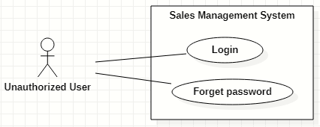

Figure 6. <<Unauthorized User>> Overview Use Case

#### Login

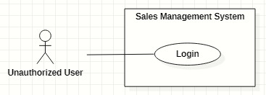

Figure 7. <<Unauthorized User>> Login

|  |  |  |  |  |  |
| --- | --- | --- | --- | --- | --- |
| ID and Name: | **UC-01 Login** | | | | |
| Created By: | GiaNH | | Date Created: | 05/02/2021 |
| Primary Actor: | Unauthorized User | | Secondary Actors: | N/A |
| Description: | This use case allows the user to log into the system to use the services of the system. | | | | |
| Trigger: | The user clicks on the “Login” button on the Login screen. | | | | |
| Preconditions: | PRE-1. The user has to own an account with a username and password.  PRE-2. The user has not logged into the system yet. | | | | |
| Post-conditions: | POST-1. The user successfully logs into the system, and be redirected to the Home screen. | | | | |
| Normal Flow: | **Step** | **Actor Action** | | **System Response** | |
| 1 | The user opens the login view in web browsers. | | The system requires identifying information from the user:   * “Username”: text input, required. * “Password”: text input, required. | |
| 2 | The user inputs into the “username” and “password” fields on Login form. | | [Exception 1] | |
| 3 | The user clicks on “Login” button. | | The system allows the user to access into and redirects to the corresponding Home screen (based on the role of user).  [Exception 2]  [Exception 3] | |
| Alternative Flows: | N/A | | | | |
| Exceptions: | **No** | **Cause** | | **System Response** | |
| 1 | The user inputs invalid format content into the “username” and “password” fields. | | The system shows the error message: “Invalid username or password”. | |
| 2 | The user inputs the wrong username or password. | | The system shows the error message: “Wrong username or password”. | |
| 3 | The user’s device does not connect to the Internet or the server has internal error. | | The system shows the error message: “Connection Failed or Internal Error”. | |
| Priority: | Normal | | | | |
| Frequency of Use: | Usually | | | | |
| Business Rules: | * BR-01, BR-07 * The required information are username, password. * The username must be 8 – 30 characters length and must not include special characters. * The password must be 8 – 30 characters length and must be hashed encrypted. | | | | |
| Other Information: | N/A | | | | |
| Assumptions: | N/A | | | | |

Table 17. <<Unauthorized User>> Login

#### Forget password

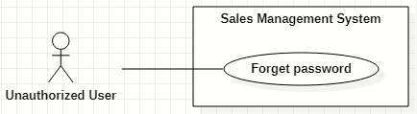

Figure 8. <<Unauthorized User>> Forget password

|  |  |  |  |  |  |
| --- | --- | --- | --- | --- | --- |
| ID and Name: | **UC-02 Forget password** | | | | |
| Created By: | HaPTN | | Date Created: | 12/04/2021 |
| Primary Actor: | Unauthorized User | | Secondary Actors: | N/A |
| Description: | This use case allows the user to reset their forgotten password. | | | | |
| Trigger: | The user clicks on “Forgot password?” link on the Login screen. | | | | |
| Preconditions: | PRE-1. The user has to own an account with a username and password.  PRE-2. The user has not logged into the system yet. | | | | |
| Post-conditions: | POST-1. The user’s password has been updated in the database.  POST-2. The user is redirected to Login screen. | | | | |
| Normal Flow: | **Step** | **Actor Action** | | **System Response** | |
| 1 | The user clicks on “Forgotten password?” link on the Login screen in Web browsers. | | The system redirects to “Reset your password” screen which requires user to input:   * “Username”: text input, required. * “Email”: text input, required. * “Send me verification code”: button. | |
| 2 | The user inputs into the “username” and “email” fields on “Reset your password” form. | | [Exception 1] | |
| 3 | The user clicks on “Send me verification code” button. | | The system sends a verification code via email that user has just provided.  [Exception 2]  [Exception 3] | |
|  | 4 |  | | The system redirects to “Enter verification code” screen which have:   * “Verification code”: text input. * “Continue”: button. | |
|  | 5 | On “Enter verification code” form, the user inputs into the “verification code” then clicks on “Continue” button. | | The system redirects to “Enter new password” screen which have:   * “New password”: text input, required. * “Re-new password”: text input, required. * “Save”: button.   [Exception 3]  [Exception 4] | |
|  | 6 | The user inputs into the “new password” and “re-new password” fields on “Enter new password”. | | [Exception 5] | |
|  | 7 | The user clicks on “Save” button. | | The system shows the successful message: “Password has been changed successfully”, then redirects to the “Login” screen  [Exception 3] | |
| Alternative Flows: | N/A | | | | |
| Exceptions: | **No** | **Cause** | | **System Response** | |
| 1 | The user inputs invalid format content into the “username” and “email” fields. | | The system shows the error message: “Invalid username or email”. | |
| 2 | The username or email in form do not match to fields “username” and “user_email” in the database. | | The system shows the error message: “Wrong username or email”. | |
| 3 | The user’s device does not connect to the Internet or the server has internal error. | | The system shows the error message: “Connection Failed or Internal Error”. | |
|  | 4 | The user inputs wrong verification code. | | The system shows the error message: “Please check your verification code and try again.”. | |
| Priority: | Normal | | | | |
| Frequency of Use: | Usually | | | | |
| Business Rules: | * BR-03 * The “new password” and “re-new password” must be 8 – 30 characters length and must be hashed encrypted. | | | | |
| Other Information: | N/A | | | | |
| Assumptions: | N/A | | | | |

Table 18. <<Unauthorized User>> Forget password

### 2.3 <<Authorized User>> Overview Use Case

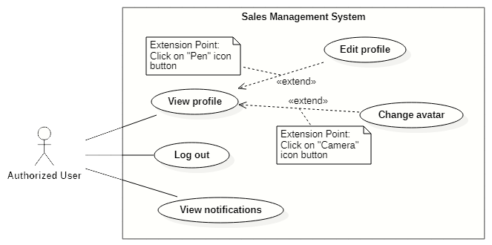

Figure 9. <<Authorized User>> Overview Use Case

#### View profile

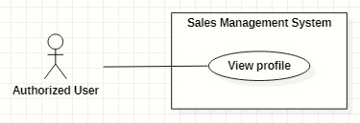

Figure 10. <<Authorized User>> View profile

|  |  |  |  |  |  |
| --- | --- | --- | --- | --- | --- |
| ID and Name: | **UC-03 View profile** | | | | |
| Created By: | GiaNH | | Date Created: | 05/02/2021 |
| Primary Actor: | Authorized User | | Secondary Actors: | N/A |
| Description: | This use case allows the user to view his/her profile. | | | | |
| Trigger: | The user selects “Profile” command in the options menu under the user avatar (at the top right corner of the screen). | | | | |
| Preconditions: | PRE-1. The user has been logged into the system. | | | | |
| Post-conditions: | POST-1. The user’s information is displayed in details as a form. | | | | |
| Normal Flow: | **Step** | **Actor Action** | | **System Response** | |
| 1 | The user clicks on the avatar on the right corner of the topbar. | | The system redirects to the “Profile” screen.  The detail information of the user is displayed on the screen.  [Exception 1] | |
| Alternative Flows: | N/A | | | | |
| Exceptions: | **No** | **Cause** | | **System Response** | |
| 1 | The user’s device does not connect to the Internet or the server has internal error. | | The system shows the error message: “Connection Failed or Internal Error”. | |
| Priority: | Normal | | | | |
| Frequency of Use: | Usually | | | | |
| Business Rules: | BR-05 | | | | |
| Other Information: | N/A | | | | |
| Assumptions: | N/A | | | | |

Table 19. <<Authorized User>> View profile

#### Edit profile

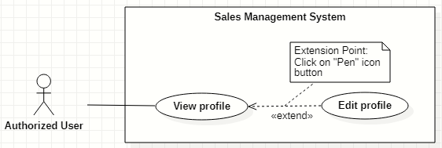

Figure 11. <<Authorized User>> Edit profile

|  |  |  |  |  |  |
| --- | --- | --- | --- | --- | --- |
| ID and Name: | **UC-04 Edit profile** | | | | |
| Created By: | GiaNH | | Date Created: | | 05/02/2021 |
| Primary Actor: | Authorized User | | Secondary Actors: | | N/A |
| Description: | This use case allows the user to edit his/her profile. | | | | |
| Trigger: | The user clicks on “Pen” icon button. | | | | |
| Preconditions: | PRE-1. The user has been logged into the system.  PRE-2. The user is at the “Profile” screen. | | | | |
| Post-conditions: | POST-1. The user’s information is edited in the system. | | | | |
| Normal Flow: | **Step** | **Actor Action** | | **System Response** | |
| 1 | On Profile screen, the user clicks on “Pen” icon button at the right of the information row that he/she wants to edit.  [Alternative 1 ] | | At the selected row, the system opens the collapsed div to show the text field with the following format:   * “Password”: text. * “Address”: text. * “Email”: text. * “Birthdate”: date. * “IsMale”: two radio buttons, required, only select one. * “Phone” text. * “Avatar”: image. | |
| 2 | The user inputs the information into the selected text field. | | [Exception 1]  [Exception 2]  [Exception 3] | |
| 3 | The user selects “Save” button.  [Exception 4] | | The system shows the the successful message: “Updated Successfullly”.  [Exception 5] | |
| Alternative Flows: | **Step** | **Actor Action** | | **System Response** | |
| 1 | The user selects “Pen” icon button at “Password” line. | | The system shows the accordion that contains following information:   * “Current Password”: text, required. * “New Password”: text, required. * “Confirm New Password”: text, required.   *Continue to step 2 of Normal Flow*. | |
| Exceptions: | **No** | **Cause** | | **System Response** | |
| 1 | The user inputs invalid format content into fields. | | The system shows the error message: “Incorrect entry”. | |
| 2 | The user inputs the wrong old password. | | The system shows the error message: “Invalid password” and “Update Unsuccessful”. | |
| 3 | The user inputs the confirm-new password that does not match to new password. | | The system shows the error message: “You must enter the same password twice in order to confirm it”. | |
| 4 | The user selects “Cancel” button to cancel updating. | | The system discards all changes and returns the “Profile” screen. | |
| 5 | The user’s device does not connect to the Internet or the server has internal error. | | The system shows the error message: “Connection Failed or Internal Error”. | |
| Priority: | Normal | | | | |
| Frequency of Use: | Usually | | | | |
| Business Rules: | * BR-05 * All fields related to “password” must be 8 – 30 characters length and must be hashed encrypted. * Fields that could be edited are: password, email, phone number, address and avatar. * Phone must be in format “/(84|0[3|5|7|8|9])+([0-9]{8})\b/g” and have max length is 10 (when starts with 0) or 11 (when starts with 84).   *(Resources:* [*https://www.regextester.com/106725*](https://www.regextester.com/106725)*)*   * Fields which are not allowed users to edit are: username, fullname, birthdate and isMale. | | | | |
| Other Information: | N/A | | | | |
| Assumptions: | N/A | | | | |

Table 20. <<Authorized User>> Edit profile

#### Change avatar

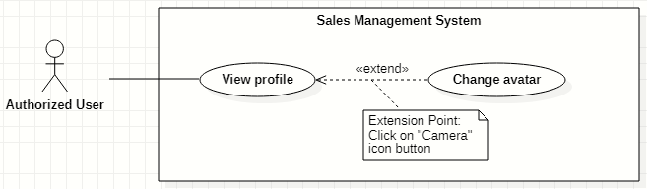

Figure 12. <<Authorized User>> Change avatar

|  |  |  |  |  |  |
| --- | --- | --- | --- | --- | --- |
| ID and Name: | **UC-05 Change avatar** | | | | |
| Created By: | HaPTN | | Date Created: | | 12/04/2021 |
| Primary Actor: | Authorized User | | Secondary Actors: | | N/A |
| Description: | This use case allows the user to update his/her profile avatar. | | | | |
| Trigger: | The user clicks on “Camera” icon button next to the avatar. | | | | |
| Preconditions: | PRE-1. The user has been logged into the system.  PRE-2. The user is at the “Profile” screen. | | | | |
| Post-conditions: | POST-1. The user’s new avatar is edited in the system. | | | | |
| Normal Flow: | **Step** | **Actor Action** | | **System Response** | |
| 1 | On Profile screen, the user clicks on “Camera” icon button next to the avatar image. | | The system opens the Windows Explorer dialog for user to upload an image. | |
| 2 | The user chooses an image in the Windows Explorer dialog and clicks on “Open” button.  [Exception 1]  [Exception 2] | | The system updates avatar with the chosen image and shows the the successful message: “Updated Successfullly”.  [Exception 3] | |
| Alternative Flows: | N/A | | | | |
| Exceptions: | **No** | **Cause** | | **System Response** | |
| 1 | The user chooses invalid image format. | | The system shows the error message: “Update Unsuccessful”. | |
| 2 | The user closes the Windows Explorer (by clicking on “x” button or “Cancel” button). | | The system shows the error message: “Update Unsuccessful”. | |
| 3 | The user’s device does not connect to the Internet or the server has internal error. | | The system shows the error message: “Connection Failed or Internal Error”. | |
| Priority: | Normal | | | | |
| Frequency of Use: | Usually | | | | |
| Business Rules: | * BR-05 * In the Windows Explorer dialog, the user can only choose one image at a time. * The system only accepts image files in type “.png”, “.jpg”, “.jpeg”. | | | | |
| Other Information: | N/A | | | | |
| Assumptions: | N/A | | | | |

Table 21. <<Authorized User>> Change avatar

#### Logout

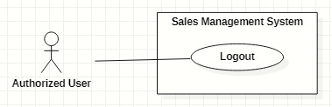

Figure 13. <<Authorized User>> Logout

|  |  |  |  |  |  |  |
| --- | --- | --- | --- | --- | --- | --- |
| ID and Name: | **UC-06 Logout** | | | | | |
| Created By: | GiaNH | | Date Created: | 05/02/2021 | |
| Primary Actor: | Authorized User | | Secondary Actors: | N/A | |
| Description: | This use case allows the users to log out of the system. | | | | | |
| Trigger: | The user clicks on “Logout” button. | | | | | |
| Preconditions: | PRE-1. The user has been logged into the system. | | | | | |
| Post-conditions: | POST-1. The user logs out the system. | | | | | |
| Normal Flow: | **Step** | **Actor Action** | | | **System Response** | |
| 1 | The user clicks on the “Avatar” icon button to open “Profile” screen. | | | The system redirects to the “Profile” screen. | |
| 2 | The user clicks on “Log out” button at the top right corner of the “Profile” screen. | | | The system clears cookies and access token then returns to the “Login” screen. | |
| Alternative Flows: | N/A | | | | | |
| Exceptions: | N/A | | | | | |
| Priority: | Normal | | | | | |
| Frequency of Use: | Usually | | | | | |
| Business Rules: | User’s token is removed in client and the session is destroyed in server. | | | | | |
| Other Information: | N/A | | | | | |
| Assumptions: | N/A | | | | | |

Table 22. <<Authorized User>> Logout

#### View notifications

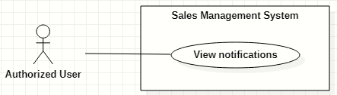

Figure 14. <<Authorized User>> View notifications

|  |  |  |  |  |  |  |
| --- | --- | --- | --- | --- | --- | --- |
| ID and Name: | **UC-07 View notifications** | | | | | |
| Created By: | HaPTN | | Date Created: | 12/04/2021 | |
| Primary Actor: | Authorized User | | Secondary Actors: | N/A | |
| Description: | This use case allows the users. | | | | | |
| Trigger: | The user clicks on “Bell” icon button (at the top right corner of the screen). | | | | | |
| Preconditions: | PRE-1. The user has been logged into the system. | | | | | |
| Post-conditions: | POST-1. The user is redirect to the corresponding screen depends on what notification he/she selects. | | | | | |
| Normal Flow: | **Step** | **Actor Action** | | | **System Response** | |
| 1 | The user clicks on “Bell” icon button (at the top right corner of the screen) to view list of notifications. | | | The system shows list of notifications in a popover, near the “Bell” icon button. | |
|  | 2 | The user select specific notification.  [Alternative 1]  [Alternative 2] | | | [Exception 1] | |
| Alternative Flows: | **Step** | **Actor Action** | | | **System Response** | |
| 1 | The user clicks on notification type “report”. | | | The system redirects to “Report details” screen for user to view comment of supervisor/manager. | |
| 2 | The user clicks on notification type “contract”. | | | The system redirects to “Contract details” screen for user to view contract’s details. | |
| Exceptions: | **No** | **Cause** | | | **System Response** | |
| 1 | The user’s device does not connect to the Internet or the server has internal error. | | | The system shows the error message: “Connection Failed or Internal Error”. | |
| Priority: | Normal | | | | | |
| Frequency of Use: | Usually | | | | | |
| Business Rules: | * BR-26 (notification type “report”) * BR-33 (notification type “contract”) | | | | | |
| Other Information: | N/A | | | | | |
| Assumptions: | N/A | | | | | |

Table 23. <<Authorized User>> View notifications

### 2.4 <<Administrator>> Overview Use Case

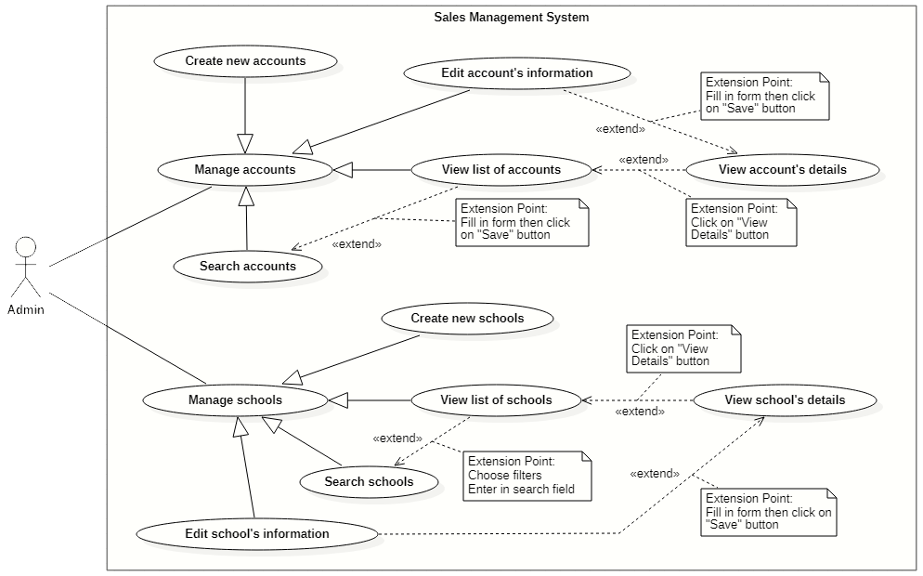

Figure 15. <<Administrator>> Overview Use Case

#### Create new accounts

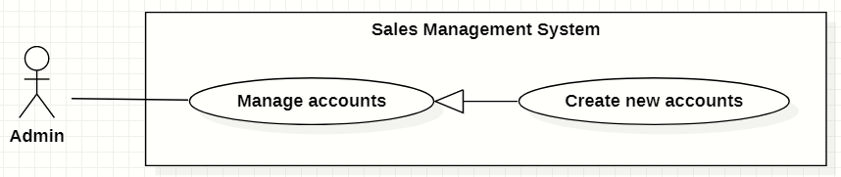

Figure 16. <<Administrator>> Create new accounts

|  |  |  |  |  |  |
| --- | --- | --- | --- | --- | --- |
| ID and Name: | **UC-08 Create new accounts** | | | | |
| Created By: | GiaNH | | Date Created: | | 15/02/2021 |
| Primary Actor: | Administrator | | Secondary Actors: | | N/A |
| Description: | This use case allows the user to create new account. | | | | |
| Trigger: | The user clicks on the “Create” button in “Accounts” screen. | | | | |
| Preconditions: | PRE-1. The user has been logged into the system with role Admin.  PRE-2. The user is on the “Accounts” screen. | | | | |
| Post-conditions: | POST-1. The new account is added in the system. | | | | |
| Normal Flow: | **Step** | **Actor Action** | | **System Response** | |
| 1 | The user selects “Accounts” on the navigation bar (sidebar). | | The system redirects the Accounts screen. | |
| 2 | The user selects on “Create” button in screen. | | The system displays the “Create Account” form with the following required information:   * “Username”: input text filed, required. * “Role”: selections (Salesman, Sales Supervisor, Sales Manager, Admin). * “Full name”: input text field, required. * “Email”: input text field. * “Phone”: input text field, required. * “Address”: input text field. * “IsMale”: radio buttons, required. * “Birthdate”: date picker. * “Save”: button. * “Cancel”: button. | |
| 3 | The user inputs into required information fields. | | [Exception 1]  [Exception 2] | |
| 4 | The user selects on the “Save” button.  [Exception 4] | | The system shows the successful message: “New account has been created successfully. Please check your email to get the password.”.  [Exception 3]  [Exception 5] | |
| 5 |  | | The system sends the new user an email which contains the his/her password.  [Exception 3] | |
| 6 |  | | The system updates the table of list of schools in the “Schools” screen.  [Exception 3] | |
| Alternative Flows: | N/A | | | | |
| Exceptions: | **No** | **Cause** | | **System Response** | |
| 1 | The user leaves the blank fields or inputs the invalid format content. | | The system shows the error message: “Please input the valid format content”. | |
| 2 | The content that the user inputs into “Confirm password” is not matched the “Password” field. | | The system show the error message: “Confirm password is not matched the password”. | |
| 3 | The user’s device does not connect to the Internet or the server has internal error. | | The system shows the error message: “Connection Failed or Internal Error”. | |
| 4 | The user selects “Cancel” button. | | The system closes the “Create Account” view and returns the “Accounts” screen. | |
| 5 | The content that the user inputs into “username” field is duplicate in the system. | | The system shows the error message: “The username has already existed”. | |
| Priority: | High | | | | |
| Frequency of Use: | Usually | | | | |
| Business Rules: | * BR-04, BR-09 * The username must be 8 – 30 characters, not include special characters. * Admin does not create password for users. * Password is randomly generated by the system and is sent to the provided user’s email. * The password which is stored in the Database must be hasheded encrypted by Bcript. * The email must be validated. * Phone must be in format “/(84|0[3|5|7|8|9])+([0-9]{8})\b/g” and have max length is 10 (when starts with 0) or 11 (when starts with 84).   *(Resources:* [*https://www.regextester.com/106725*](https://www.regextester.com/106725)*)* | | | | |
| Other Information: | N/A | | | | |
| Assumptions: | N/A | | | | |

Table 24. <<Administrator>> Create new accounts

#### Search accounts

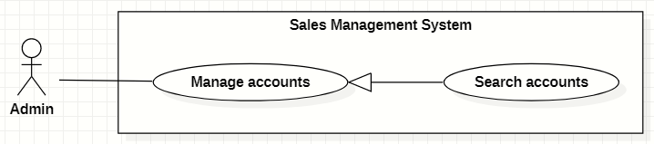

Figure 17. <<Administrator>> Search accounts

|  |  |  |  |  |  |  |  |
| --- | --- | --- | --- | --- | --- | --- | --- |
| ID and Name: | **UC-09 Search accounts** | | | | | | |
| Created By: | GiaNH | | | Date Created: | | | 16/02/2021 |
| Primary Actor: | Administrator | | | Secondary Actors: | | | N/A |
| Description: | This use case allows the users to find the accounts based on the role, status, username, phone, address,… | | | | | | |
| Trigger: | The user selects filters or inputs in search field on the “Accounts” screen. | | | | | | |
| Preconditions: | PRE-1. The user has been logged into the system with role Admin.  PRE-2. The user is on “Accounts” screen. | | | | | | |
| Post-conditions: | POST-1. The list of accounts is shown. | | | | | | |
| Normal Flow: | **Step** | | **Actor Action** | | **System Response** | | |
| 1 | | The user inputs in the search field or selects filters to looking for accounts. | | The system displays the list of accounts as the table.  Available filters on this screen:   * “isActive”: selections (true, false) * “Roles”: selections (Admin, Sales Manager, Sales Supervisor, Salesman). * Search field: text field. | | |
| 2 | |  | | The list of Accounts is shown as a table on the Accounts screen.  Table will includes these fields:   * “Username”: text. * “Fullname”: image (avatar) and text. * “Phone”: text. * “Email”: text. * “Role”: Label. | | |
| Alternative Flows: | N/A | | | | | | |
| Exceptions: | **No** | **Cause** | | | | **System Response** | |
| 1 | The content of search field or selecting filter that the user inputted is not matched any data in database. | | | | The system displays “No records found” line. | |
| Priority: | Normal | | | | | | |
| Frequency of Use: | Usually | | | | | | |
| Business Rules: | * The default values of filter “isActive” is “true” * The default values of filter “Role” is “All”. | | | | | | |
| Other Information: | N/A | | | | | | |
| Assumptions: | N/A | | | | | | |

Table 25. <<Administrator>> Search accounts

#### View list of accounts

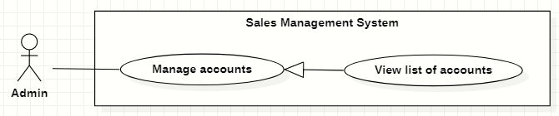

Figure 18. <<Administrator>> View list of accounts

|  |  |  |  |  |  |
| --- | --- | --- | --- | --- | --- |
| ID and Name: | **UC-10 View list of accounts** | | | | |
| Created By: | GiaNH | | Date Created: | | 15/02/2021 |
| Primary Actor: | Administrator | | Secondary Actors: | | N/A |
| Description: | This use case allows the user to view list of accounts. | | | | |
| Trigger: | The user selects “Accounts” on the navigation bar (sidebar). | | | | |
| Preconditions: | PRE-1. The user has been logged into the system with role Admin. | | | | |
| Post-conditions: | POST-1. The list of Accounts is shown as a table on the “Accounts” screen. | | | | |
| Normal Flow: | **Step** | **Actor Action** | | **System Response** | |
| 1 | The user selects “Accounts” on the navigation bar (sidebar). | | The system redirects the Accounts screen. | |
| 2 |  | | The list of Accounts is shown as a table on the Accounts screen.  Table will includes these fields:   * “Username”: text. * “Fullname”: image (avatar) and text. * “Phone”: text. * “Email”: text. * “Role”: Label. | |
| Alternative Flows: | N/A | | | | |
| Exceptions: | **No** | **Cause** | | **System Response** | |
| 1 | The data is null or empty in database. | | The system shows “No records found” line on the table. | |
| Priority: | Medium | | | | |
| Frequency of Use: | Usually | | | | |
| Business Rules: | * The default values of filter “isActive” is “true” * The default values of filter “Role” is “All”. | | | | |
| Other Information: | N/A | | | | |
| Assumptions: | N/A | | | | |

Table 26. <<Administrator>> View list of accounts

#### View account’s details

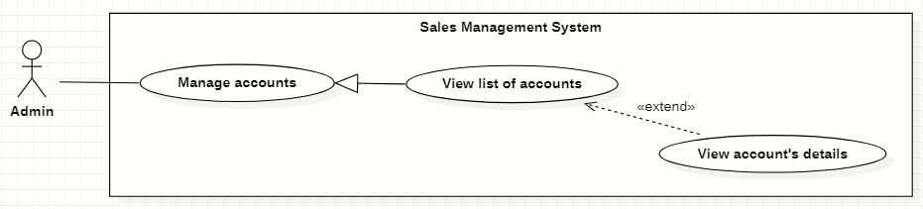

Figure 19. <<Administrator>> View account’s details

|  |  |  |  |  |  |
| --- | --- | --- | --- | --- | --- |
| ID and Name: | **UC-11 View account’s details** | | | | |
| Created By: | GiaNH | | Date Created: | | 16/02/2021 |
| Primary Actor: | Administrator | | Secondary Actors: | | N/A |
| Description: | This use case allows the user to view the detail information of an account. | | | | |
| Trigger: | The user clicks on the “View details” command on the menu options at the end of row in table list of accounts. | | | | |
| Preconditions: | PRE-1. The user has been logged into the system with role Admin.  PRE-2. The user is on the “Accounts” screen. | | | | |
| Post-conditions: | POST-1. The detail information of account is shown as a form. | | | | |
| Normal Flow: | **Step** | **Actor Action** | | **System Response** | |
| 1 | On the “Accounts” screen, at the end of each row in the table, the user clicks on action icon button, then selects “View detail” command on the menu options. | | The system displays “Account’s details” view, the account’s information is displayed as a form.   * “Username”: input text filed, required. * “Password”: input password text field, required. * “Confirm password: input password text field, required. * “Role”: selections (Salesman, Sales Supervisor, Sales Manager, Admin). * “Full name”: input text field, required. * “Email”: input text field. * “Phone”: input text field, required. * “IsMale”: radio buttons, required. * “Birthdate”: date picker. * “Address”: input text field. * “Save”: button, inactive. | |
| Alternative Flows: | N/A | | | | |
| Exceptions: | N/A | | | | |
| Priority: | Medium | | | | |
| Frequency of Use: | Usually | | | | |
| Business Rules: | N/A | | | | |
| Other Information: | N/A | | | | |
| Assumptions: | N/A | | | | |

Table 27. <<Administrator>> View account’s details

#### Edit account’s information

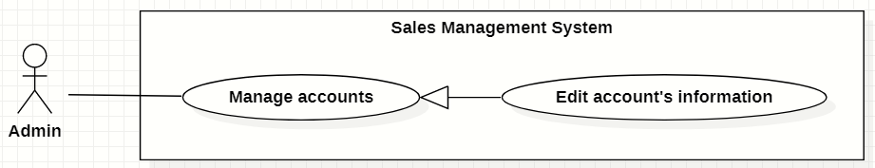

Figure 20. <<Administrator>> Edit account’s information

|  |  |  |  |  |  |  |  |
| --- | --- | --- | --- | --- | --- | --- | --- |
| ID and Name: | **UC-12 Edit account’s information** | | | | | | |
| Created By: | GiaNH | | | Date Created: | | | 16/02/2021 |
| Primary Actor: | Administrator | | | Secondary Actors: | | | N/A |
| Description: | This use case allows the users to edit the account’s information. | | | | | | |
| Trigger: | The user edits on fields in “Account’s details” screen then clicks “Save” button. | | | | | | |
| Preconditions: | PRE-1. The user has been logged into the system with role Admin.  PRE-2. The user is on the “Account’s details” screen. | | | | | | |
| Post-conditions: | POST-1. The Account information is edited in database. | | | | | | |
| Normal Flow: | **Step** | | **Actor Action** | | | **System Response** | |
| 1 | |  | | | The system displays the “Account’s detail” screen as a form with the following required information:   * “Username”: text field, disabled. * “Full name”: input text field. * “Email”: input text field. * “Phone”: input text field, required. * “IsMale”: radio buttons. * “Birthdate”: date picker. * “Address”: input text field. * “Roles”: selections (Admin, Sales Manager, Sales Supervisor, Salesman). * “isActive”: toggle, required. * “Save”: button, only active when the form is dirty. | |
| 2 | | The user edits on fields in this form. | | | [Exception 1] | |
| 3 | | The user clicks “Save” button when finish. | | | The system has successful edit and displays the successful message: “Updated Successfully”. [Exception 2] | |
| Alternative Flows: | N/A | | | | | | |
| Exceptions: | **No** | **Cause** | | | **System Response** | | |
| 1 | The user inputs invalid format content into fields. | | | The system informs the users that the content of fields is invalid format. | | |
| 2 | The user’s device does not connect to the Internet or the server has internal error. | | | The system shows the error message: “Connection Failed or Internal Error”. | | |
| Priority: | Medium | | | | | | |
| Frequency of Use: | Usually | | | | | | |
| Business Rules: | * BR-06, BR-08, BR-09 * Phone must be in format “/(84|0[3|5|7|8|9])+([0-9]{8})\b/g” and have max length is 10 (when starts with 0) or 11 (when starts with 84).   *(Resources:* [*https://www.regextester.com/106725*](https://www.regextester.com/106725)*)* | | | | | | |
| Other Information: | N/A | | | | | | |

Table 28. <<Administrator>> Edit account’s information

#### Create new schools

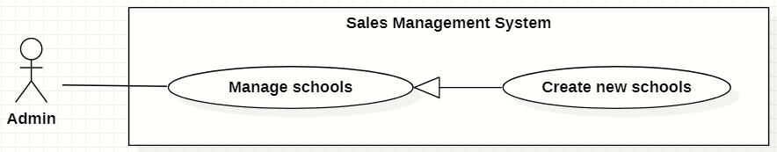

Figure 21. <<Administrator>> Create new schools

|  |  |  |  |  |  |  |  |
| --- | --- | --- | --- | --- | --- | --- | --- |
| ID and Name: | **UC-13 Create new schools** | | | | | | |
| Created By: | GiaNH | | | | Date Created: | | 15/02/2021 |
| Primary Actor: | Administrator | | | | Secondary Actors: | | N/A |
| Description: | This use case allows the user to create new school. | | | | | | |
| Trigger: | The user clicks on the “Create” button in “Schools” screen. | | | | | | |
| Preconditions: | PRE-1. The user has been logged into the system with role Admin.  PRE-2. The user is on the “Schools” screen. | | | | | | |
| Post-conditions: | POST-1. The new account is added in the system. | | | | | | |
| Normal Flow: | **Step** | | **Actor Action** | | | **System Response** | |
| 1 | | The user selects “Schools” on the navigation bar (sidebar). | | | The system redirects to the “Schools” screen. | |
| 2 | | The user hovers on “Create” button in screen. | | | The systems shows a menu list which contains two options (“Import”, “Create a school”). | |
| 3 | | The user clicks on “Create a school” option in the menu list.  [Alternative 1] | | | The system displays the “Create new schools” form with the following required information:  *School’s information:*   * “School name”: input text filed, required. * “School phone”: input text field. * “District”: selections, required. * “Address”: input text field. * “isActive”: boolean, default value is true. * “Description”: input text field. * “School type”: selections (Công lập, Ngoài công lập, Bán công), required. * “Educational level”: selections (Tiểu học, THCS, THPT), required. * “School scale”: selections (Lớn, Vừa, Nhỏ).   “School status”: selections (Leads, Customer, Ngưng hợp tác).  *Representative’s information:*   * “Full name”: input text field. * “Email”: input text field. * “Phone”: input text field. * “IsMale”: radio buttons. * “Cancel”: button. * “Save”: button. | |
| 4 | | The user inputs into information fields. | | | [Exception 1] | |
| 5 | | The user selects on the “Save” button.  [Exception 3] | | | The system shows the successful message: “Create Successfully”.  [Exception 2] | |
| 6 | |  | | | The system updates the table of list of schools in the “Schools” screen.  [Exception 2] | |
| Alternative Flows: | **No** | **Step** | | **Actor Action** | | **System Response** | |
| 1 | 1 | | The user clicks on “Import” option in the menu list. | | The system displays the “Import” dialog which contains:   * “You can download the sample template *here*”: text, link. * “Browse”: button. * “Cancel”: button. * “Save”: button. | |
| 2 | | The user clicks on “Browse” button to upload a file from the device.  [Alternative 1.1]  [Exception 4]  [Exception 5]  [Exception 6] | | The system displays the Windows Explorer dialog for user to retrieve file in user’s device. | |
| 3 | | The user selects the file to import and chooses confirm command.  [Exception 2] | | The system shows the selected file’s name on the “Import” dialog. | |
| 4 | | The users clicks on “Save” button.  [Alternative 1.2]  [Exception 3] | | The system shows the successful message: “Create Successfully”.  *Continue to the step 6 in Normal Flow.* | |
| 1.1 | 1 | | The user clicks on “You can download the sample template *here*” link. | | The systems downloads a sample Excel file to the user’s device. | |
| 2 | | The users add data in that Excel file and upload it. | | *Continue to the step 2 in the Alternative Flow 1.* | |
| 1.2 | 1 | | The user clicks on “Browse” button again and chooses another file to upload. | | *Continue to the step 3 in the Alternative Flow 1.* | |
| Exceptions: | **No** | | **Cause** | | | **System Response** | |
| 1 | | The user leaves the blank fields or inputs the invalid format content. | | | The system shows the error message: “Please input the valid format content”. | |
| 2 | | The user’s device does not connect to the Internet or the server has internal error. | | | The system shows the error message: “Connection Failed or Internal Error”. | |
| 3 | | The user selects “Cancel” button. | | | The system closes the “Create School” view and returns the “Schools” screen. | |
| 4 | | The user chooses invalid image format. | | | The system shows the error message: “Please choose the right file format”. | |
| 5 | | The size of file is larger than 5MB. | | | The system shows the error message: “This file is too large. Please choose file with size within 5MB”. | |
| 6 | | The user closes the Windows Explorer (by clicking on “x” button or “Cancel” button). | | | The system closes the Windows Explorer and does not shows anything errors or messages. | |
| Priority: | High | | | | | | |
| Frequency of Use: | Usually | | | | | | |
| Business Rules: | * BR-09, BR-10 * Phone must be in format “/(84|0[3|5|7|8|9])+([0-9]{8})\b/g” and have max length is 10 (when starts with 0) or 11 (when starts with 84).   *(Resources:* [*https://www.regextester.com/106725*](https://www.regextester.com/106725)*)*   * The system only accepts Excel files in type “.xlsx”, “.xls”, “.csv”, “.xslx” or “.xml”. * The size of file is no larger than 5MB. * In the Windows Explorer dialog, the user can only choose one file at a time. | | | | | | |
| Other Information: | N/A | | | | | | |
| Assumptions: | N/A | | | | | | |

Table 29. <<Administrator>> Create new schools

#### Search schools

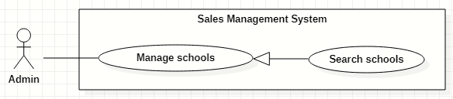

Figure 22. <<Administrator>> Search schools

|  |  |  |  |  |  |  |  |
| --- | --- | --- | --- | --- | --- | --- | --- |
| ID and Name: | **UC-14 Search schools** | | | | | | |
| Created By: | GiaNH | | | Date Created: | | | 16/02/2021 |
| Primary Actor: | Administrator | | | Secondary Actors: | | | N/A |
| Description: | This use case allows the users to find the schools based on school’s name, district, school status, school educational level, school type, address,… | | | | | | |
| Trigger: | The user selects filters or inputs in search field on the “Schools” screen. | | | | | | |
| Preconditions: | PRE-1. The user has been logged into the system with role Admin.  PRE-2. The user is on “Schools” screen. | | | | | | |
| Post-conditions: | POST-1. The list of schools is shown. | | | | | | |
| Normal Flow: | **Step** | | **Actor Action** | | **System Response** | | |
| 1 | | The user inputs in the search field or selects filters to looking for schools. | | The system displays the list of accounts as the table.  Available filters on this screen:   * “Districts”: selections (24 districts in Ho Chi Minh City) * “School Statuses”: selections (Leads, Customer, Ngưng hợp tác). * “School Types”: selections (Công lập, Ngoài công lập, Bán công). * “School Levels”: selections (Tiểu học, THCS, THPT). * “School Scales”: selections (Lớn, Vừa, Nhỏ). * Search field: text field. | | |
| 2 | |  | | The list of Schools is shown as a table on the “Schools” screen.  Table will includes these fields:   * “School Name”: text. * “Address”: text. * “Principal”: text. * “Status”: Label. | | |
| Alternative Flows: | N/A | | | | | | |
| Exceptions: | **No** | **Cause** | | | | **System Response** | |
| 1 | The content of search field or selecting filter that the user inputted is not matched any data in database. | | | | The system displays “No records found” line. | |
| Priority: | Normal | | | | | | |
| Frequency of Use: | Usually | | | | | | |
| Business Rules: | The default values of all filters are “All”. | | | | | | |
| Other Information: | N/A | | | | | | |
| Assumptions: | N/A | | | | | | |

Table 30. <<Administrator>> Search schools

#### View list of schools

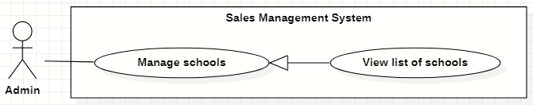

Figure 23. <<Administrator>> View list of schools

|  |  |  |  |  |  |
| --- | --- | --- | --- | --- | --- |
| ID and Name: | **UC-15 View list of schools** | | | | |
| Created By: | GiaNH | | Date Created: | | 15/02/2021 |
| Primary Actor: | Administrator | | Secondary Actors: | | N/A |
| Description: | This use case allows the user to view list of schools. | | | | |
| Trigger: | The user selects “Schools” on the navigation bar (sidebar). | | | | |
| Preconditions: | PRE-1. The user has been logged into the system with role Admin. | | | | |
| Post-conditions: | POST-1. The list of Schools is shown as a table on the “Schools” screen. | | | | |
| Normal Flow: | **Step** | **Actor Action** | | **System Response** | |
| 1 | The user selects “Schools” on the navigation bar (sidebar). | | The system redirects the “Schools” screen. | |
| 2 |  | | The list of Schools is shown as a table on the “Schools” screen.  Table will includes these fields:   * “School Name”: text. * “Address”: text. * “Principal”: text. * “Status”: Label. | |
| Alternative Flows: | N/A | | | | |
| Exceptions: | **No** | **Cause** | | **System Response** | |
| 1 | The data is null or empty in database. | | The system shows “No records found” line on the table. | |
| Priority: | Medium | | | | |
| Frequency of Use: | Usually | | | | |
| Business Rules: | The default values of all filters are “All”. | | | | |
| Other Information: | N/A | | | | |
| Assumptions: | N/A | | | | |

Table 31. <<Administrator>> View list of schools

#### View school’s details

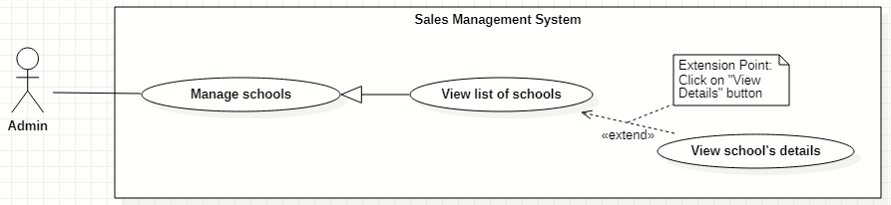

Figure 24. <<Administrator>> View school’s details

|  |  |  |  |  |  |
| --- | --- | --- | --- | --- | --- |
| ID and Name: | **UC-16 View school’s details** | | | | |
| Created By: | GiaNH | | Date Created: | | 16/02/2021 |
| Primary Actor: | Administrator | | Secondary Actors: | | N/A |
| Description: | This use case allows the user to view the detail information of a school. | | | | |
| Trigger: | The user clicks on the “View details” command on the menu options at the end of row in table list of schools. | | | | |
| Preconditions: | PRE-1. The user has been logged into the system with role Admin.  PRE-2. The user is on the “Schools” screen. | | | | |
| Post-conditions: | POST-1. The detail information of school is shown as a form. | | | | |
| Normal Flow: | **Step** | **Actor Action** | | **System Response** | |
| 1 | On the “Schools” screen, at the end of each row in the table, the user clicks on action icon button, then selects “View detail” command on the menu options. | | The system displays “School’s details” view, the school’s information is displayed as a form.  *School’s information:*   * “School name”: input text filed, required. * “School phone”: input text field. * “District”: selections (24 districts in Ho Chi Minh City). * “Address”: input text field. * “isActive”: boolean, default value is true. * “Description”: input text field. * “School type”: selections (Công lập, Ngoài công lập, Bán công), required. * “Educational level”: selections (Tiểu học, THCS, THPT), required. * “School scale”: selections (Lớn, Vừa, Nhỏ). * “School status”: selections (Leads, Customer, Ngưng hợp tác).   *Representative’s information:*   * “Full name”: input text field. * “Email”: input text field. * “Phone”: input text field. * “IsMale”: radio buttons (Male, Female). | |
| Alternative Flows: | N/A | | | | |
| Exceptions: | N/A | | | | |
| Priority: | Medium | | | | |
| Frequency of Use: | Usually | | | | |
| Business Rules: | N/A | | | | |
| Other Information: | N/A | | | | |
| Assumptions: | N/A | | | | |

Table 32. <<Administrator>> View school’s details

#### Edit school’s information

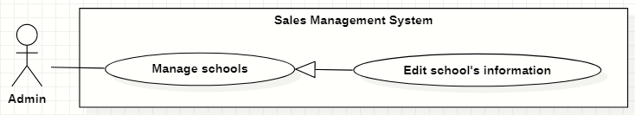

Figure 25. <<Administrator>> Edit school’s information

|  |  |  |  |  |  |  |  |
| --- | --- | --- | --- | --- | --- | --- | --- |
| ID and Name: | **UC-17 Edit school’s information** | | | | | | |
| Created By: | GiaNH | | | Date Created: | | | 16/02/2021 |
| Primary Actor: | Administrator | | | Secondary Actors: | | | N/A |
| Description: | This use case allows the users to edit the school’s information. | | | | | | |
| Trigger: | The user edits on fields in “School’s details” screen then clicks “Save” button. | | | | | | |
| Preconditions: | PRE-1. The user has been logged into the system with role Admin.  PRE-2. The user is on the “School’s details” screen. | | | | | | |
| Post-conditions: | POST-1. The School information is edited in database. | | | | | | |
| Normal Flow: | **Step** | | **Actor Action** | | | **System Response** | |
| 1 | |  | | | The system displays the “School’s detail” screen as a form with the following required information:  *School’s information:*   * “School name”: input text filed, required. * “School phone”: input text field. * “District”: selections (24 districts in Ho Chi Minh City). * “Address”: input text field. * “isActive”: boolean, default value is true. * “Description”: input text field. * “School type”: selections (Công lập, Ngoài công lập, Bán công), required. * “Educational level”: selections (Tiểu học, THCS, THPT), required. * “School scale”: selections (Lớn, Vừa, Nhỏ). * “School status”: selections (Leads, Customer, Ngưng hợp tác). * “Save”: button, only active when the form is dirty.   *Representative’s information:*   * “Full name”: input text field. * “Email”: input text field. * “Phone”: input text field. * “IsMale”: radio buttons (Male, Female). * “Save”: button, only active when the form is dirty. | |
| 2 | | The user edits on fields in this form.  [Exception 1] | | |  | |
| 3 | | The user clicks “Save” button when finish. | | | The system has successful edit and displays the successful message: “Updated Successfully”.  [Exception 2] | |
| Alternative Flows: | N/A | | | | | | |
| Exceptions: | **No** | **Cause** | | | **System Response** | | |
| 1 | The user inputs invalid format content into fields. | | | The system informs the users that the content of fields is invalid format. | | |
| 2 | The user’s device does not connect to the Internet or the server has internal error. | | | The system shows the error message: “Connection Failed or Internal Error”. | | |
| Priority: | Medium | | | | | | |
| Frequency of Use: | Usually | | | | | | |
| Business Rules: | * BR-09 * Phone must be in format “/(84|0[3|5|7|8|9])+([0-9]{8})\b/g” and have max length is 10 (when starts with 0) or 11 (when starts with 84).   *(Resources:* [*https://www.regextester.com/106725*](https://www.regextester.com/106725)*)* | | | | | | |
| Other Information: | N/A | | | | | | |

Table 33. <<Administrator>> Edit school’s information

### 2.5 <<Salesman>> Overview Use Case

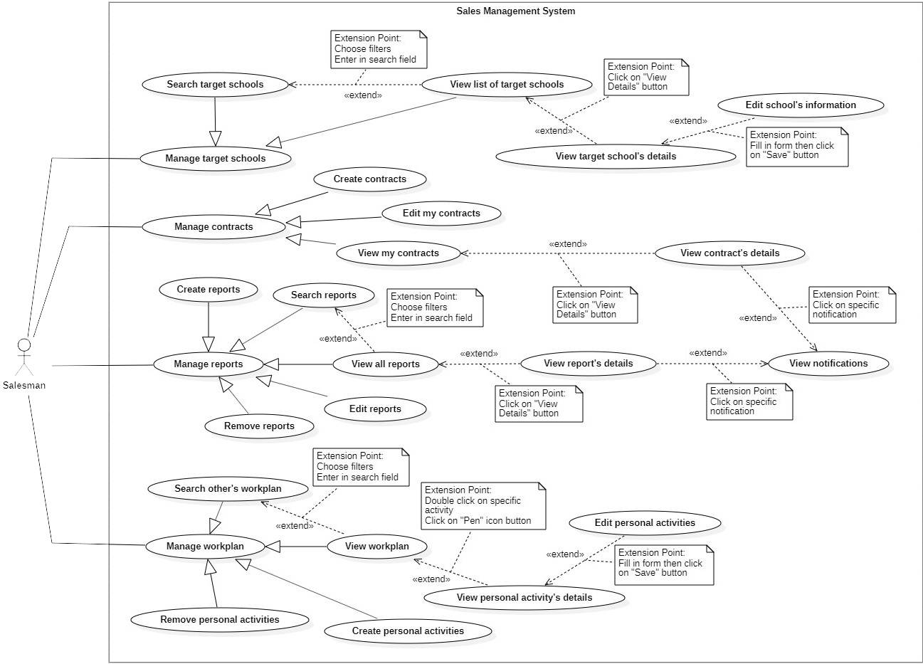

Figure 26. <<Salesman>> Overview Use Case

#### Search target schools

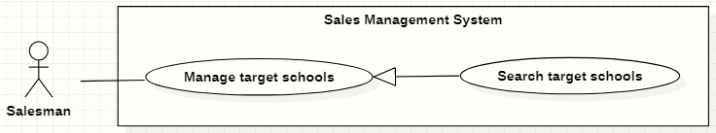

Figure 27. <<Salesman>> Search target schools

|  |  |  |  |  |  |
| --- | --- | --- | --- | --- | --- |
| ID and Name: | **UC-18 Search target schools** | | | | |
| Created By: | GiaNH | | Date Created: | | 07/02/2021 |
| Primary Actor: | Salesman, Sales Supervisor, Sales Manager | | Secondary Actors: | | N/A |
| Description: | This use case allows the users to find the target schools based on school’s name, district, school status, school educational level, school type, address,… | | | | |
| Trigger: | The user selects filters or inputs in search field on the “Target Schools” screen. | | | | |
| Preconditions: | PRE-1. The user has been logged into the system with role Salesman, Sales Supervisor or Sales Manager.  PRE-2. The user is on the “Target Schools” screen. | | | | |
| Post-conditions: | POST-1. The list of target schools is shown as a table. | | | | |
| Normal Flow: | **Step** | **Actor Action** | | **System Response** | |
| 1 | The user inputs in the search field or selects filters to looking for schools. | | The system displays the list of accounts as the table.  Available filters on this screen:   * “Purposes”: selections (   - Leads: Sales mới, Theo dõi;  - Customer: Chăm sóc, Tái ký hợp đồng, Ký mới hợp đồng;  - Ngưng hợp tác  )   * “Districts”: selections (24 districts in Ho Chi Minh City) * “School Years”: selections (2020-2021, 2019-2020, 2018-2019,…). * “School Types”: selections (Công lập, Ngoài công lập, Bán công). * “School Levels”: selections (Tiểu học, THCS, THPT). * “School Scales”: selections (Lớn, Vừa, Nhỏ). * Search field: text field. | |
| 2 |  | | The system displays the list of target schools as a table.   * “School Name”: text. * “Principal”: text. * “School Year”: text. * “Purpose”: Label.   [Exception 1]  [Exception 2] | |
| Alternative Flows: | N/A | | | | |
| Exceptions: | **No** | **Cause** | | **System Response** | |
| 1 | The content of search field or selecting filter that The user inputted do not match any stored data in the system. | | The system displays “No records found” line on the table. | |
| 2 | The user’s device does not connect to the Internet or the server has internal error. | | The system shows the error message: “Connection Failed or Internal Error”. | |
| Priority: | Normal | | | | |
| Frequency of Use: | Usually | | | | |
| Business Rules: | * BR-19, BR-20, BR-40 * The default values of all filters are “All”. | | | | |
| Other Information: | N/A | | | | |
| Assumptions: | N/A | | | | |

Table 34. <<Salesman>> Search target schools

#### View list of target schools

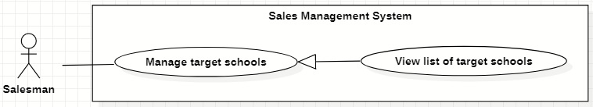

Figure 28. <<Salesman>> View list of target schools

|  |  |  |  |  |  |
| --- | --- | --- | --- | --- | --- |
| ID and Name: | **UC-19 View list of target schools** | | | | |
| Created By: | GiaNH | | Date Created: | | 07/02/2021 |
| Primary Actor: | Salesman, Sales Supervisor, Sales Manager | | Secondary Actors: | | N/A |
| Description: | This use case allows the user to view list of his assigned target schools. | | | | |
| Trigger: | The user selects “Target Schools” on the navigation bar (sidebar). | | | | |
| Preconditions: | PRE-1. The user has been logged into the system with role Salesman, Sales Supervisor or Sales Manager. | | | | |
| Post-conditions: | POST-1. The list of target schools is shown as a table. | | | | |
| Normal Flow: | **Step** | **Actor Action** | | **System Response** | |
| 1 | The user selects “Target Schools” on the navigation bar (sidebar). | | The system redirects to the “Target schools” screen and shows the target schools table with following columns:   * “School Name”: text. * “Principal”: text. * “School Year”: text. * “Purpose”: label.   Available filters on this screen:   * “Purposes”: selections (   - Leads: Sales mới, Theo dõi;  - Customer: Chăm sóc, Tái ký hợp đồng, Ký mới hợp đồng;  - Ngưng hợp tác  )   * “Districts”: selections (24 districts in Ho Chi Minh City) * “School Years”: selections (2020-2021, 2019-2020, 2018-2019,…). * “School Types”: selections (Công lập, Ngoài công lập, Bán công). * “School Levels”: selections (Tiểu học, THCS, THPT). * “School Scales”: selections (Lớn, Vừa, Nhỏ). * Search field: text field.   [Exception 1]  [Exception 2] | |
| Alternative Flows: | N/A | | | | |
| Exceptions: | **No** | **Cause** | | **System Response** | |
| 1 | No stored target schools data in the system. | | The system displays “No records found” line on the table. | |
| 2 | The user’s device does not connect to the Internet or the server has internal error. | | The system shows the error message: “Connection Failed or Internal Error”. | |
| Priority: | Normal | | | | |
| Frequency of Use: | Usually | | | | |
| Business Rules: | * BR-19, BR-20, BR-40 * The default values of all filters are “All”. | | | | |
| Other Information: | N/A | | | | |
| Assumptions: | N/A | | | | |

Table 35. <<Salesman>> View list of target schools

#### View target school’s details

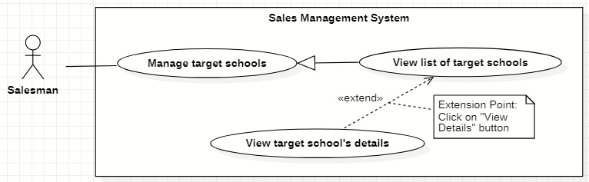

Figure 29. <<Salesman>> View target school’s details

|  |  |  |  |  |  |
| --- | --- | --- | --- | --- | --- |
| ID and Name: | **UC-20 View target school’s details** | | | | |
| Created By: | GiaNH | | Date Created: | | 07/02/2021 |
| Primary Actor: | Salesman, Sales Supervisor, Sales Manager | | Secondary Actors: | | N/A |
| Description: | This use case allows the user to view the detail information of the target school. | | | | |
| Trigger: | The user clicks on the “View details” command on the menu options at the end of row in table list of target schools. | | | | |
| Preconditions: | PRE-1. The user has been logged into the system with role Salesman, Sales Supervisor or Sales Manager.  PRE-2. The user is at the “Target Schools” screen. | | | | |
| Post-conditions: | POST-1. The detail information of target school is shown as a form. | | | | |
| Normal Flow: | **Step** | **Actor Action** | | **System Response** | |
| 1 | On the “Target Schools” screen, at the end of each row in the table, the user clicks on action icon button, then selects “View detail” command on the menu options. | | The system shows “Target School’s Details” screen, which contains 3 tabs. Each tab has a form with following information:   1. Tab “General Info”:   *School’s information:*   * “School name”: input text filed, required. * “School phone”: input text field. * “District”: selections (24 districts in Ho Chi Minh City). * “Address”: input text field. * “isActive”: boolean, default value is true. * “Description”: input text field. * “School type”: selections (Công lập, Ngoài công lập, Bán công), required. * “Educational level”: selections (Tiểu học, THCS, THPT), required. * “School scale”: selections (Lớn, Vừa, Nhỏ). * “School status”: selections (Leads, Customer, Ngưng hợp tác).   *Representative’s information:*   * “Full name”: input text field. * “Email”: input text field. * “Phone”: input text field. * “IsMale”: radio buttons (Male, Female).   2> Tab “Assign info”:  *Assign information:*   * “PIC”: text. * “PIC’s phone”: text. * “PIC’s email”: text. * “Purpose”: text. * “Note”: input text field.   3> Tab “Contract info”:  *Contracts information:*   * “ID”: text. * “Duration”: text. * “Services”: check boxes, read only. * “Revenue Criteria”: text. * “Note”: input text field.   [Exception 1] | |
| Alternative Flows: | N/A | | | | |
| Exceptions: | **No** | **Cause** | | **System Response** | |
| 1 | The user’s device does not connect to the Internet or the server has internal error. | | The system shows the error message: “Connection Failed or Internal Error”. | |
| Priority: | Medium | | | | |
| Frequency of Use: | Usually | | | | |
| Business Rules: | * BR-40 * Contracts belongs to this target school.   If that target school does not have any contracts, the system does not show this tab to the users. | | | | |
| Other Information: | N/A | | | | |
| Assumptions: | N/A | | | | |

Table 36. <<Salesman>> View target school’s details

#### Edit school’s information

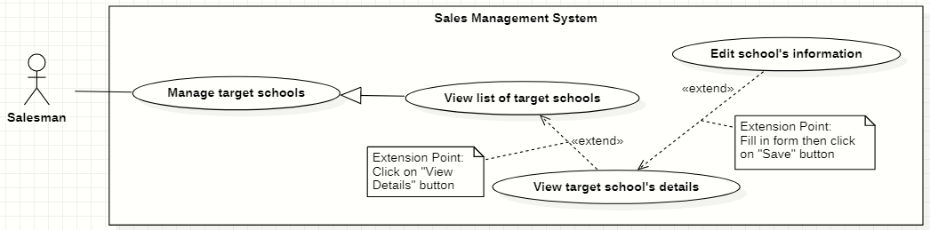

Figure 30. <<Salesman>> Edit school’s information

|  |  |  |  |  |  |
| --- | --- | --- | --- | --- | --- |
| ID and Name: | **UC-21 Edit school’s information** | | | | |
| Created By: | HaPTN | | Date Created: | | 12/04/2021 |
| Primary Actor: | Salesman, Sales Supervisor, Sales Manager | | Secondary Actors: | | N/A |
| Description: | This use case allows the user to view the detail information of the target school. | | | | |
| Trigger: | The user edits on fields in “Target School’s details” screen then clicks “Save” button. | | | | |
| Preconditions: | PRE-1. The user has been logged into the system with role Salesman, Sales Supervisor or Sales Manager.  PRE-2. The user is on the tab “General Info” in “Target School’s details” screen. | | | | |
| Post-conditions: | POST-1. The detail information of target school is edited in database. | | | | |
| Normal Flow: | **Step** | **Actor Action** | | **System Response** | |
|  | 1 | The user edits on fields in “Target School’s details” screen then clicks “Save” button. | | The system displays the “Target School’s detail” screen, on the tab “General Info”, there is a form with the following information:  *School’s information:*   * “School name”: input text filed, read only. * “School phone”: input text field, read only. * “District”: selections (24 districts in Ho Chi Minh City), read only. * “Address”: input text field, read only. * “isActive”: boolean, read only. * “Description”: input text field, read only. * “School type”: selections (Công lập, Ngoài công lập, Bán công), read only. * “Educational level”: selections (Tiểu học, THCS, THPT), read only. * “School scale”: selections (Lớn, Vừa, Nhỏ), read only. * “School status”: selections (Leads, Customer, Ngưng hợp tác), read only.   *Representative’s information:*   * “Full name”: input text field. * “Email”: input text field. * “Phone”: input text field. * “IsMale”: radio buttons (Male, Female). * “Save”: button, only active when the form is dirty. | |
|  | 2 | The user edits on fields in this form.  [Exception 1] | |  | |
|  | 3 | The user clicks “Save” button when finish. | | The system edits new data in the database and displays the successful message: “Updated Successfully”.  [Exception 2] | |
| Alternative Flows: | N/A | | | | |
| Exceptions: | **No** | **Cause** | | **System Response** | |
| 1 | The user inputs invalid format content into fields. | | The system informs the users that the content of fields is invalid format. | |
| 2 | The user’s device does not connect to the Internet or the server has internal error. | | The system shows the error message: “Connection Failed or Internal Error”. | |
| Priority: | Medium | | | | |
| Frequency of Use: | Usually | | | | |
| Business Rules: | * BR-30, BR-09, BR-40 * The user can only edit fields related to the school’s representative: full name, isMale, email, phone. * Phone must be in format “/(84|0[3|5|7|8|9])+([0-9]{8})\b/g” and have max length is 10 (when starts with 0) or 11 (when starts with 84).   *(Resources:* [*https://www.regextester.com/106725*](https://www.regextester.com/106725)*)*   * Any school’s data, the user needs to inform to the Admin and only Admin have right to edit school’s information. | | | | |
| Other Information: | N/A | | | | |
| Assumptions: | N/A | | | | |

Table 37. <<Salesman>> Edit school’s information

#### Create contracts

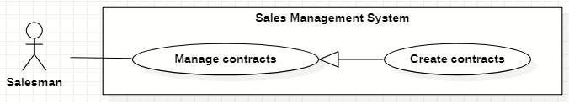

Figure 31 <<Salesman>> Create contracts

|  |  |  |  |  |  |
| --- | --- | --- | --- | --- | --- |
| ID and Name: | **UC-22 Create contracts** | | | | |
| Created By: | HaPTN | | Date Created: | | 12/04/2021 |
| Primary Actor: | Salesman, Sales Supervisor, Sales Manager | | Secondary Actors: | | N/A |
| Description: | This use case allows the user to create contracts of his/her assigned target schools. | | | | |
| Trigger: | The user selects the “Create” button on “Contracts” screen. | | | | |
| Preconditions: | PRE-1. The user has been logged into the system with role Salesman, Sales Supervisor or Sales Manager.  PRE-2. The user is on the tab “Contracts” in “Target School’s details” screen. | | | | |
| Post-conditions: | POST-1. A new contract is created in the system. | | | | |
| Normal Flow: | **Step** | **Actor Action** | | **System Response** | |
| 1 | The user selects the “Create” button on “Contracts” screen. | | The system shows “Create Contract” view that contains following information fields:   * “ID”: text. * “Target Schools”: text. * “Duration”: input text field, required. * “Service”: checkbox, required. * “Revenue Criteria”: checkbox, required. * “Note”: input text field, required. | |
| 2 | The user inputs the information into the required fields.  [ | |  | |
| 3 | The user selects “Save” button to create a new contract.  [Exception 3] | | The system shown the successful message: “Create Successfully”.  [Exception 1]  [Exception 2] | |
| 4 |  | | The system updates the table of list of contracts in the “Contracts” screen.  [Exception 2] | |
| Alternative Flows: | N/A | | | | |
| Exceptions: | **No** | **Cause** | | **System Response** | |
| 1 | The user leaves the blank fields or inputs invalid format content. | | The system shows the error message: “Please input the valid format content”. | |
| 2 | The user’s device does not connect to the Internet or the server has internal error. | | The system shows the error message: “Connection Failed or Internal Error”. | |
| 3 | The user selects “Cancel” button. | | The system closes the “Create Contract” view and returns the Contracts screen. | |
|  | 4 | The “ID” that the user inputed is duplicate in the system. | | The system shows the error message: “The contract ID has already existed”. | |
| Priority: | High | | | | |
| Frequency of Use: | Usually | | | | |
| Business Rules: | BR-31, BR-32, BR-33, BR-40 | | | | |
| Other Information: | N/A | | | | |
| Assumptions: | N/A | | | | |

Table 38. <<Salesman>> Create contracts

#### View my contracts

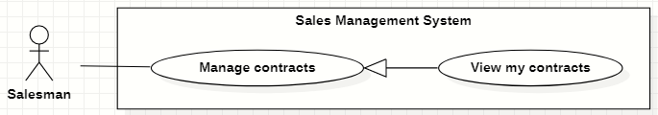

Figure 32. <<Salesman>> View my contracts

|  |  |  |  |  |  |
| --- | --- | --- | --- | --- | --- |
| ID and Name: | **UC-23 View my contracts** | | | | |
| Created By: | HaPTN | | Date Created: | | 12/04/2021 |
| Primary Actor: | Salesman, Sales Supervisor, Sales Manager | | Secondary Actors: | | N/A |
| Description: | This use case allows the user to view the list of contract’s of his/her assigned target schools. | | | | |
| Trigger: | The user selects tab “Contracts” in “Target School’s details” screen. | | | | |
| Preconditions: | PRE-1. The user has been logged into the system with role Salesman, Sales Supervisor or Sales Manager.  PRE-2. The user is on the tab “Contracts” in “Target School’s details” screen. | | | | |
| Post-conditions: | POST-1. Contract’s list is displayed as the table in “Contracts” screen. | | | | |
| Normal Flow: | **Step** | **Actor Action** | | **System Response** | |
| 1 | The user selects tab “Contracts” in “Target School’s details” screen. | | The system displays “Contracts” screen, contract’s list is displayed as the table.   * “Target Schools”: text. * “Duration”: text. * “Service”: text. * “Revenue Criteria”: text. * “Note”: text. | |
| Alternative Flows: | N/A | | | | |
| Exceptions: | **No** | **Cause** | | **System Response** | |
| 1 | No stored contracts data in the system. | | The system displays “No records found” line on the table. | |
|  | 2 | The user’s device does not connect to the Internet or the server has internal error. | | The system shows the error message: “Connection Failed or Internal Error”. | |
| Priority: | High | | | | |
| Frequency of Use: | Usually | | | | |
| Business Rules: | BR-31, BR-32, BR-34, BR-40 | | | | |
| Other Information: | N/A | | | | |
| Assumptions: | N/A | | | | |

Table 39. <<Salesman>> View my contracts

#### View contract’s details

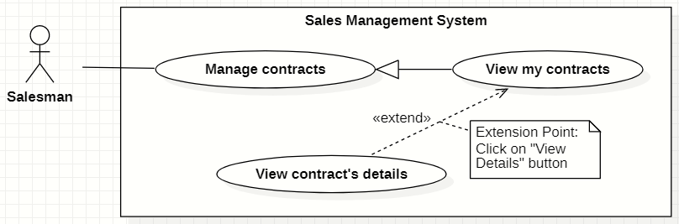

Figure 33. <<Salesman>> View contract’s details

|  |  |  |  |  |  |
| --- | --- | --- | --- | --- | --- |
| ID and Name: | **UC-24 View contract’s details** | | | | |
| Created By: | HaPTN | | Date Created: | | 12/04/2021 |
| Primary Actor: | Sales Manager | | Secondary Actors: | | N/A |
| Description: | This use case allows the user to view a contract’s details. | | | | |
| Trigger: | The user selects a specific contract in the list of contracts in tab “Contracts” on “Target School’s details” screen. | | | | |
| Preconditions: | PRE-1. The user has been logged into the system with role Sales Manager.  PRE-2. The user is on the tab “Contracts” in “Target School’s details” screen. | | | | |
| Post-conditions: | POST-1. Contract’s details is displayed as the dialog in “Contracts” screen. | | | | |
| Normal Flow: | **Step** | **Actor Action** | | **System Response** | |
|  | 1 | The user clicks on a specific contract in the list of contracts in tab “Contracts” on “Target School’s details” screen. | | The system displays the “Contract’s details” dialog with the following information:   * “ID”: text. * “Target Schools”: text. * “Duration”: text. * “Service”: text. * “Revenue Criteria”: text. * “Note”: text.   [Exception 1] | |
| Alternative Flows: | N/A | | | | |
| Exceptions: | **No** | **Cause** | | **System Response** | |
|  | 1 | The user’s device does not connect to the Internet or the server has internal error. | | The system shows the error message: “Connection Failed or Internal Error”. | |
| Priority: | Medium | | | | |
| Frequency of Use: | Usually | | | | |
| Business Rules: | BR-31, BR-32, BR-34, BR-40 | | | | |
| Other Information: | N/A | | | | |
| Assumptions: | N/A | | | | |

Table 40. <<Salesman>> View contract’s details

#### Edit my contracts

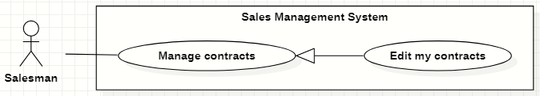

Figure 34. <<Salesman>> Edit my contracts

|  |  |  |  |  |  |
| --- | --- | --- | --- | --- | --- |
| ID and Name: | **UC-25 Edit my contracts** | | | | |
| Created By: | HaPTN | | Date Created: | | 12/04/2021 |
| Primary Actor: | Salesman, Sales Supervisor, Sales Manager | | Secondary Actors: | | N/A |
| Description: | This use case allows the user to edit the information of contract’s of his/her assigned target schools. | | | | |
| Trigger: | The user selects tab “Contracts” in “Target School’s details” screen. | | | | |
| Preconditions: | PRE-1. The user has been logged into the system with role Salesman, Sales Supervisor or Sales Manager.  PRE-2. The user is on the tab “Contracts” in “Target School’s details” screen. | | | | |
| Post-conditions: | POST-1. The detail information of this contract is edited in database. | | | | |
| Normal Flow: | **Step** | **Actor Action** | | **System Response** | |
| 1 | The user selects a specific row of contracts in “Target School’s details” screen. | | The system displays “Contract’s detail” dialog which contains:   * “Target Schools”: text, read only. * “Duration”: input text field. * “Service”: check boxes. * “Revenue Criteria”: check boxes. * “Note”: text area. * “Cancel”: button. * “Save”: button. | |
|  | 2 | The user edits on fields in this form.  [Exception 1] | |  | |
|  | 3 | The user clicks “Save” button when finish. | | The system update new information in the database, then displays the successful message: “Updated Successfully”.  [Exception 2] | |
| Alternative Flows: | N/A | | | | |
| Exceptions: | **No** | **Cause** | | **System Response** | |
| 1 | The user inputs invalid format content into fields. | | The system informs the users that the content of fields is invalid format. | |
|  | 2 | The user’s device does not connect to the Internet or the server has internal error. | | The system shows the error message: “Connection Failed or Internal Error”. | |
| Priority: | High | | | | |
| Frequency of Use: | Usually | | | | |
| Business Rules: | BR-31, BR-32, BR-34, BR-40 | | | | |
| Other Information: | N/A | | | | |
| Assumptions: | N/A | | | | |

Table 41. <<Salesman>> Edit my contracts

#### Create reports

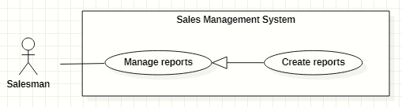

Figure 35. <<Salesman>> Create reports

|  |  |  |  |  |  |
| --- | --- | --- | --- | --- | --- |
| ID and Name: | **UC-26 Create reports** | | | | |
| Created By: | GiaNH | | Date Created: | | 08/02/2021 |
| Primary Actor: | Salesman, Sales Supervisor, Sales Manager | | Secondary Actors: | | N/A |
| Description: | This use case allows the user to create daily reports. | | | | |
| Trigger: | The user selects the “Create” command on “Reports” screen. | | | | |
| Preconditions: | PRE-1. The user has been logged into the system with role Salesman, Sales Supervisor or Sales Manager.  PRE-2. The user is on the “Reports” screen. | | | | |
| Post-conditions: | POST-1. A new report is created in the system. | | | | |
| Normal Flow: | **Step** | **Actor Action** | | **System Response** | |
| 1 | The user selects the “Create” button on “Reports” screen.  [Alternative] | | The system shows “Create Report” view that contains following information fields:   * “Target Schools”: input text field, required. * “Date”: date, read only, default is current date. * “Result”: input text field, required. * “Description”: input text field, required. * “Positivity”: input text field. * “Difficulty”: input text field. * “Future plan”: input text field. | |
| 2 | The user inputs the information into the required fields.  [Exception 1] | |  | |
| 3 | The user clicks on “Save” button to create a new daily report.  [Alternative 1] | | The system shows the successful message: “Created successfully”.  [Exception 2]  [Exception 3] | |
| 4 |  | | The system updates the table of list of reports in the “Reports” screen.  [Exception 2] | |
| Alternative Flows: | **Step** | **Actor Action** | | **System Response** | |
| 1 | The user clicks on “+” button to continue create daily report for another school. | | The system resets the “Create Report” form and shows the previous inputted reports in “Preview” table.  Table contains these columns:   * “School Name”: text. * “Result”: text. * “Description”: text.   *Continue to step 2 of Normal Flow*. | |
| Exceptions: | **No** | **Cause** | | **System Response** | |
| 1 | The user leaves the blank fields or inputs invalid format content. | | The system shows the error message: “Please input the valid format content”. | |
| 2 | The user’s device does not connect to the Internet or the server has internal error. | | The system shows the error message: “Connection Failed or Internal Error”. | |
| 3 | The user selects “Cancel” button. | | The system closes the “Create Report” view and returns the Reports screen. | |
| Priority: | High | | | | |
| Frequency of Use: | Usually | | | | |
| Business Rules: | BR-21, BR-22, BR-23, BR-24, BR-40 | | | | |
| Other Information: | N/A | | | | |
| Assumptions: | N/A | | | | |

Table 42. <<Salesman>> Create reports

#### Search reports

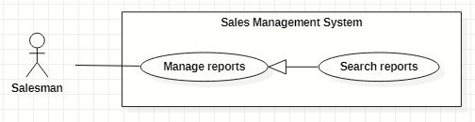

Figure 36. <<Salesman>> Search reports

|  |  |  |  |  |  |
| --- | --- | --- | --- | --- | --- |
| ID and Name: | **UC-27 Search reports** | | | | |
| Created By: | HaPTN | | Date Created: | | 09/02/2021 |
| Primary Actor: | Salesman, Sales Supervisor, Sales Manager | | Secondary Actors: | | N/A |
| Description: | This use case allows the user to find the reports based on target school’s name, district, PIC’s name, from date to date,…. | | | | |
| Trigger: | The user selects on the searching command on “Reports” screen. | | | | |
| Preconditions: | PRE-1. The user has been logged into the system with role Salesman, Sales Supervisor or Sales Manager.  PRE-2. The user is on the “Reports” screen. | | | | |
| Post-conditions: | POST-1. The list of reports is displayed as the table. | | | | |
| Normal Flow: | **Step** | **Actor Action** | | **System Response** | |
| 1 | The user inputs the search field or select searching filters on toolbar to find reports. | | The system displays the list of reports as the table.  Available filters on this screen:  “PICs”: selections (all salesmen in the Sales Department)   * “Districts”: selections (24 districts in Ho Chi Minh City) * “School Years”: selections (2020-2021, 2019-2020, 2018-2019,…). * “From date” – “To date”: date range picker, disable future days. * “School Statuses”: selections (Leads, Customer, Ngưng hợp tác). * “Purposes”: selections (   - Leads: Sales mới, Theo dõi;  - Customer: Chăm sóc, Tái ký hợp đồng, Ký mới hợp đồng;  - Ngưng hợp tác  )   * Search field: text field. | |
|  | 2 |  | | The system displays the list of target schools as a table.   * “Date”: date. * “School Name”: text. * “PIC”: image (avatar) and text. * “Purpose”: Label. * “Result”: text. * “Description”: text.   [Exception 1]  [Exception 2] | |
| Alternative Flows: | N/A | | | | |
| Exceptions: | **No** | **Cause** | | **System Response** | |
| 1 | The content of search field or selecting filter that The user inputted is not matched any stored data in the system. | | The system displays “No records found” line on the table. | |
| 2 | The user’s device does not connect to the Internet or the server has internal error. | | The system shows the error message: “Connection Failed or Internal Error”. | |
| Priority: | Medium | | | | |
| Frequency of Use: | Usually | | | | |
| Business Rules: | * BR-20, BR-24, BR-39, BR-40 * The default values of all filters are “All”. | | | | |
| Other Information: | N/A | | | | |
| Assumptions: | N/A | | | | |

Table 43. <<Salesman>> Search reports

#### View all reports

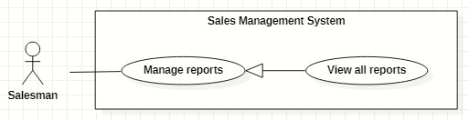

Figure 37. <<Salesman>> View all reports

|  |  |  |  |  |  |
| --- | --- | --- | --- | --- | --- |
| ID and Name: | **UC-28 View all reports** | | | | |
| Created By: | GiaNH | | Date Created: | | 08/02/2021 |
| Primary Actor: | Salesman, Sales Supervisor, Sales Manager | | Secondary Actors: | | N/A |
| Description: | This use case allows the user to view list of all daily report’s of all members in Major Sales Department. | | | | |
| Trigger: | The user selects “Reports” on the navigation bar (sidebar). | | | | |
| Preconditions: | PRE-1. The user has been logged into the system with role Salesman, Sales Supervisor or Sales Manager. | | | | |
| Post-conditions: | POST-1. Report’s list is displayed as the table in “Reports” screen. | | | | |
| Normal Flow: | **Step** | **Actor Action** | | **System Response** | |
| 1 | The user selects “Reports” on the navigation bar (sidebar). | | The system displays “Reports” screen, report’s list is displayed as the table.   * “Date”: date. * “School Name”: text. * “PIC”: image (avatar) and text. * “Purpose”: label. * “Result”: text. * “Description”: text.   Available filters on this screen:  “PICs”: selections (all salesmen in the Sales Department)   * “Districts”: selections (24 districts in Ho Chi Minh City) * “School Years”: selections (2020-2021, 2019-2020, 2018-2019,…). * “From date” – “To date”: date range picker, disable future days. * “School Statuses”: selections (Leads, Customer, Ngưng hợp tác). * “Purposes”: selections (   - Leads: Sales mới, Theo dõi;  - Customer: Chăm sóc, Tái ký hợp đồng, Ký mới hợp đồng;  - Ngưng hợp tác  )   * Search field: text field.   [Exception 1]  [Exception 2] | |
| Alternative Flows: | N/A | | | | |
| Exceptions: | **No** | **Cause** | | **System Response** | |
| 1 | No stored reports data in the system. | | The system displays “No records found” line on the table. | |
|  | 2 | The user’s device does not connect to the Internet or the server has internal error. | | The system shows the error message: “Connection Failed or Internal Error”. | |
| Priority: | High | | | | |
| Frequency of Use: | Usually | | | | |
| Business Rules: | BR-20, BR-24, BR-39, BR-40 | | | | |
| Other Information: | N/A | | | | |
| Assumptions: | N/A | | | | |

Table 44. <<Salesman>> View all reports

#### View report’s details

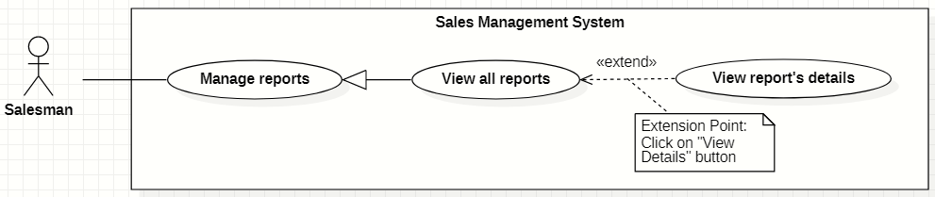

Figure 38. <<Salesman>> View report’s details

|  |  |  |  |  |  |
| --- | --- | --- | --- | --- | --- |
| ID and Name: | **UC-29 View report’s details** | | | | |
| Created By: | HaPTN | | Date Created: | | 12/04/2021 |
| Primary Actor: | Administrator | | Secondary Actors: | | N/A |
| Description: | This use case allows the user to view the detail information of a report. | | | | |
| Trigger: | The user clicks on the “View details” command on the menu options at the end of row in table list of reports. | | | | |
| Preconditions: | PRE-1. The user has been logged into the system with role Salesman, Sales Supervisor or Sales Manager.  PRE-2. The user is on the “Reports” screen. | | | | |
| Post-conditions: | POST-1. The detail information of report is shown as a form. | | | | |
| Normal Flow: | **Step** | **Actor Action** | | **System Response** | |
| 1 | On the “Reports” screen, at the end of each row in the table, the user clicks on action icon button, then selects “View detail” command on the menu options. | | The system displays “Report’s details” view, the report’s information is displayed as a form.   * “School Year”: text. * “Date”: text. * “School Name”: text. * “PIC”: image (avatar) and text. * “Purpose”: text. * “Result”: input text field, required. * “Description”: input text field, required. * “Positivity”: input text field. * “Difficulty”: input text field. * “Future plan”: input text field. * “Supervisor comment”: input text field, read only. * “Save”: button, inactive.   [Exception 1] | |
| Alternative Flows: | N/A | | | | |
| Exceptions: | **No** | **Cause** | | **System Response** | |
| 1 | The user’s device does not connect to the Internet or the server has internal error. | | The system shows the error message: “Connection Failed or Internal Error”. | |
| Priority: | Medium | | | | |
| Frequency of Use: | Usually | | | | |
| Business Rules: | BR-20, BR-24, BR-39, BR-40 | | | | |
| Other Information: | N/A | | | | |
| Assumptions: | N/A | | | | |

Table 45. <<Salesman>> View report’s details

#### Edit reports

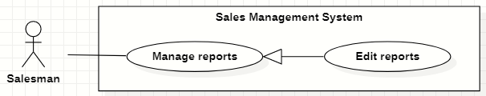

Figure 39. <<Salesman>> Edit reports

|  |  |  |  |  |  |
| --- | --- | --- | --- | --- | --- |
| ID and Name: | **UC-30 Edit reports** | | | | |
| Created By: | HaPTN | | Date Created: | | 12/04/2021 |
| Primary Actor: | Salesman, Sales Supervisor, Sales Manager | | Secondary Actors: | | N/A |
| Description: | This use case allows the user to edit a daily report. | | | | |
| Trigger: | The user edits on fields in “Report’s details” screen then clicks “Save” button. | | | | |
| Preconditions: | PRE-1. The user has been logged into the system with role Salesman, Sales Supervisor or Sales Manager.  PRE-2. The user is on the “Report’s details” screen. | | | | |
| Post-conditions: | POST-1. A new report is updated in the database. | | | | |
| Normal Flow: | **Step** | **Actor Action** | | **System Response** | |
| 1 | The user edits on fields in “Report’s details” screen then clicks “Save” button. | | The system displays “Report’s details” view, the report’s information is displayed as a form.   * “School Year”: text. * “Date”: text. * “School Name”: text. * “PIC”: image (avatar) and text. * “Purpose”: text. * “Result”: input text field, required. * “Description”: input text field, required. * “Positivity”: input text field. * “Difficulty”: input text field. * “Future plan”: input text field. * “Supervisor comment”: input text field, read only. * “Save”: button, only active when the form is dirty. | |
| 2 | The user edits on fields in this form.  [Exception 1] | |  | |
| 3 | The user clicks “Save” button when finish. | | The system has successful edit and displays the successful message: “Updated Successfully”.  [Exception 2] | |
| Alternative Flows: | N/A | | | | |
| Exceptions: | **No** | **Cause** | | **System Response** | |
| 1 | The user inputs invalid format content into fields. | | The system informs the users that the content of fields is invalid format. | |
|  | 2 | The user’s device does not connect to the Internet or the server has internal error. | | The system shows the error message: “Connection Failed or Internal Error”. | |
| Priority: | High | | | | |
| Frequency of Use: | Usually | | | | |
| Business Rules: | * BR-24, BR-28, BR-29, BR-30, BR-39, BR-40 * The user can only edit reports which have not been commented by the supervisor or the manager. | | | | |
| Other Information: | N/A | | | | |
| Assumptions: | N/A | | | | |

Table 46. <<Salesman>> Edit reports

#### Remove reports

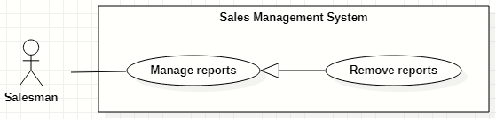

Figure 40. <<Salesman>> Remove reports

|  |  |  |  |  |  |
| --- | --- | --- | --- | --- | --- |
| ID and Name: | **UC-31 Remove reports** | | | | |
| Created By: | HaPTN | | Date Created: | | 12/04/2021 |
| Primary Actor: | Salesman, Sales Supervisor, Sales Manager | | Secondary Actors: | | N/A |
| Description: | This use case allows the user to remove a daily report. | | | | |
| Trigger: | The user clicks on the “Remove” command on the menu options at the end of row in table list of reports. | | | | |
| Preconditions: | PRE-1. The user has been logged into the system with role Salesman, Sales Supervisor or Sales Manager.  PRE-2. The user is on the “Reports” screen. | | | | |
| Post-conditions: | POST-1. A daily report is removed in the database. | | | | |
| Normal Flow: | **Step** | **Actor Action** | | **System Response** | |
|  | 1 | The user clicks on the “Remove” command on the menu options at the end of row in table list of reports. | | The system shows a “Confirm Remove” dialog to alert.   * “Cancel”: button. * “Remove”: button. | |
|  | 2 | The user clicks on “Remove” button.  [Exception 1] | | The system shows a successful message: “Removed successfully”, and closes the confirm dialog. | |
| Alternative Flows: | N/A | | | | |
| Exceptions: | **No** | **Cause** | | **System Response** | |
| 1 | The user selects “Cancel” button. | | The system closes the “Confirm Remove” dialog and returns the Reports screen. | |
| 2 | The user’s device does not connect to the Internet or the server has internal error. | | The system shows the error message: “Connection Failed or Internal Error”. | |
| Priority: | High | | | | |
| Frequency of Use: | Sometimes | | | | |
| Business Rules: | * BR-28, BR-29, BR-40 * The user can only edit reports The user can only remove reports which have not been commented by the supervisor or the manager. | | | | |
| Other Information: | N/A | | | | |
| Assumptions: | N/A | | | | |

Table 47 <<Salesman>> Remove reports

#### Create personal activities

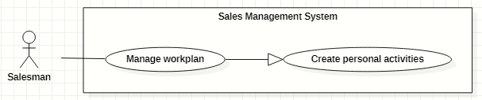

Figure 41. <<Salesman>> Create personal activities

|  |  |  |  |  |  |  |  |
| --- | --- | --- | --- | --- | --- | --- | --- |
| ID and Name: | **UC-32 Create personal activities** | | | | | | |
| Created By: | GiaNH, HaPTN | | | | Date Created: | | 12/04/2021 |
| Primary Actor: | Salesman, Sales Supervisor, Sales Manager | | | | Secondary Actors: | | N/A |
| Description: | This use case allows the user to create one or multiple personal activities in his/her workplan. | | | | | | |
| Trigger: | The user wants to create one or multiple personal activities. | | | | | | |
| Preconditions: | PRE-1. The user has been logged into the system with role Salesman, Sales Supervisor or Sales Manager.  PRE-2. The user is on the “Work-plan” screen. | | | | | | |
| Post-conditions: | POST-1. New personal activity/personal activities is/are added in work-plan schedule. | | | | | | |
| Normal Flow: | **Step** | | **Actor Action** | | | **System Response** | |
| 1 | | The user clicks on a cell and chooses “More details” button on the “Work-plan” screen.  [Alternative 1] | | | The system displays the “Add Activity” form dialog that contains the following format fields:   * “Title”: text, required. * “Location”: text. * “Description”: text. * “Remark”: text. * “Start time”: date time, required. * “End time”: date time, required. * “isAllDay”:check box [True- False] , default is “False”. * “Repeat”: selection (Never, Daily, Weekly, Monthly, Yearly), default is “Never”. * “isCompleted”: check box [True, False], defalt is False. * “Cancel”: button. * “Save”: button. | |
| 2 | | The user inputs into the information fields.  [Exception 1]  [Alternative 2] | | |  | |
| 3 | | The user selects the “Save” button. | | | The system creates new activity in the database and update the “Work-plan” screen.  [Exception 2] | |
| Alternative Flows: | No | **Step** | | **Actor Action** | | **System Response** | |
| 1 | 1 | | The user clicks on a cell and on the “Work-plan” screen. | | The system shows a quick create dialog which contains:   * “Title”: text, required. * “Time”: text, read only. * “More details”: button. * “Save”: button. | |
| 2 | | The user selects the “Save” button. | | The system creates new activity in the database and update the “Work-plan” screen.  [Exception 2] | |
| 2 | 1 | | The user selects other options (Daily, Weekly, Monthly, Yearly). | | The system shows relative option’s details for each case. | |
| 2 | | The user selects the “Save” button. | | The system creates a serie of activities in the database and update the “Work-plan” screen.  [Exception 2] | |
| Exceptions: | **No** | | **Actor Action** | | | **System Response** | |
| 1 | | The user leaves the blank fields or inputs invalid format content into fields. | | | The system shows the error message: “Please input the valid format content”. | |
| 2 | | The user’s device does not connect to the Internet or the server has internal error. | | | The system shows the error message: “Connection Failed or Internal Error”. | |
| Priority: | Normal | | | | | | |
| Frequency of Use: | Usually | | | | | | |
| Business Rules: | BR-35, BR-36, BR-37, BR-38, BR-40 | | | | | | |
| Other Information: | N/A | | | | | | |
| Assumptions: | N/A | | | | | | |

Table 48. <<Salesman>> Create personal activities

#### Search other’s workplan

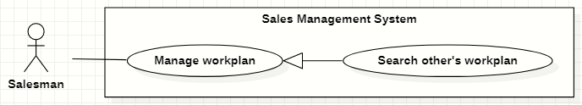

Figure 42. <<Salesman>> Search other’s workplan

|  |  |  |  |  |  |
| --- | --- | --- | --- | --- | --- |
| ID and Name: | **UC-33 Search other’s workplan** | | | | |
| Created By: | GiaNH, HaPTN | | Date Created: | | 12/04/2021 |
| Primary Actor: | Salesman, Sales Supervisor, Sales Manager | | Secondary Actors: | | N/A |
| Description: | This use case allows the user to search the work-plan of other users. | | | | |
| Trigger: | The user input in the search field on “Work-plan” screen. | | | | |
| Preconditions: | PRE-1. The user has been logged into the system with role Salesman, Sales Supervisor or Sales Manager.  PRE-2. The user is on the “Work plan” screen. | | | | |
| Post-conditions: | POST-1. The work plan schedule is displayed on the screen. | | | | |
| Normal Flow: | **Step** | **Actor Action** | | **System Response** | |
| 1 | On the “Work plan” screen, the user inputs into the search field username or full name of people he/she wants to view the work-plan. | | The system provides suggestions that presents Salesman to users as they enter their search query into the search box. | |
|  | 2 | The user selects a Salesman item in suggestions. | | The system displays “work-plan” screen. The Work-plan has the personal activity items that present as a schedule. | |
| Alternative Flows: | N/A | | | | |
| Exceptions: | **No** | **Actor Action** | | **System Response** | |
| 1 | The content of search field or selecting filter that the user inputted is not matched any stored data in the system. | | The system displays “No records found” line on the table. | |
|  | 2 | The user’s device does not connect to the Internet or the server has internal error. | | The system shows the error message: “Connection Failed or Internal Error”. | |
| Priority: | Normal | | | | |
| Frequency of Use: | Usually | | | | |
| Business Rules: | * BR-35, BR-39, BR-40 * The Sales Manager can view the Salesman’s work-plan and other Sales Manager’s work-plan. * The Salesman can only view the work-plan of other Salesman. * The user is not allowed to create/edit/remove anything in other person’s work-plan. | | | | |
| Other Information: | N/A | | | | |
| Assumptions: | N/A | | | | |

Table 49. <<Salesman>> Search other’s workplan

#### View workplan

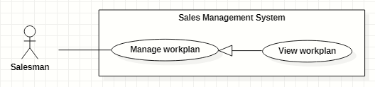

Figure 43. <<Salesman>> View workplan

|  |  |  |  |  |  |
| --- | --- | --- | --- | --- | --- |
| ID and Name: | **UC-34 View workplan** | | | | |
| Created By: | GiaNH, HaPTN | | Date Created: | | 12/04/2021 |
| Primary Actor: | Salesman, Sales Supervisor, Sales Manager | | Secondary Actors: | | N/A |
| Description: | This use case allows the user to view a whole workplan of himself/herself or other’s. | | | | |
| Trigger: | The user selects “Workplans” on the navigation bar (sidebar). | | | | |
| Preconditions: | PRE-1. The user has been logged into the system with role Salesman, Sales Supervisor or Sales Manager. | | | | |
| Post-conditions: | POST-1. The personal activities are displayed in workplan schedule. | | | | |
| Normal Flow: | **Step** | **Actor Action** | | **System Response** | |
| 1 | The user selects “Workplans” on the navigation bar (sidebar). | | The system displays “work-plan” screen. The Work-plan has the personal activity items that present as a schedule  [Exception 1] | |
| Alternative Flows: | N/A | | | | |
| Exceptions: | **No** | **Cause** | | **System Response** | |
| 1 | The user’s device does not connect to the Internet or the server has internal error. | | The system shows the error message: “Connection Failed or Internal Error”. | |
| Priority: | Normal | | | | |
| Frequency of Use: | Usually | | | | |
| Business Rules: | * BR-35, BR-39, BR-40 * The system displays the “Work-plan” as a week’s schedule with the activity item is a cell in the schedule. * The activity items have different colors to distinguish based on status. * The users can view the Work-plan by Day, Week, Month. | | | | |
| Other Information: | N/A | | | | |
| Assumptions: | N/A | | | | |

Table 50. <<Salesman>> View workplan

#### View personal activity’s details

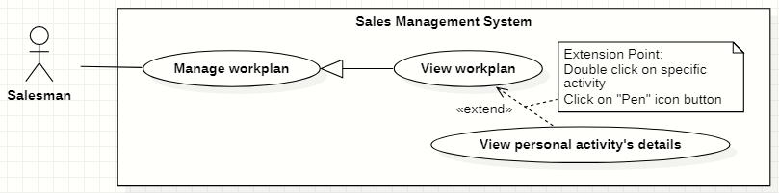

Figure 44. <<Salesman>> View personal activity’s details

|  |  |  |  |  |  |
| --- | --- | --- | --- | --- | --- |
| ID and Name: | **UC-35 View personal activity’s details** | | | | |
| Created By: | GiaNH, HaPTN | | Date Created: | | 12/04/2021 |
| Primary Actor: | Salesman, Sales Supervisor, Sales Manager | | Secondary Actors: | | N/A |
| Description: | This use case allows the user to view the detail information of personal activity. | | | | |
| Trigger: | The user clicks on the personal activity item on work-plan screen. | | | | |
| Preconditions: | PRE-1. The user has been logged into the system with role Salesman, Sales Supervisor or Sales Manager.  PRE-2. The user is on the “Work-plan” screen. | | | | |
| Post-conditions: | POST-1. The detail information of personal activity is shown as a form. | | | | |
| Normal Flow: | **Step** | **Actor Action** | | **System Response** | |
| 1 | The user clicks on an item and chooses “pen” icon button on the “Work-plan” screen.  [Alternative 1] | | *If the user is viewing his/her own work-plan*:  The system displays the “Activity’s details” form dialog that contains the following format fields:   * “Title”: text, required. * “Location”: text. * “Description”: text. * “Remark”: text. * “Start time”: date time, required. * “End time”: date time, required. * “isAllDay”:check box [True- False] , default is “False”. * “Repeat”: selection (Never, Daily, Weekly, Monthly, Yearly), default is “Never”. * “isCompleted”: check box [True, False], defalt is False.   ----------  *If the user is viewing other’s work-plan*:  The system displays the “Activity’s details” quick dialog that contains:   * “Title”: text. * “Location”: text. * “Description”: text. * “Time”: text (including start time and end time). * “isCompleted” is displayed by different colors. | |
| Alternative Flows: | **Step** | **Actor Action** | | **System Response** | |
| 1 | The user double clicks on an item on the “Work-plan” screen. | | The system displays the “Activity’s details” quick dialog that contains the following format fields:   * “Title”: text, required. * “Location”: text. * “Description”: text. * “Time”: text (including start time and end time). * “isCompleted” is displayed by different colors. | |
| Exceptions: | **No** | **Actor Action** | | **System Response** | |
| 1 | The user’s device does not connect to the Internet or the server has internal error. | | The system shows the error message: “Connection Failed or Internal Error”. | |
| Priority: | Normal | | | | |
| Frequency of Use: | Usually | | | | |
| Business Rules: | BR-35, BR-39, BR-40 | | | | |
| Other Information: | N/A | | | | |
| Assumptions: | N/A | | | | |

Table 51. <<Salesman>> View personal activity’s details

#### Edit personal activities

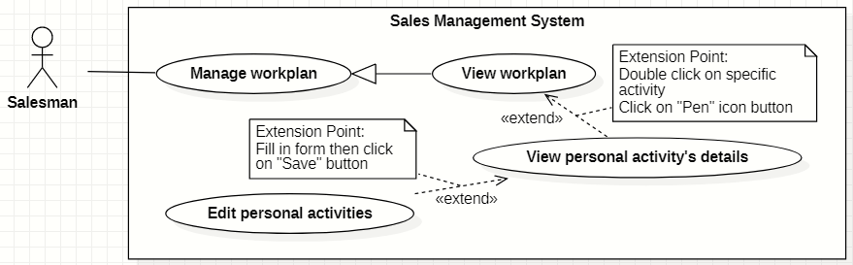

Figure 45. <<Salesman>> Edit personal activities

|  |  |  |  |  |  |
| --- | --- | --- | --- | --- | --- |
| ID and Name: | **UC-36 Edit personal activities** | | | | |
| Created By: | GiaNH, HaPTN | | Date Created: | | 12/04/2021 |
| Primary Actor: | Salesman, Sales Supervisor, Sales Manager | | Secondary Actors: | | N/A |
| Description: | This use case allows the user to edit personal activities in his/her workplan. | | | | |
| Trigger: | The user wants to edit one or multiple personal activities. | | | | |
| Preconditions: | PRE-1. The user has been logged into the system with role Salesman, Sales Supervisor or Sales Manager.  PRE-2.1. The user is on the “Workplan” screen. | | | | |
| Post-conditions: | POST-1. The personal activity/personal activities is/are updated in the database. | | | | |
| Normal Flow: | **Step** | **Actor Action** | | **System Response** | |
| 1 | The user clicks on an item and chooses “pen” icon button on the “Work-plan” screen.  [Alternative 1] | | The system displays the “Edit Activity” form dialog that contains the following format fields:   * “Title”: text, required. * “Location”: text. * “Description”: text. * “Remark”: text. * “Start time”: date time, required. * “End time”: date time, required. * “isAllDay”:check box [True- False] , default is “False”. * “Repeat”: selection (Never, Daily, Weekly, Monthly, Yearly), default is “Never”. * “isCompleted”: check box [True, False], defalt is False. * “Cancel”: button. * “Save”: button. * “Delete”: button. | |
| 2 | The user inputs the new content in the fields. | |  | |
| 3 | The user clicks “Save” button.  [Exception 1] | | The system update “Work-plan” screen with new data.  [Exception 2] | |
| Alternative Flows: | **Step** | **Actor Action** | | **System Response** | |
| 1 | The user double clicks on an item on the “Work-plan” screen. | | The system shows the dialog “Edit event” for the use to choose whether edit an activity or edit the entire series. | |
| 2 |  | | The system displays the “Edit Activity” form dialog that contains the following format fields:   * “Title”: text, required. * “Location”: text. * “Description”: text. * “Remark”: text. * “Start time”: date time, required. * “End time”: date time, required. * “isAllDay”:check box [True- False] , default is “False”. * “Repeat”: selection (Never, Daily, Weekly, Monthly, Yearly), default is “Never”. * “isCompleted”: check box [True, False], defalt is False. * “Cancel”: button. * “Save”: button. * “Delete”: button.   *Continue to step 2 in the Normal Flow.* | |
| Exceptions: | **No** | **Actor Action** | | **System Response** | |
| 1 | The user selects “Cancel” button to cancel the editing. | | The system discards all changes and close the “Edit Activity” dialog. | |
| 2 | The user’s device does not connect to the Internet or the server has internal error. | | The system shows the error message: “Connection Failed or Internal Error”. | |
| Priority: | Normal | | | | |
| Frequency of Use: | Usually | | | | |
| Business Rules: | BR-35, BR-36, BR-38, BR-39, BR-40 | | | | |
| Other Information: | N/A | | | | |
| Assumptions: | N/A | | | | |

Table 52. <<Salesman>> Edit personal activities

#### Remove personal activities

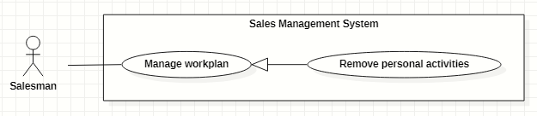

Figure 46. <<Salesman>> Remove personal activities

|  |  |  |  |  |  |
| --- | --- | --- | --- | --- | --- |
| ID and Name: | **UC-37 Remove personal activities** | | | | |
| Created By: | GiaNH, HaPTN | | Date Created: | | 12/04/2021 |
| Primary Actor: | Salesman, Sales Supervisor, Sales Manager | | Secondary Actors: | | N/A |
| Description: | This use case allows the user to remove personal activities in his/her workplan. | | | | |
| Trigger: | The user wants to remove one or multiple personal activities. | | | | |
| Preconditions: | PRE-1. The user has been logged into the system with role Salesman, Sales Supervisor or Sales Manager.  PRE-2.1. The user is on the “Workplan” screen. | | | | |
| Post-conditions: | POST-1. The personal activity/personal activities is/are removed in the database. | | | | |
| Normal Flow: | **Step** | **Actor Action** | | **System Response** | |
| 1 | On the “Work-plan” screen, the user clicks on an item and selects “Remove” icon button in the quick view pop-up.  [Alternative 1] | | The system shows the dialog “Delete Activity” for the use to choose whether remove an activity or remove the entire series. | |
| 2 | The user selects a button to confirm the removing.  [Exception 1] | | The system update “Work-plan” screen with new data.  [Exception 2] | |
| Alternative Flows: | **Step** | **Actor Action** | | **System Response** | |
| 1 | The user double clicks on an item on the “Work-plan” screen. | | The system displays the “Edit Activity” form dialog that contains the following format fields:   * “Title”: text, required. * “Location”: text. * “Description”: text. * “Remark”: text. * “Start time”: date time, required. * “End time”: date time, required. * “isAllDay”:check box [True- False] , default is “False”. * “Repeat”: selection (Never, Daily, Weekly, Monthly, Yearly), default is “Never”. * “isCompleted”: check box [True, False], defalt is False. * “Cancel”: button. * “Save”: button. * “Delete”: button. | |
|  | 2 | The user clicks on “Delete” button.  [Exception 1] | | The system shows confirmation dialog “Delete Activity” which includes:   * “Delete”: button. * “Cancel”: button. | |
|  | 3 | The user clicks on “Delete” button.  [Exception 1] | | The system update “Work-plan” screen with new data.  [Exception 2] | |
| Exceptions: | **No** | **Actor Action** | | **System Response** | |
| 1 | The user selects “Cancel” button to cancel the removing. | | The system returns the “Work-plan” screen. | |
|  | 2 | The user’s device does not connect to the Internet or the server has internal error. | | The system shows the error message: “Connection Failed or Internal Error”. | |
| Priority: | Normal. | | | | |
| Frequency of Use: | Usually | | | | |
| Business Rules: | BR-35, BR-36, BR-39, BR-40 | | | | |
| Other Information: | N/A | | | | |
| Assumptions: | N/A | | | | |

Table 53. <<Salesman>> Remove personal activities

### 2.6 <<Sales Supervisor>> Overview Use Case

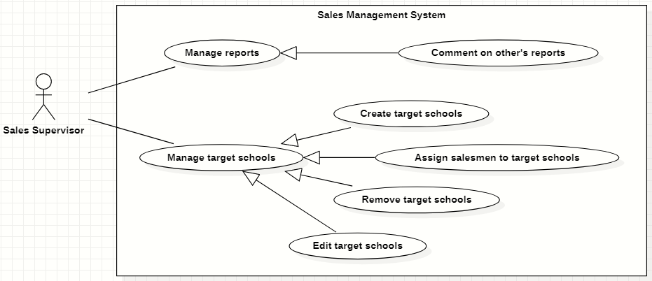

Figure 47. <<Sales Supervisor>> Overview Use Case

#### Create target schools

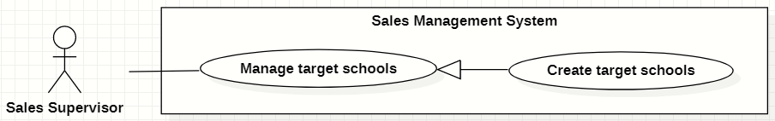

Figure 48. <<Sales Supervisor>> Create target schools

|  |  |  |  |  |  |
| --- | --- | --- | --- | --- | --- |
| ID and Name: | **UC-38 Create target schools** | | | | |
| Created By: | GiaNH, HaPTN | | | Date Created: | 15/02/2021 |
| Primary Actor: | Sales Supervisor, Sales Manager | | | Secondary Actors: | N/A |
| Description: | This use case allows the user to create new target schools from the list of all schools. | | | | |
| Trigger: | The user clicks on the “Create” button on “Target Schools” screen. | | | | |
| Preconditions: | PRE-1. The user has been logged into the system with role Sales Supervisor or Sales Manager.  PRE-2. The user is on the “Target Schools” screen. | | | | |
| Post-conditions: | POST-1. The new target schools are created in the system. | | | | |
| Normal Flow: | **Step** | **Actor Action** | **System Response** | | |
| 1 | The user clicks on the “Create” button on “Target Schools” screen. | The system displays the “Create Target School” form with following required information:   * “School year”: text, default is the current school year, read only. * A table of all schools which has the following columns: * “”: checkbox. * “School Name”: text. * “Principal”: text. * “School Status”: text. * “Purpose”: selections (   - Leads: Sales mới, Theo dõi;  - Customer: Chăm sóc, Tái ký hợp đồng, Ký mới hợp đồng;  - Ngưng hợp tác  ) (value of purpose depends on value of “School Status”), required.   * “Note”: text. * Preview panel: div (to display school’s details). * “Cancel”: button. * “Save”: button. | | |
| 2 | The user ticks the check boxes and chooses “Purpose” in the selections.  [Alternative 1] |  | | |
| 3 | The user selects “Save” button.  [Exception 2] | The system shows the successful message: “Created successfully”.  [Exception 1] | | |
| 4 |  | The system updates the table of list of target schools in the “Target Schools” screen.  [Exception 1] | | |
| Alternative Flows: | **Step** | **Actor Action** | **System Response** | | |
| 1 | The users clicks on a table row. | The systems display that school’s details in the preview panel.   * “School Name”: text. * “School level”: text. * “School type”: text. * “School scale”: text. * “School status”: text. * “Address”: text. * “School phone”: text. * “Representative name”: text. * “Representative phone”: text. * “Representative email”: text. * “Representative isMale”: text. * “This school also be targeted in”: text, list of school year.   *Continue to step 2 of Normal Flow*. | | |
| Exceptions: | **No** | **Cause** | **System Response** | | |
| 1 | The user’s device does not connect to the Internet or the server has internal error. | The system shows the error message: “Connection Failed or Internal Error”. | | |
| 2 | The user selects “Cancel” button. | The system closes the “Create Target Schools” form and returns to the “Target Schools” screen. | | |
| Priority: | High | | | | |
| Frequency of Use: | Usually | | | | |
| Business Rules: | * BR-11, BR-12, BR-13 * Sales Supervisor/Sales Manager can only create the target schools at the current school year. | | | | |
| Other Information: | N/A | | | | |
| Assumptions: | N/A | | | | |
| Assumptions: | N/A | | | | |

Table 41. <<Sales Supervisor>> Create target schools

#### Edit target schools

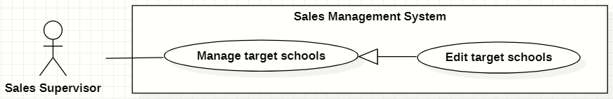

Figure 49. <<Sales Supervisor>> Edit target schools

|  |  |  |  |  |  |
| --- | --- | --- | --- | --- | --- |
| ID and Name: | **UC-39 Edit target schools** | | | | |
| Created By: | HaPTN | | Date Created: | | 12/04/2021 |
| Primary Actor: | Sales Supervisor, Sales Manager | | Secondary Actors: | | N/A |
| Description: | This use case allows the user to edit a target school. | | | | |
| Trigger: | The user edits on fields in “Target School’s details” screen then clicks “Save” button. | | | | |
| Preconditions: | PRE-1. The user has been logged into the system with role Sales Supervisor or Sales Manager.  PRE-2. The user is on the tab “Assign Info” in “Target School’s details” screen. | | | | |
| Post-conditions: | POST-1. The detail information of target school is edited in database. | | | | |
| Normal Flow: | **Step** | **Actor Action** | | **System Response** | |
|  | 1 | The user edits on fields in “Target School’s details” screen then clicks “Save” button. | | The system displays the “Target School’s detail” screen, on the tab “Assign Info”, there is a form with the following information:   * “School year”: text. * “PIC”: input text field, read only. * “PIC’s phone”: input text field, disabled. * “PIC’s email”: input text field, disabled. * “Purpose”: label. * “Note”: input text field. | |
|  | 2 | The user edits on fields in this form.  [Exception 1] | |  | |
|  | 3 | The user clicks “Save” button when finish. | | The system has successful edit and displays the successful message: “Updated Successfully”.  [Exception 2] | |
| Alternative Flows: | N/A | | | | |
| Exceptions: | **No** | **Cause** | | **System Response** | |
| 1 | The user inputs invalid format content into fields. | | The system informs the users that the content of fields is invalid format. | |
| 2 | The user’s device does not connect to the Internet or the server has internal error. | | The system shows the error message: “Connection Failed or Internal Error”. | |
| Priority: | Normal | | | | |
| Frequency of Use: | Usually | | | | |
| Business Rules: | * BR-12, BR-13 * The user can only edit fields: note. * To change PIC, the user needs to unsiaggn the current PIC and then assign a new PIC. | | | | |
| Other Information: | N/A | | | | |
| Assumptions: | N/A | | | | |

Table 55. <<Sales Supervisor>> Edit target schools

#### Assign salesmen to target schools

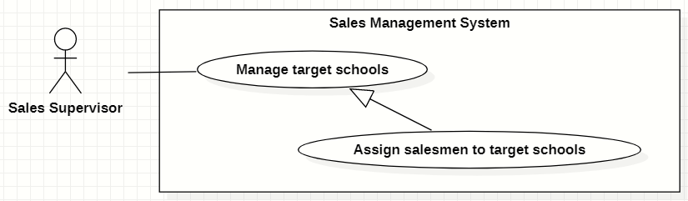

Figure 50. <<Sales Supervisor>> Assign salesmen to target schools

|  |  |  |  |  |  |
| --- | --- | --- | --- | --- | --- |
| ID and Name: | **UC-40 Assign salesmen to target schools** | | | | |
| Created By: | GiaNH | | Date Created: | | 11/02/2021 |
| Primary Actor: | Sales Supervisor, Sales Manager | | Secondary Actors: | | N/A |
| Description: | This use case allows the user to assign salesmen to one or multiple target schools. | | | | |
| Trigger: | The user clicks on the “Assign” button in “Target schools” screen. | | | | |
| Preconditions: | PRE-1. The user has been logged into the system with role Sales Supervisor or Sales Manager.  PRE-2. The user is on the “Target Schools” screen. | | | | |
| Post-conditions: | POST-1. The target schools are assigned to salesmen. | | | | |
| Normal Flow: | **Step** | **Actor Action** | | **System Response** | |
| 1 | The user ticks on the target school rows that he/she wants to assign, then clicks on “Assign” button on the “Target Schools” screen.  [Exception 1]  [Alternative 1] | | The system displays the “Assign Salesmen” form with the following information:   * + “PICs”: input text field, required.   + Table of target schools, which contains columns: * “School Name”: text. * “PIC”: text (get value from “PICs” input text field above). * “Purpose”: text. * “Note”: input text field / editable table cell.   + “Cancel”: button.   + “Save”: button. | |
| 2 | The user inputs/chooses a PIC in the input text field and inputs “Note”. | |  | |
| 3 | The user selects “Save” button.  [Exception 4] | | The system updates target schools’ data with field “PIC”, then shows the successful message: “Updated Successfully”.  [Exception 2]  [Exception 3] | |
| Alternative Flows: | **Step** | **Actor Action** | | **System Response** | |
| 1 | On the “Target Schools” screen, at the end of each row in the table, the user clicks on action icon button, then selects “Assign” command on the menu options. | | The system displays the “Assign” form with the following information:  -“Salesman”: input text field, required.  - “Note”: input text field.  *Continue step 2 of Normal Flow* | |
| Exceptions: | **No** | **Cause** | | **System Response** | |
| 1 | The user selects the target schools which have already been assigned. | | The system shows an alert dialog to state that “The school *[…school name]* is assigned already. If you want to assign to a new PIC, you need to unassign before assigning again.” | |
| 2 | The target school has been already assigned in the same school year. | | The system shows the error message: “The target school has been already assigned in the same school year”. | |
| 3 | The user’s device does not connect to the Internet or the server has internal error. | | The system shows the error message: “Connection Failed or Internal Error”. | |
| 4 | The user selects “Cancel” button. | | The system closes the “Assign” form and returns the “Target School” screen. | |
| Priority: | Usually | | | | |
| Frequency of Use: | N/A | | | | |
| Business Rules: | BR-12, BR-13, BR-14, BR-15, BR-16, BR-17, BR-18 | | | | |
| Other Information: | N/A | | | | |
| Assumptions: | N/A | | | | |

Table 56. <<Sales Supervisor>> Assign salesmen to target schools

#### Remove target schools

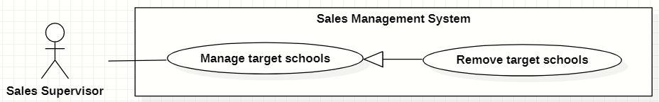

Figure 51. <<Sales Supervisor>> Remove target schools

|  |  |  |  |  |  |
| --- | --- | --- | --- | --- | --- |
| ID and Name: | **UC-41 Remove target schools** | | | | |
| Created By: | GiaNH | | Date Created: | | 15/02/2021 |
| Primary Actor: | Sales Supervisor, Sales Manager | | Secondary Actors: | | N/A |
| Description: | This use case allows the user to remove a target school. | | | | |
| Trigger: | The user clicks on the “Remove” command on the menu options at the end of row in table list of target schools. | | | | |
| Preconditions: | PRE-1. The user has been logged into the system with role Sales Supervisor or Sales Manager.  PRE-2. The user is on the “Target Schools” screen. | | | | |
| Post-conditions: | POST-1. The target school is removed out of table. | | | | |
| Normal Flow: | **Step** | **Actor Action** | | **System Response** | |
| 1 | The user clicks on the “Remove” command on the menu options at the end of row in table list of target schools. | | The system shows a “Confirm Remove” dialog to alert.   * “Cancel”: button. * “Remove”: button. | |
|  | 2 | The user clicks on “Remove” button.  [Exception 1] | | The system shows a successful message: “Removed successfully”, and closes the confirm dialog.  [Exception 2] | |
| Alternative Flows: | N/A | | | | |
| Exceptions: | **No** | **Cause** | | **System Response** | |
| 1 | The user clicks on “Cancel” button. | | The system closes the “Confirm Remove” dialog and returns to the “Target Schools” screen. | |
| 2 | The user’s device does not connect to the Internet or the server has internal error. | | The system shows the error message: “Connection Failed or Internal Error”. | |
| Priority: | High | | | | |
| Frequency of Use: | Usually | | | | |
| Business Rules: | * BR-12, BR-13, BR-18 * The user must not remove the target school if: * This target school has been being assigned. * The contract(s) of this target school has not expired yet. | | | | |
| Other Information: | N/A | | | | |
| Assumptions: | N/A | | | | |

Table 57. <<Sales Supervisor>> Remove target schools

#### Comment on Salesmen’s reports

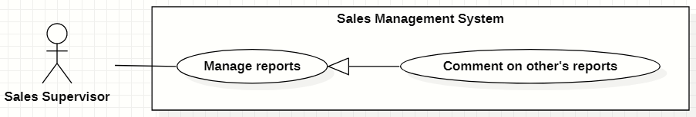

Figure 52. <<Sales Supervisor>> Comment on Salesmen’s reports

|  |  |  |  |  |  |
| --- | --- | --- | --- | --- | --- |
| ID and Name: | **UC-42 Comment on Salesmen’s reports** | | | | |
| Created By: | GiaNH | | Date Created: | | 12/02/2021 |
| Primary Actor: | Sales Supervisor, Sales Manager | | Secondary Actors: | | N/A |
| Description: | This use case allows the user to comment on Salesmen’s Reports. | | | | |
| Trigger: | The user clicks on the “Comment” command on the menu options at the end of row in table list of reports. | | | | |
| Preconditions: | PRE-1. The user has been logged into the system with role Sales Supervisor or Sales Manager.  PRE-2. The user is on the “Reports” screen. | | | | |
| Post-conditions: | POST-1. The comment is added on Salesmen’s reports. | | | | |
| Normal Flow: | **Step** | **Actor Action** | | **System Response** | |
| 1 | The user clicks on the “Comment” command on the menu options at the end of row in table list of reports.  [Alternative 1] | | The system displays “Comment on Report” dialog with the following information.   * “School Year”: text. * “Date”: text. * “School Name”: text. * “PIC”: image (avatar) and text. * “Purpose”: text. * “Result”: text. * “Description”: text. * “Positivity”: text. * “Difficulty”: text. * “Future plan”: text. * “Supervisor comment”: input text field, required. * “Cancel”: button. * “Save”: button. | |
| 2 | The user inputs his/her comment into the text field. | |  | |
|  | 3 | The user selects “Save” button.  [Exception 1] | | The system updates this report in the database with the new comment and closes the “Comment on Report” dialog .  [Exception 2] | |
| Alternative Flows: | **Step** | **Actor Action** | | **System Response** | |
| 1 | On the “Reports” screen, at the end of each row in the table, the user clicks on action icon button, then selects “View detail” command on the menu options. | | The system displays “Report’s details” view, the report’s information is displayed as a form.   * “School Year”: text. * “Date”: text. * “School Name”: text. * “PIC”: image (avatar) and text. * “Purpose”: text. * “Result”: input text field, read only. * “Description”: input text field, read only. * “Positivity”: input text field, read only. * “Difficulty”: input text field, read only. * “Future plan”: input text field, read only. * “Supervisor comment”: input text field. * “Save”: button, only active when the form is dirty. | |
| 2 | The user inputs his/her comment into the text field. | |  | |
| 3 | The user selects “Save” button.  [Exception 3]  [Exception 4] | | The system updates this report in the database with the new comment and shows the sucessful message “Updated Successfully”.  [Exception 2] | |
| Exceptions: | **No** | **Cause** | | **System Response** | |
| 1 | The user clicks on “Cancel” button. | | The system closes the “Comment on Report” dialog and returns to the “Reports” screen. | |
| 2 | The user’s device does not connect to the Internet or the server has internal error. | | The system shows the error message: “Connection Failed or Internal Error”. | |
| 3 | The user clicks on back button to go to “Reports” screen without edit anything in the form. | | The system discards all changes in the form and do not update anything to the database. | |
| 4 | The user eidts in the form’s fields but does not clicks on “Save” button before going back to “Reports” screen. | | The system discards all changes in the form and do not update anything to the database. | |
| Priority: | High | | | | |
| Frequency of Use: | Usually | | | | |
| Business Rules: | * BR-25, BR-26, BR-27, BR-29 * The user is not allowed to comment on his/her own reports. * The user shall comment on reports of other Sales Managers or Sales Supervisors. | | | | |
| Other Information: | N/A | | | | |
| Assumptions: | N/A | | | | |

Table 58. <<Sales Supervisor>> Comment on Salesmen’s reports

### 2.7 <<Sales Manager>> Overview Use Case

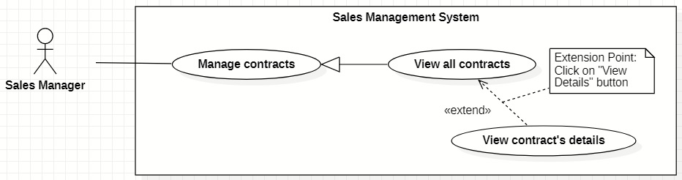

Figure 53. <<Sales Manager>> Overview Use Case

#### View all contracts

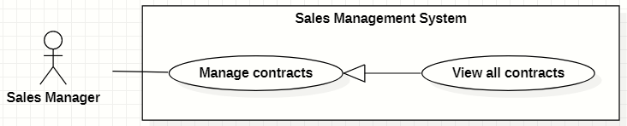

Figure 54. <<Sales Manager>> View all contracts

|  |  |  |  |  |  |  |
| --- | --- | --- | --- | --- | --- | --- |
| ID and Name: | **UC-43 View all contracts** | | | | | |
| Created By: | HaPTN | | | Date Created: | | 12/04/2021 |
| Primary Actor: | Sales Manager | | | Secondary Actors: | | N/A |
| Description: | This use case allows the user to view all contracts of all target schools. | | | | | |
| Trigger: | The user selects tab “Contracts” in “Target School’s details” screen. | | | | | |
| Preconditions: | PRE-1. The user has been logged into the system with role Sales Manager.  PRE-2. The user is on the tab “Contracts” in “Target School’s details” screen. | | | | | |
| Post-conditions: | POST-1. Contract’s list is displayed as the table in “Contracts” screen. | | | | | |
| Normal Flow: | **Step** | | **Actor Action** | | **System Response** | |
| 1 | | The user selects tab “Contracts” in “Target School’s details” screen. | | The system displays “Contracts” screen, contract’s list is displayed as the table.   * “ID”: text. * “Target Schools”: text. * “Duration”: text. * “Service”: text. * “Revenue Criteria”: text. * “Note”: text.   [Exception 1] | |
| Alternative Flows: | N/A | | | | | |
| Exceptions: | **No** | **Cause** | | | **System Response** | |
| 1 | No stored contracts data in the system. | | | The system displays “No records found” line on the table. | |
| 2 | The user’s device does not connect to the Internet or the server has internal error. | | | The system shows the error message: “Connection Failed or Internal Error”. | |
| Priority: | High | | | | | |
| Frequency of Use: | Usually | | | | | |
| Business Rules: | BR-31, BR-34 | | | | | |
| Other Information: | N/A | | | | | |
| Assumptions: | N/A | | | | | |
| Assumptions: | N/A | | | | | |

Table 59. <<Sales Manager>> View all contracts

## 3. Functional Requirements

### 3.1 System Functional Overview

#### Screen Flow

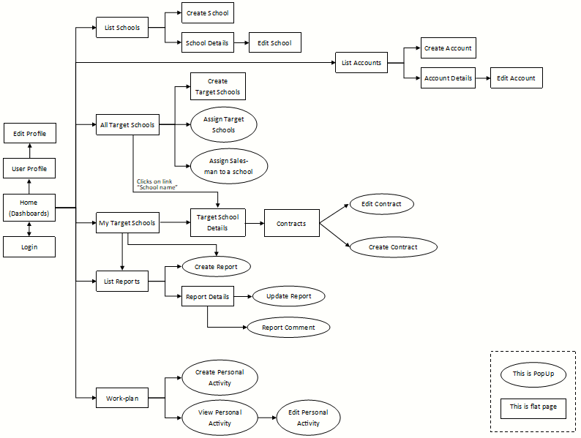

Figure 55. Screen Flow

#### Screen Details

|  |  |  |  |
| --- | --- | --- | --- |
| **#** | **Feature** | **Screen** | **Description** |
| 1 | Login | Login |  |
| 2 |  | Home (Dashboards) |  |
| 3 | View Profile | User Profile |  |
| 4 | Edit Profile | Edit Profile |  |
| 5 | * View list of schools * Search schools | List Schools |  |
| 6 | Create new schools | Create School |  |
| 7 | View school’s details | School Details |  |
| 8 | Edit school’s information | Edit School |  |
| 9 | * View list of accounts * Search accounts | List Accounts |  |
| 10 | Create new accounts | Create Account |  |
| 11 | View account’s details | Account Details |  |
| 12 | Edit account’s information | Edit Account |  |
| 13 | View list of all target schools | All Target Schools |  |
| 14 | Create target schools | Create Target Schools |  |
| 15 | Assign Salesmen to target schools | Assign Target Schools |  |
| 16 | Assign Salesmen to target schools | Assign Salesman to a school |  |
| 17 | * View list of assigned target schools * Search assigned target schools | My Target Schools |  |
| 18 | View target school’s details | Target Schools Details |  |
| 19 | Edit school’s information | Edit Target School Info |  |
| 20 | * View all reports * Search reports | List Reports |  |
| 21 | Create reports | Create Report |  |
| 22 | View report’s details | Report Details |  |
| 23 | Update reports | Update Report |  |
| 24 | Comment on Salesmen’s reports | Report Comment |  |
| 25 | * View my contracts * View all contracts | Contracts |  |
| 26 | * View Contract’s details * Edit my contracts | Edit Contracts |  |
| 27 | View Workplan | Workplan |  |
| 28 | Create Personal Activities | Create Personal Activities |  |
| 29 | View Personal Activity’s details | View Personal Activity |  |
| 30 | Edit Personal Activities | Edit Personal Activity |  |

Table 60. Screen Details

#### Screen Authorization

|  |  |  |  |  |
| --- | --- | --- | --- | --- |
| **Screen** | **Salesman** | **Sales Supervisor** | **Sales Manager** | **Admin** |
| Login |  |  |  |  |
| Login | X | X | X | X |
| Dashboard | X | X | X |  |
| View Profile | X | X | X | X |
| Edit Profile | X | X | X | X |
| List Schools |  |  |  |  |
| View all schools |  | X | X | X |
| View school’s details |  | X | X | X |
| Create School |  |  |  | X |
| Edit School | X | X | X | X |
| List Accounts |  |  |  | X |
| Create Account |  |  |  | X |
| Account Details |  |  |  | X |
| Edit Account |  |  |  | X |
| All Target Schools | X | X | X |  |
| Create Target Schools |  | X | X |  |
| Assign Target Schools |  | X | X |  |
| Assign Salesman to a school |  | X | X |  |
| My Target Schools | X | X | X |  |
| Target Schools Details | X | X | X |  |
| Edit Target School Info | X | X | X |  |
| List Reports | X | X | X |  |
| Create Report | X | X | X |  |
| Report Details | X | X | X |  |
| Update Report |  | X | X |  |
| Report Comment |  | X | X |  |
| Contracts | X | X | X |  |
| Edit Contracts | X | X | X |  |
| Workplan | X | X | X |  |
| Create Personal Activities | X | X | X |  |
| View Personal Activity | X | X | X |  |
| Edit Personal Activity | X | X | X |  |

Table 61. Screen Authorization

#### Non-Screen Functions

|  |  |  |  |
| --- | --- | --- | --- |
| **#** | **Feature** | **System Function** | **Description** |
| 1 | Forget password | Send email | An email is sent to user’s email to provide a verification code for resetting the forgotten password. |
| 2 | Create new account | Send email | After Admin creating a new account, an email is automatically sent to the user’s email to provide password. |

Table 62. Non-Screen Functions

#### Entity Relationship Diagram

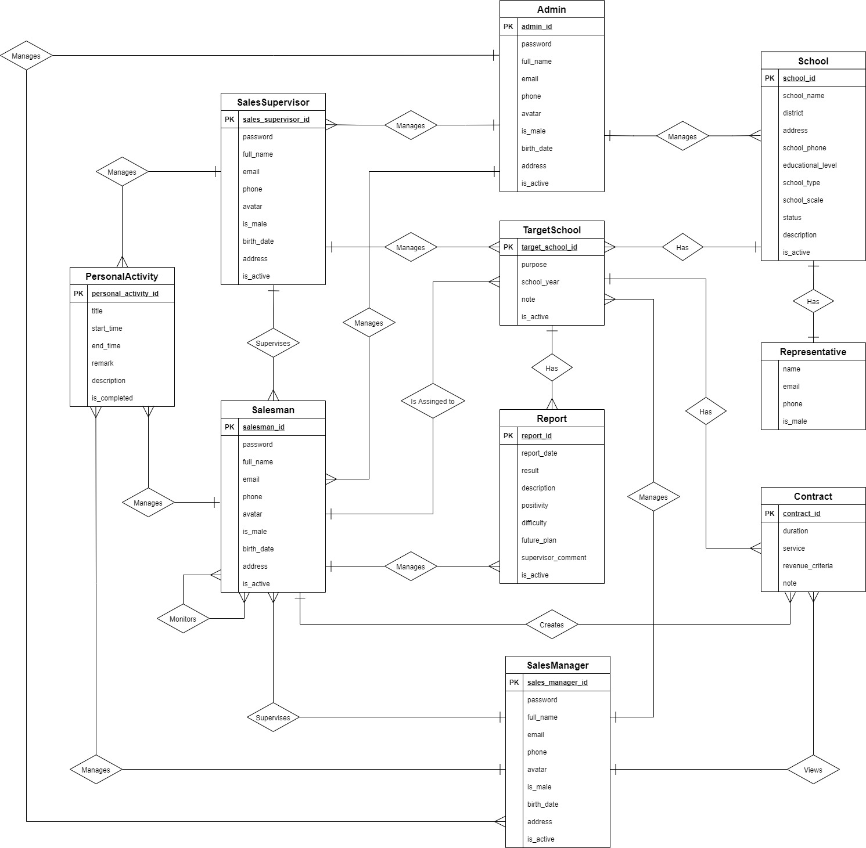

Figure 56. Entity Relationship Diagram

**Entities List**

|  |  |  |
| --- | --- | --- |
| **#** | **Entity** | **Description** |
| 1 | Admin | The Admin is an entity presenting a person who manages accounts and whole schools data of sale department.  Containing information of admin (id, password, full name, phone, email, avatar, address, birthday, isMale, isActive). |
| 2 | Salesman | The Salesman is an entity presenting a person who goes to work with the assigned target schools.  Containing information of Salesman (id, password, full name, phone, email, avatar, address, birthday, isMale, isActive). |
| 3 | Sales Manager | The Sales Manager is an entity presenting a person who manages and assigns the Target Schools to the Salesmen.  Containing information of Sales Manager (id, password, full name, phone, email, avatar, address, birthday, isMale, isActive). |
| 4 | Sales Supervisor | The Sales Supervisor is an entity presenting a person who manages, assigns the Target Schools to the Salesmen and also have right to view all contracts of all target schools.  Containing information of Sales Manager (id, password, full name, phone, email, avatar, address, birthday, isMale, isActive). |
| 5 | School | The School is an entity presenting the school that was collected information and was select to become the target.  Contain information of School (id, name, district, address, phone, scale, type, description, educational level, status, isActive). |
| 6 | Target School | The Target School is an entity presenting the target that Sales Manager creates base on Schools list and assigns to Salesmen.  Containing information of School (id, purpose, school year, note, isActive). |
| 7 | Report | The Report is an entity presenting the report that Salesmen must submits to Sales Manager.  Containing the report information (id, date, result, description, positivity, difficulty, futurePlan, supervisorComment). |
| 8 | Personal Activity | The Personal Activity is an entity presenting an activity that Salesmen or Sales Managers create in work-plan and execute based on that.  Containing the Personal Activity information (id, title, startTime, endTime, remark, description, isCompleted). |
| 9 | Representative | The Representative is an entity presenting a person who is the representative for the school to contact.  Containing information of Representative (full name, isMale, email, phone). |
| 10 | Contract | The Contract is an entity presenting a contract between a target school and Major Education.  Containing information of Contract (id, duration, service, revenueCriteria, note). |

Table 63. Entities List

## 4. Non-Functional Requirements

### 4.1 External Interfaces

UI-1: The user interfaces in general should be consistent, simple, clear, intuitive, and reminiscent.

* Some design principles will be taken into consideration: <https://material.io/design/introduction>

UI-2: The user interfaces for the software shall be compatible with: Chrome (version 52 or above), Firefox (version 51 or above), Safari (version 10 or above) browser.

UI-3: The user interfaces should be responsive on multiple screen devices: Laptop, Tablet, and Mobile.

UI-4: The user interfaces should be clear and intuitive message for the users when there is a warning or an error.

UI-5: The user interfaces should ask the users to confirm the action when having major operating actions.

#### Software Interfaces

SI-1: This web application works with: Chrome (version 52 or above), Firefox (version 51 or above), Edge (version 14 or above), Safari (version 10 or above), or Opera (version 38 or above) browser.

#### Hardware Interfaces

HI-1: Since this system is a web application, which it shall work on Laptop, Tablet and Mobile.

HI-2: The system must run over the Internet; all the hardware shall require connect to the Internet.

#### Communications Interfaces

CI-1: The system shall communicate through HTTP protocol over the Internet.

### 4.2 Quality Attributes

#### Usability

- The system is designed simple, and intuitive which the users can easily manage their work.

- The default system language is English.

- The system shall take two hours of training for the users to familiar with usage.

#### Availability

- The system is available 24/7.

#### Security

- The system demands unauthorized users to log in for using the system.

- Each authentic user has a different role and scope for accessing a set of system functions.

- The password field must be obscured with special characters representing typed characters.

- The active session time for this system is two hours, after that the user shall be demanded to log in again.

#### Maintainability

- The source code should be based on a unified convention coding so that developers can easily manage.

- The system is divided into separate components and modules which giving the ability to update or scale up the system.

## 5. Other Requirements

### 5.1 Appendix1 - Messages List

|  |  |  |  |  |
| --- | --- | --- | --- | --- |
| **#** | **Message code** | **Message Type** | **Content** | **Content** |
| 1 | MSG01 | In red, above the text box | Invalid username or password | *Wrong format or invalid entry when user logs in.* |
| 2 | MSG02 | In red, above the text box | Wrong username or password | *Wrong username or password when user logs in.* |
| 3 | MSG03 | In red, under the text box | Invalid username or email | *Wrong format or invalid entry when user resets forgotten password.* |
| 4 | MSG04 | In red, under the text box | Wrong username or email | *Wrong username or password when user resets forgotten password.* |
| 5 | MSG05 | In red, above the text box | Invalid password | *Wrong current password when user changes password.* |
| 6 | MSG06 | In red, under the text box | Incorrect entry | *Wrong format or invalid entry when user updates something.* |
| 7 | MSG07 | Toast message, green | Password has been reset successfully | *Reset forgotten password successfully.* |
| 8 | MSG08 | Toast message, green | Updated Successfully | *Update something successfully.* |
| 9 | MSG09 | Toast message, red | Update Unsuccessfully | *Update something failed.* |
| 10 | MSG10 | Toast message, green | Create Successfully | *Create something successfully.* |
| 11 | MSG11 | In line, italic, gray | No records found | *Table does not have data to show.* |
| 12 | MSG12 | In line, red | Connection Failed or Internal Error | *Trouble with the Internet connection.* |
| 13 | MSG13 | In line, red | The contract ID has already existed | *Duplicate contract ID when create new contracts.* |
| 14 | MSG14 | Dialog | The school *[…school name]* is assigned already. If you want to assign to a new PIC, you need to unassign before assigning again. | *The user ticks on the target schools which have already been assigned.* |
| 15 | MSG15 | In line, red | Please choose the right file format. | *When the user import a file to the system.* |

Table 64. Appendix1 - Messages List

# IV. Software Design Description

## 1. Overall Description

### 1.1 Assumptions

This system is designed basing on these following assumptions:

* Web application
* ReactJS
* Spring boot
* MySQL
* 3-tier architecture

### 1.2 Design Constraints

This system should be complied with following items:

* The system should work on Laptop, Tablet, Mobile.
* The system must run over the Internet; all the hardware shall require connect to the Internet.
* The system shall communicate through HTTP protocol over the Internet.
* The system shall available 24/7.

## 2. System Architecture Design

### 2.1 Overall Architecture

Our system is built on three-tier architecture, which allows us to modularize the user interface, business logic, and data storage layers. As a result, we gain great flexibility, code reusable, and easy maintenance for not only developing but also implementing the system.

|  |  |
| --- | --- |
| **Overall Architecture Data Dictionary** | |
| **Name** | **Description** |
| Presentation Tier | This tier provides a user interface and handles user interactions. It communicates with the application tier which provides the results to the browser. |
| Application Tier | This tier contains a set of rules for processing information and business logic. All communication goes through the application tier. |
| Data Tier | This tier comprises the database where the information processed by the application tier is stored. |

Table 65. Overall Architecture Data Dictionary

### 2.2 System Architecture

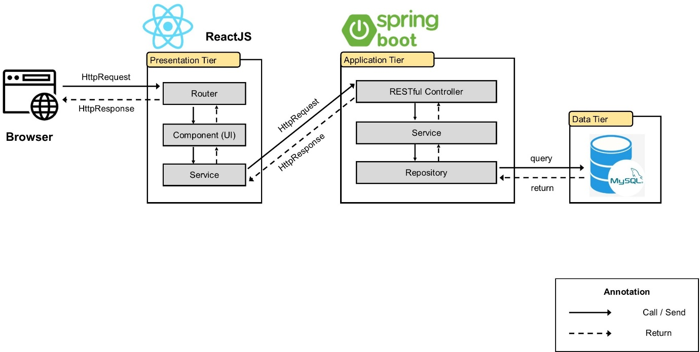

Figure 57. System Architecture

### 2.3 Package Diagram

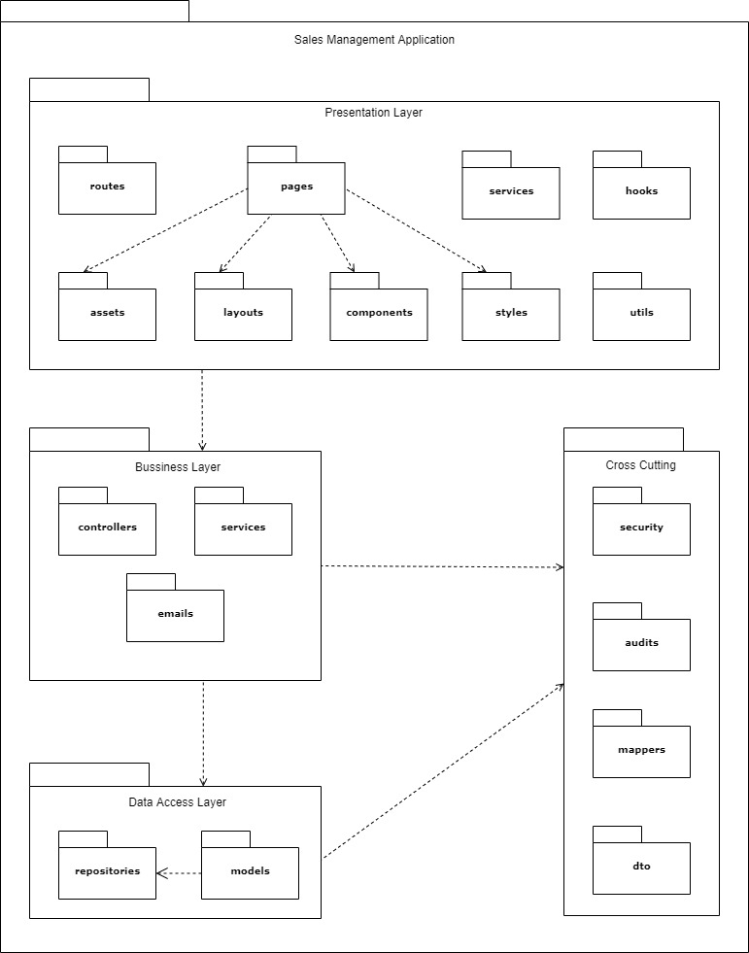

Figure 58. Package Diagram

|  |  |  |
| --- | --- | --- |
| **No** | **Package** | **Description** |
| 01 | routes | The package contains functions for app navigation. |
| 02 | pages | The package contains the pages of the routing. |
| 03 | services | The package contains functions to manage API. |
| 04 | hooks | The package contains custom hook functions. |
| 05 | assets | The package contains images and icons. |
| 06 | layouts | The package contains layout components for the app. |
| 07 | components | The package contains UI components that can be shared. |
| 08 | styles | The package contains global CSS, JavaScript for application-level styles. |
| 09 | utils | The package contains all the helper functions. |
| 10 | controllers | The package contains classes provide RESTful web services. |
| 11 | services | The package contains classes for business logic. |
| 12 | emails | The package contains a class provides email service. |
| 13 | repositories | The package contains classes responsible for communicating with data sources, processing queries, and returning data types requested by the Service layer. |
| 14 | models | The package contains classes that represent persisted data to the database. |
| 15 | security | The package contains classes for JWT handling, authentication, and authorization. |
| 16 | audits | The package contains classes for auditing entity objects. |
| 17 | mappers | The package contains a class to convert data between the DTO and entity objects. |
| 18 | dto | The package contains classes to aggregate and encapsulate data for transfer. |

Table 66. Package Diagram Specifications

## 3. System Detailed Design

### 3.1. Class Diagram

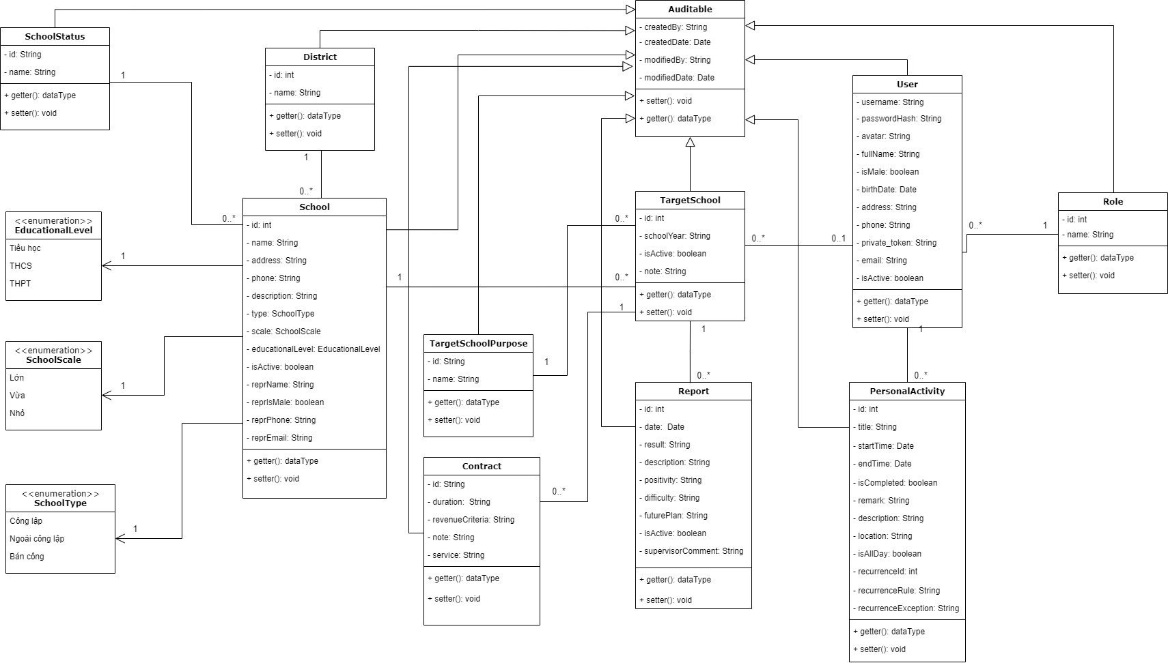

Figure 59. Class Diagram

### 3.2. Sequence Diagram(s)

#### <Sales Supervisor> Assign Salesmen to Target schools

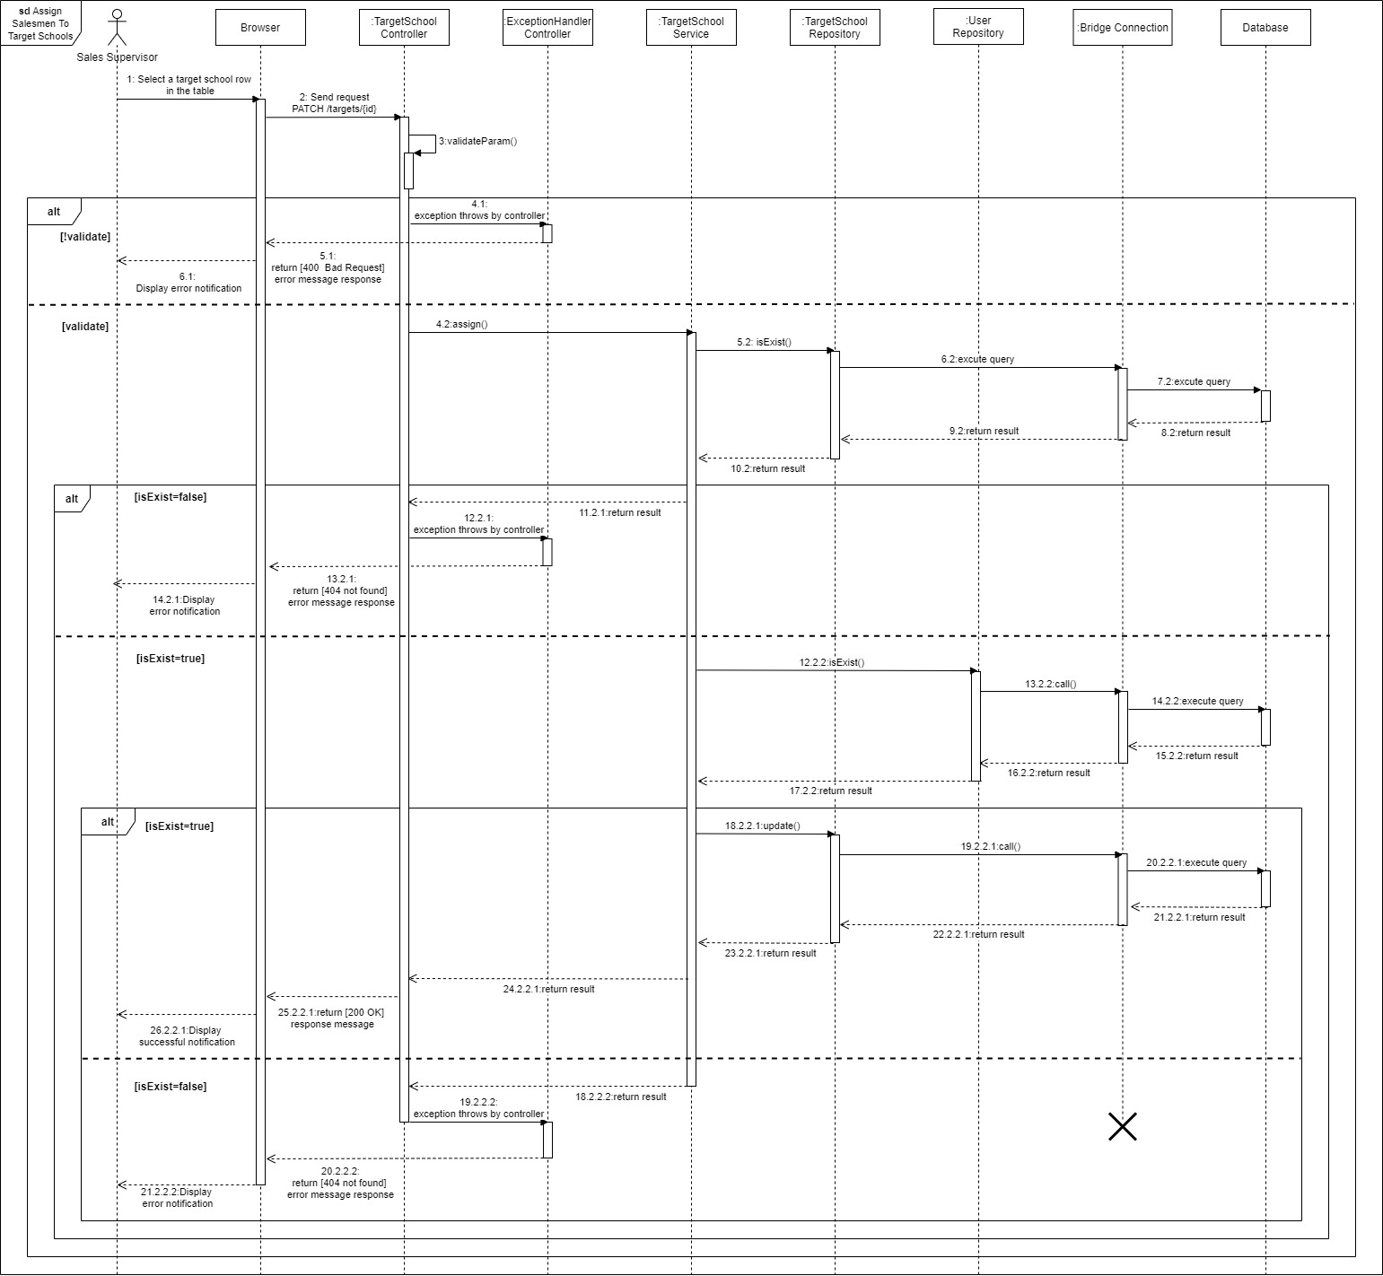

Figure 60. Assign Salesmen to Target schools

#### <Salesman> Create contract

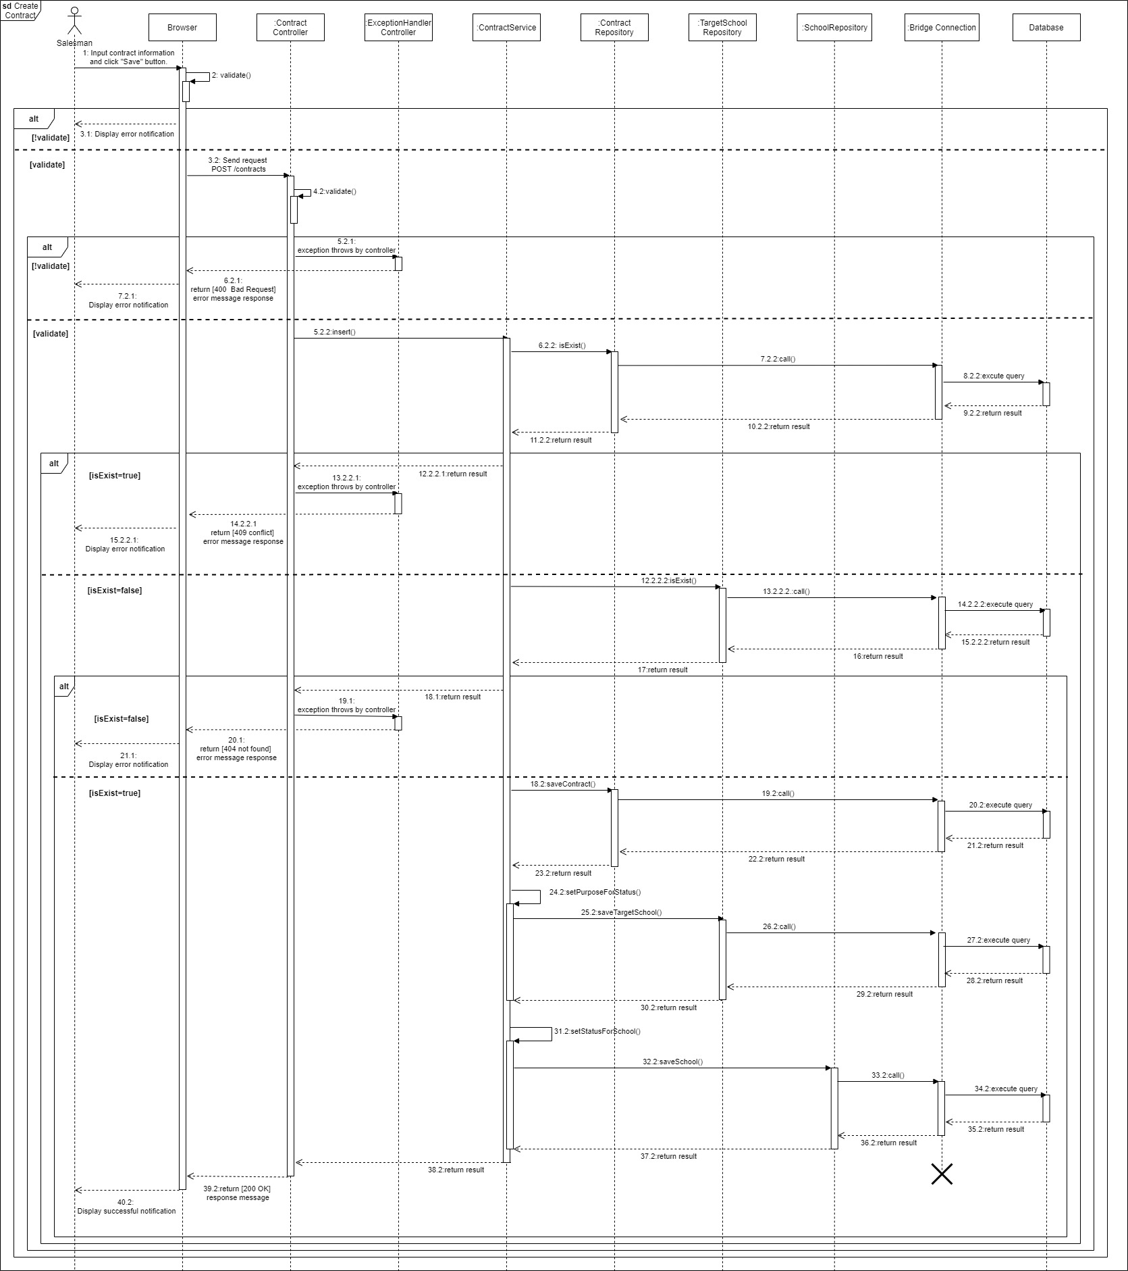

Figure 61. Create contract

#### <Administrator> Create new accounts

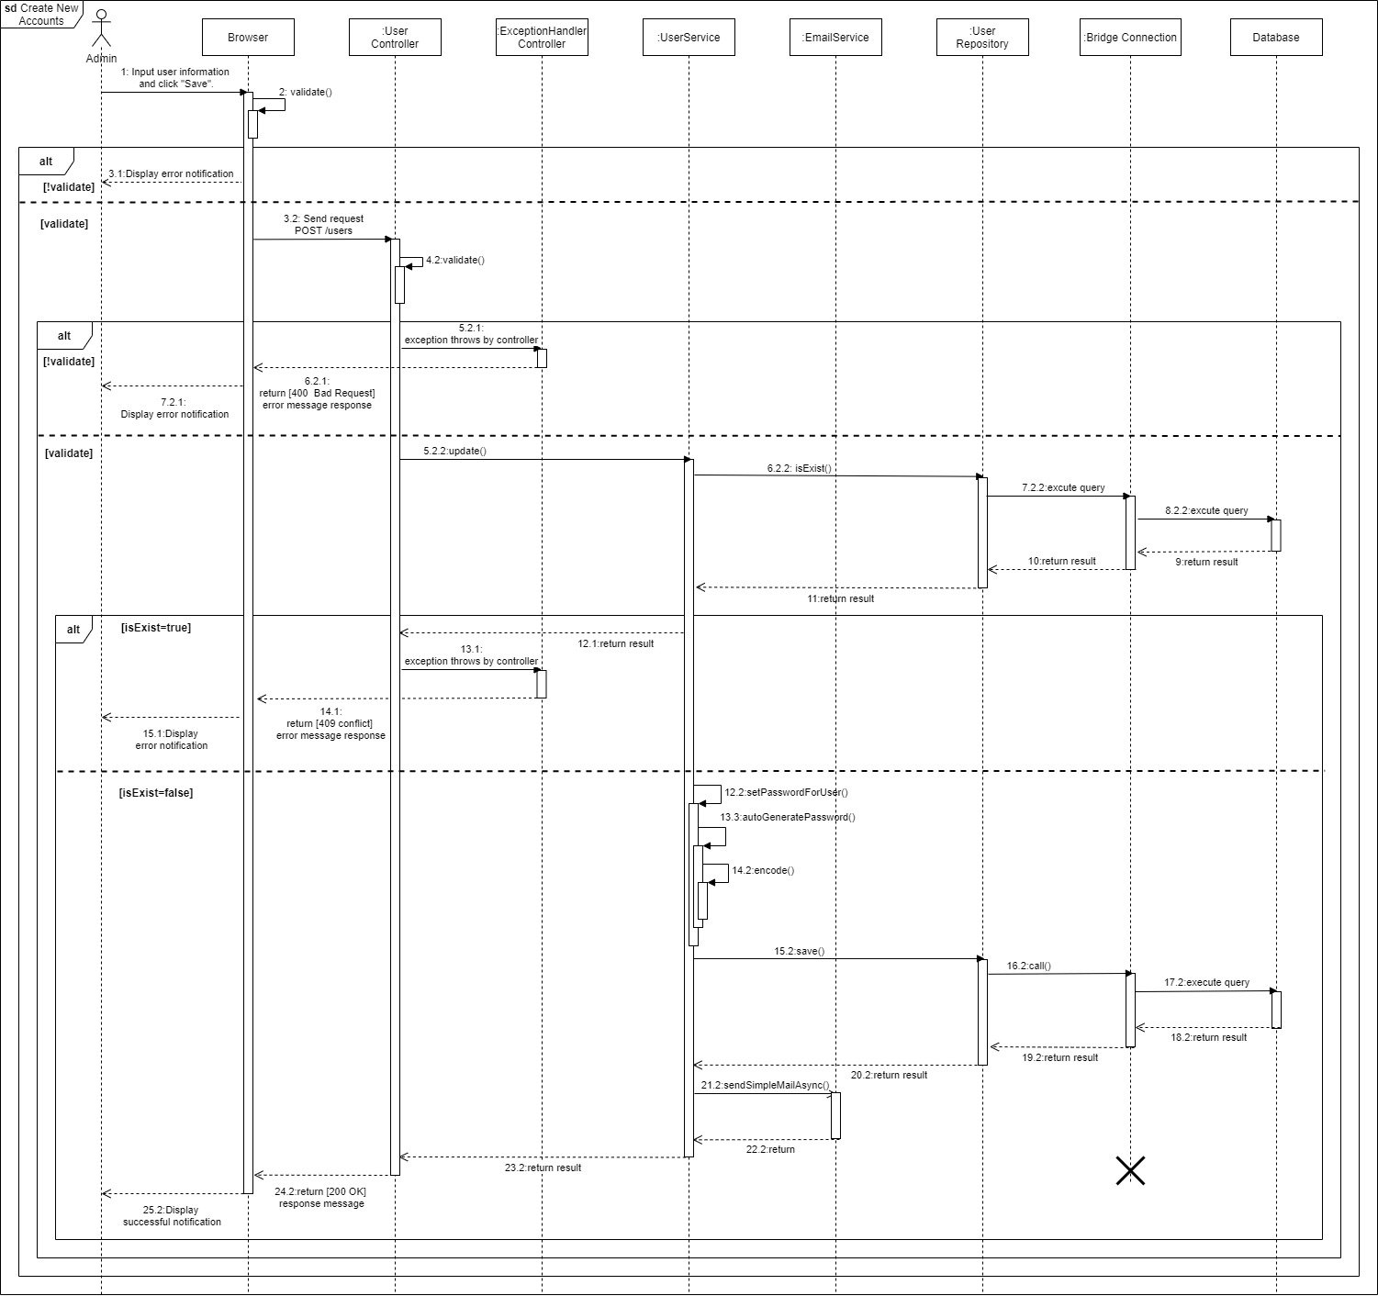

Figure 62. Create new accounts

#### <Administrator> Edit school’s information

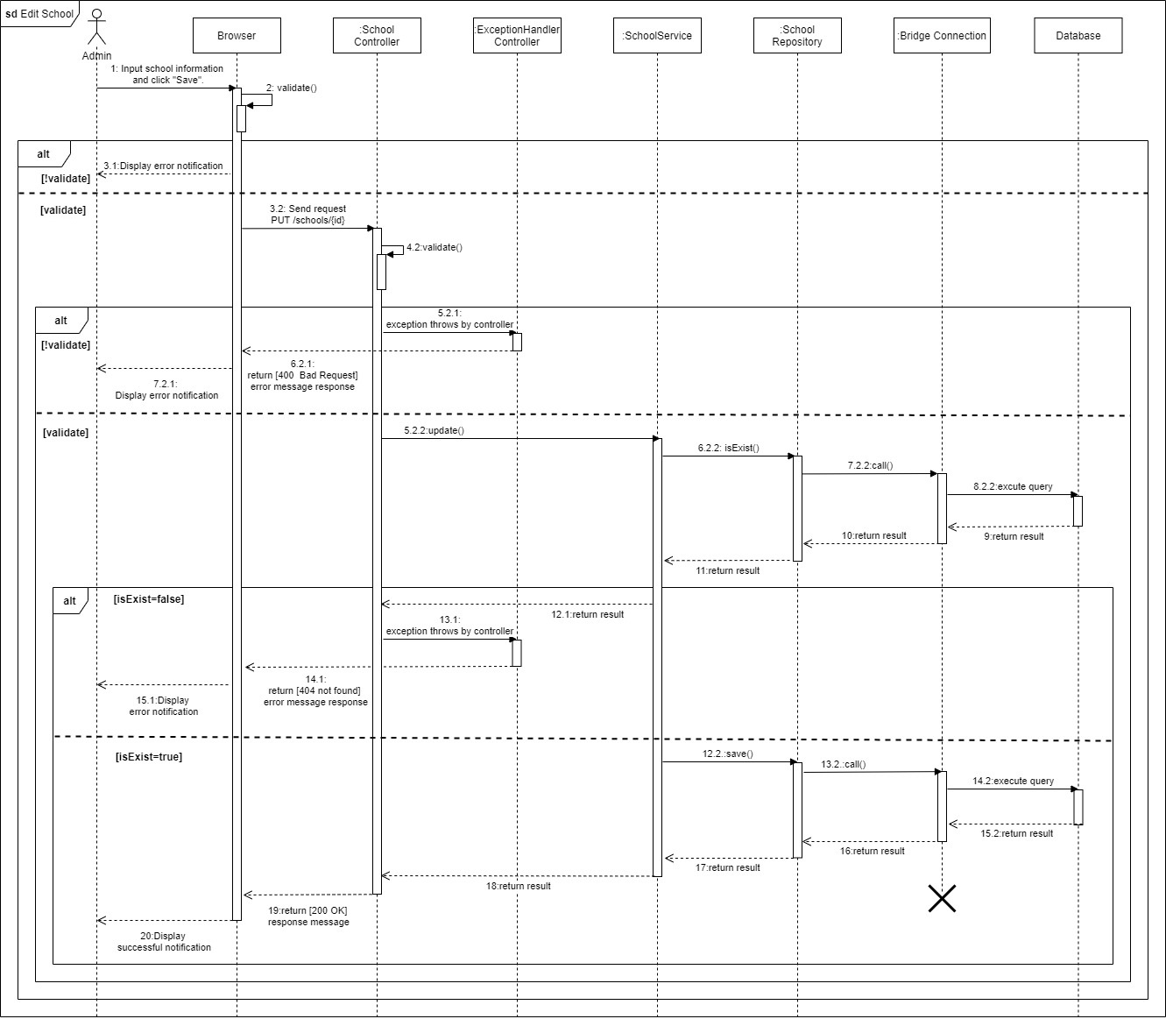

Figure 63. Edit school’s information

#### <Salesman> Remove personal activities

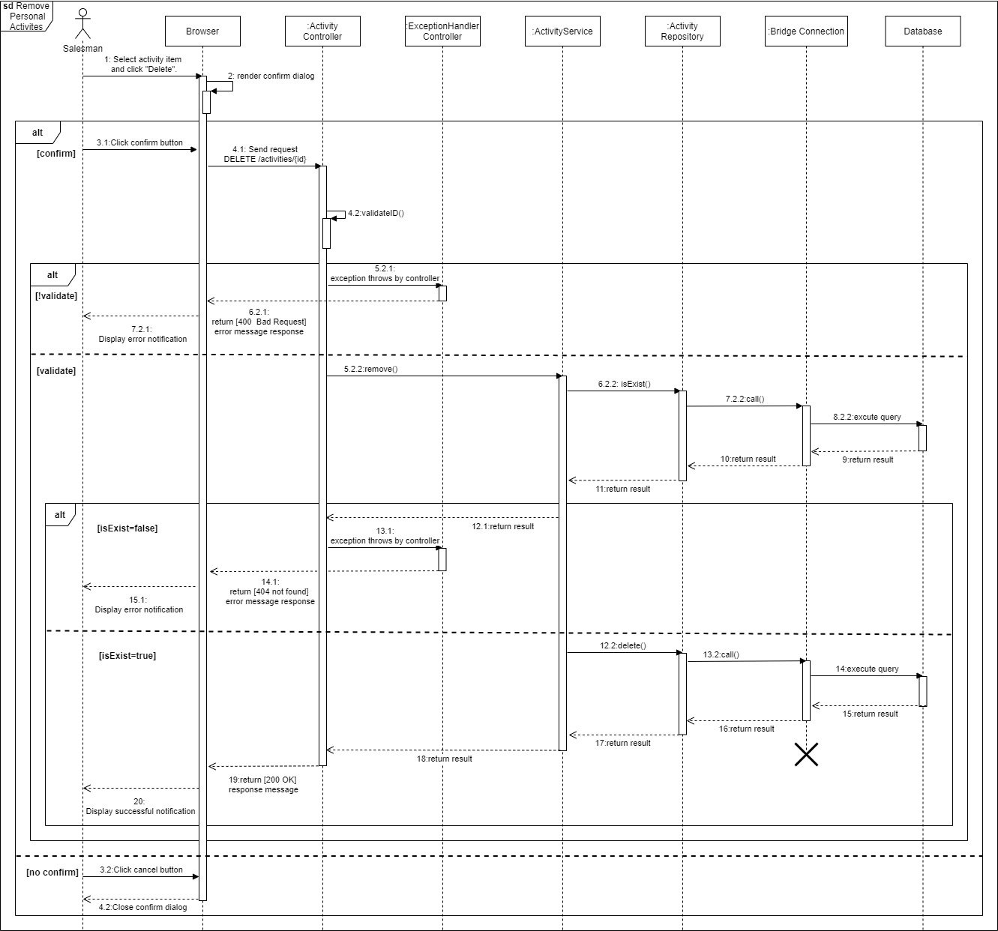

Figure 64. Remove personal activities

#### View target school details

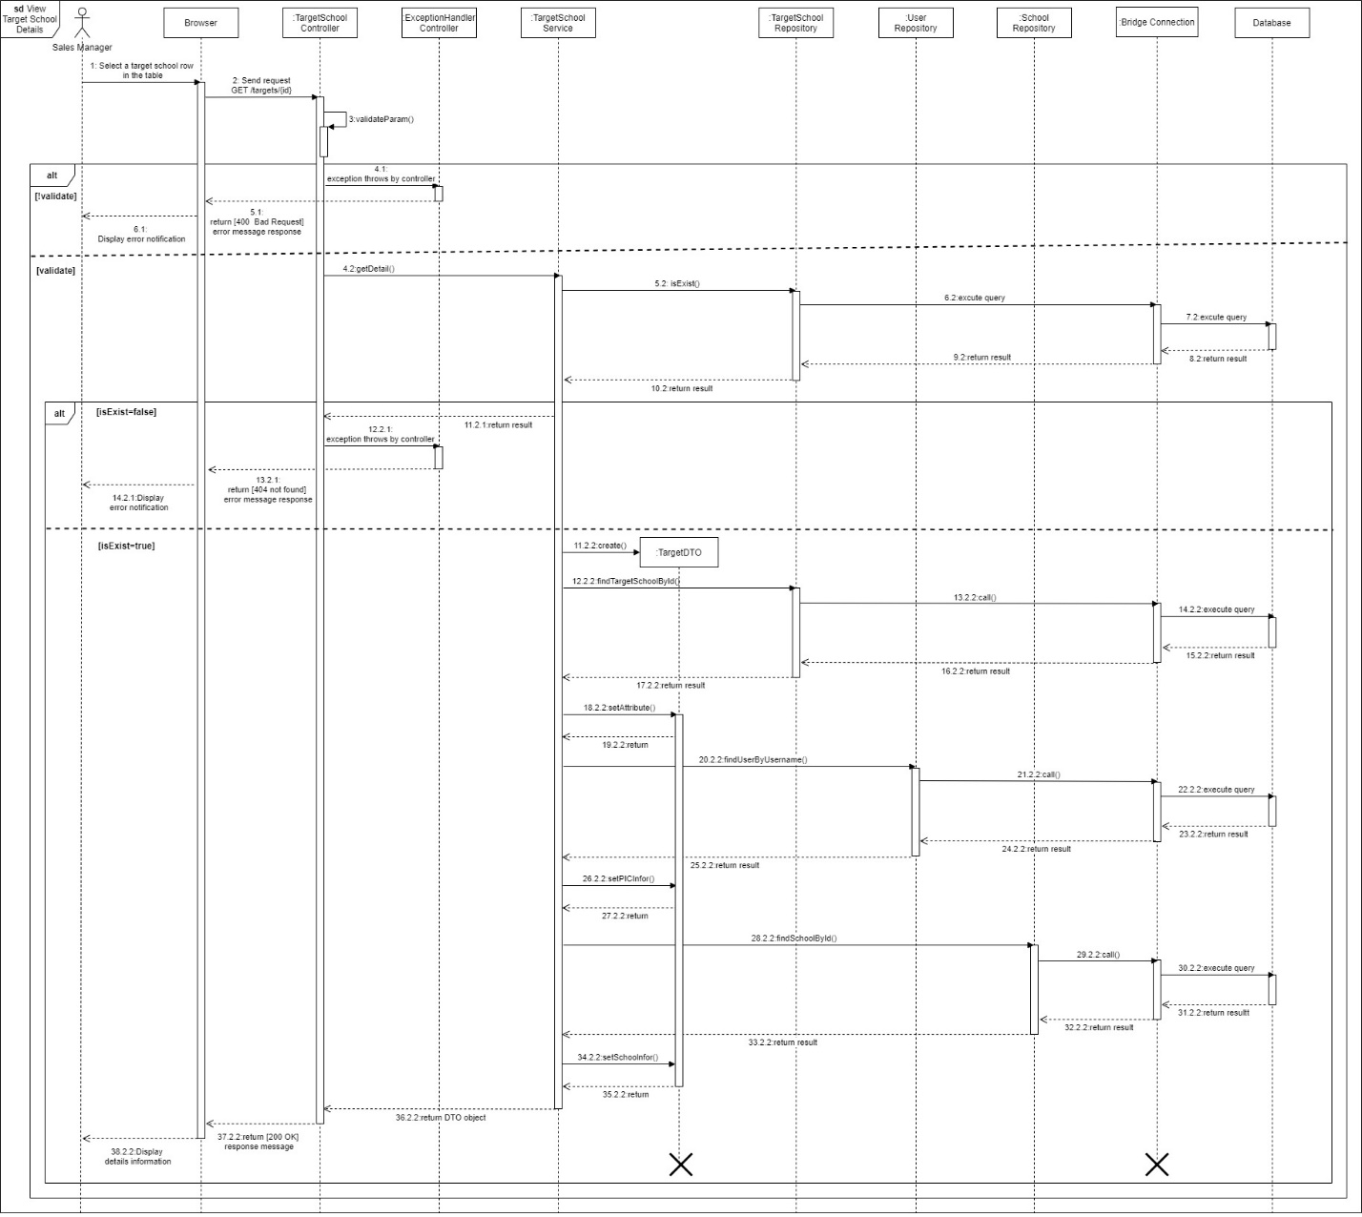

Figure 65. View target school details

### 3.3. Activity Diagram(s)

#### <Sales Manager> Create target school

Summary: This diagram shows the process by which the sales manager creates a target school.

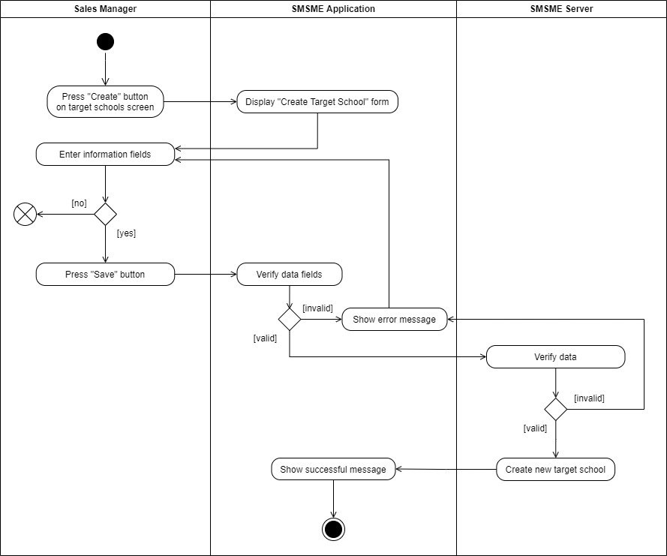

Figure 66. Create target schools

#### <Sales Manager> Assign salesman

Summary: This diagram shows the process by which the sales manager assigns a salesman to a target school.

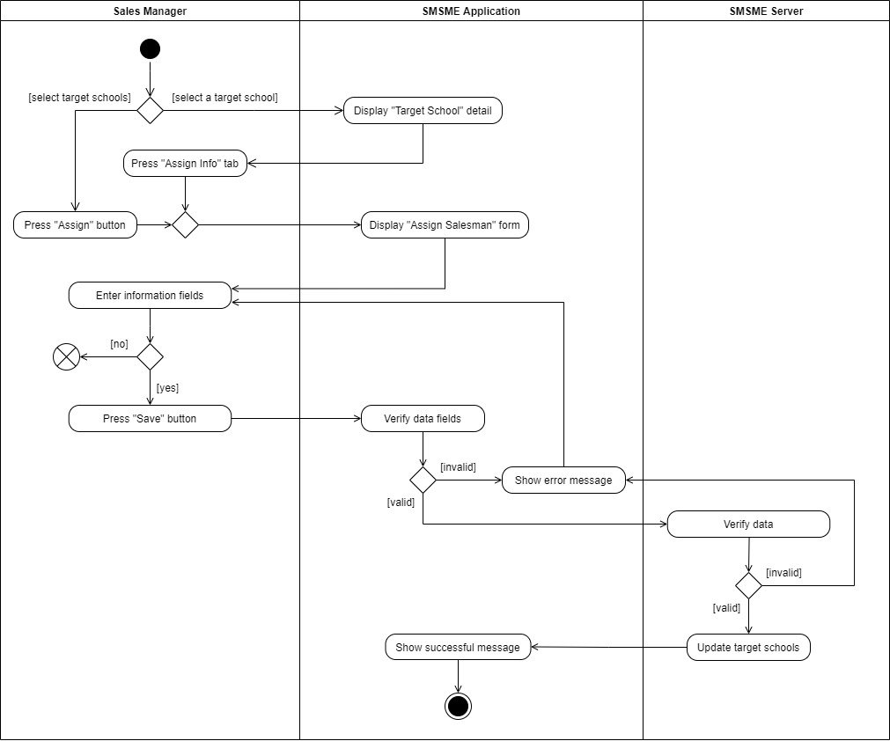

Figure 67. Assign salesmen to target schools

#### <Sales Manager> Update target school

Summary: This diagram shows the process by which the sales manager updates a target school.

Figure 68. Update target school's details

#### <Sales Manager> Remove target school

Summary: This diagram shows the process by which the sales manager removes a target school.

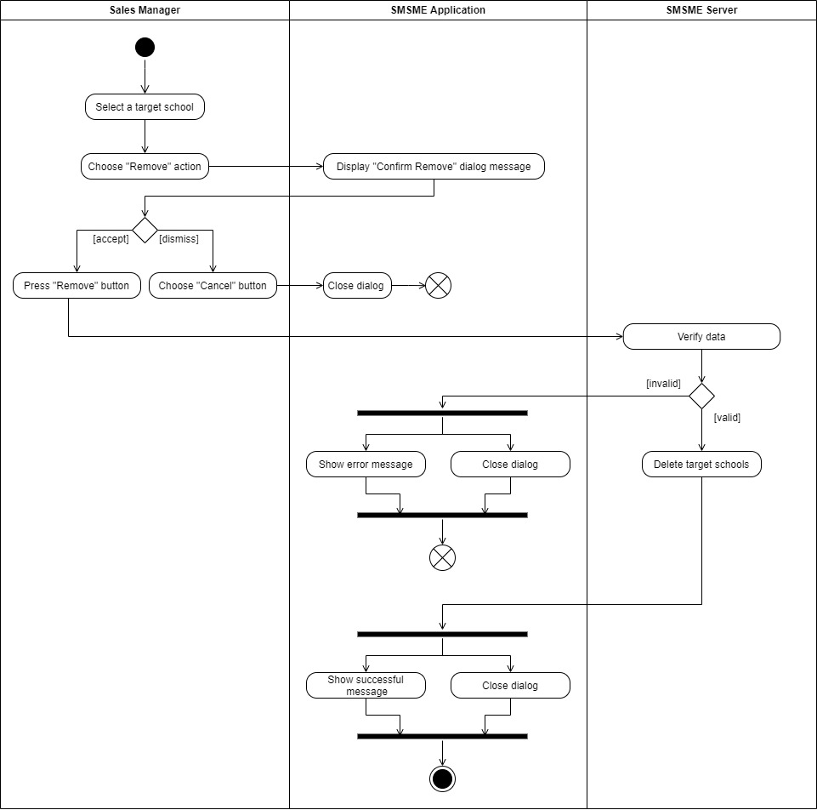

Figure 69. Remove a target school

#### <Sales Manager/ Salesman> Create report

Summary: This diagram shows the process by which the sales manager or salesman create a report.

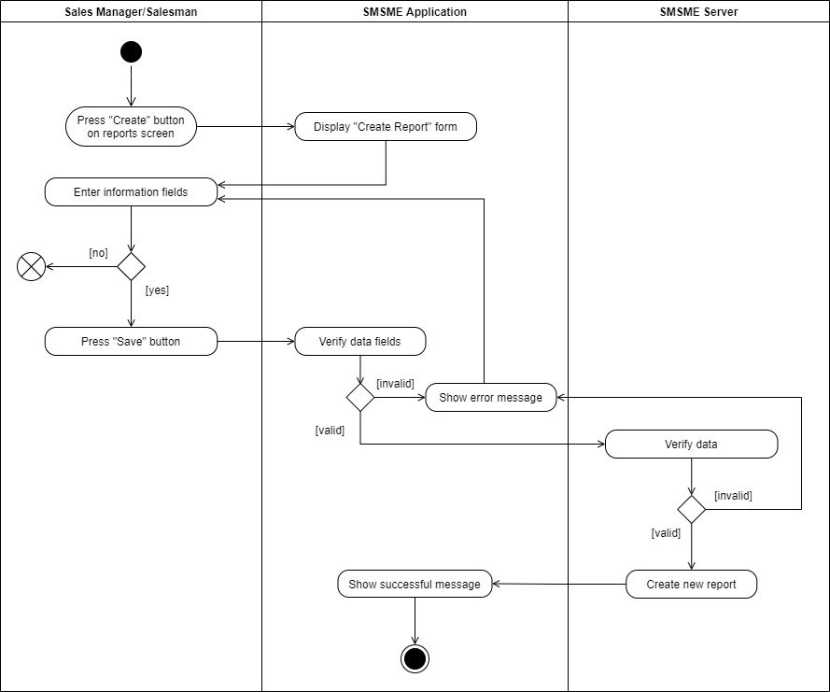

Figure 70. Create reports

#### <Sales Manager/ Salesman> Update report

Summary: This diagram shows the process by which the sales manager or salesman update a report.

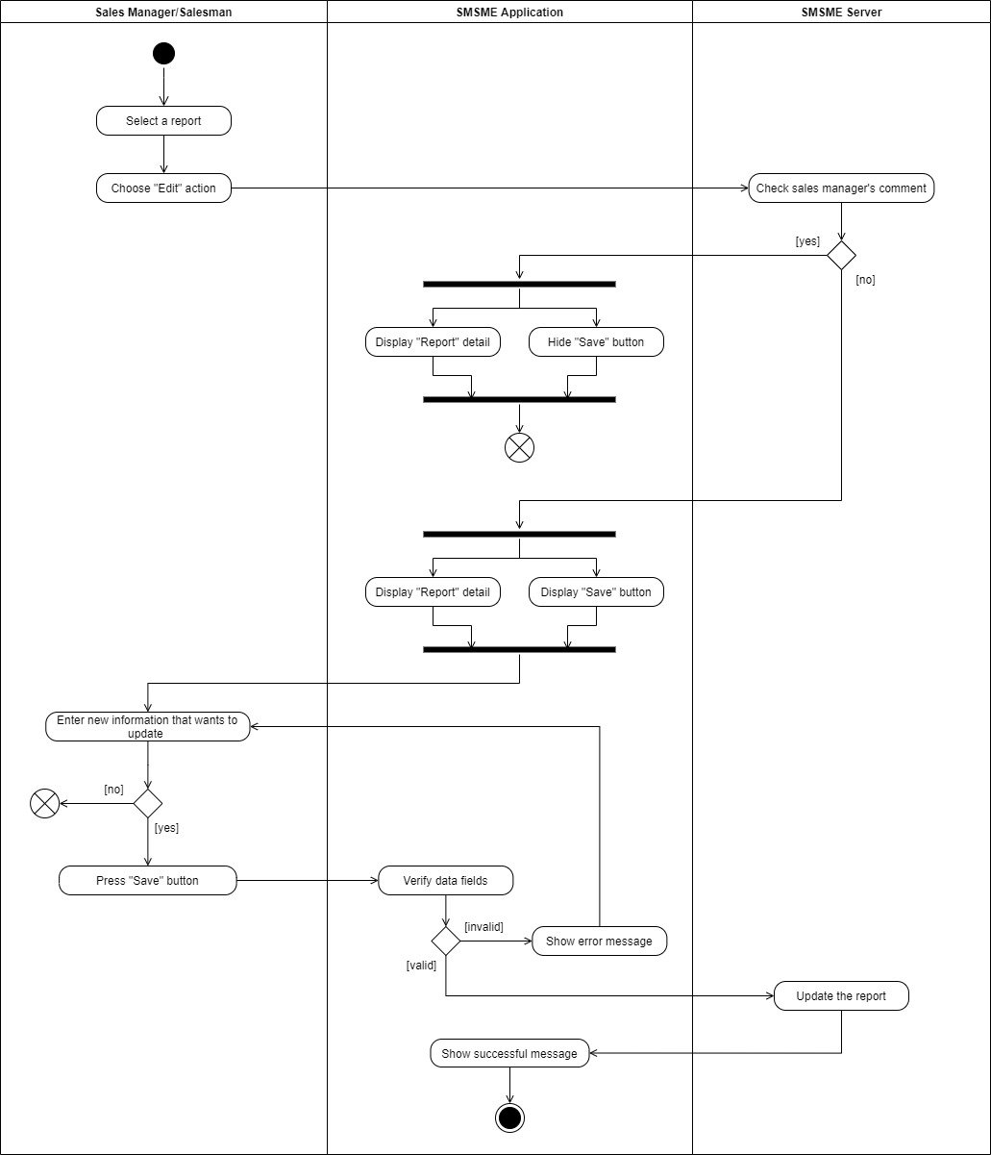

Figure 71. Update report

## 4. Class Specifications

### 4.1 User

|  |  |  |  |
| --- | --- | --- | --- |
| **Attribute** | **Type** | **Visibility** | **Description** |
| username | String | private | The unique identifier of a user |
| passwordHash | String | private | The password hash of the user |
| fullName | String | private | The full name of the user |
| address | String | private | The address of the user |
| email | String | private | The email of the user |
| phone | String | private | The phone number of the user |
| isActive | boolean | private | The active status of the user |
| avatar | String | private | The avatar of the user |
| isMale | boolean | private | The gender of the user (true 🡪 male, false 🡪 female) |
| birthDate | Date | private | The birthdate of the user |

Table 67. Class User Specification - Attributes

|  |  |  |  |  |
| --- | --- | --- | --- | --- |
| **No** | **Method** | **Visibility** | **Return Type** | **Description** |
| 1 | getter | public | dataType | get attribute value |
| 2 | setter | public | void | set attribute value |

Table 68. Class User Specification - Methods

### 4.2 PersonalActivity

|  |  |  |  |
| --- | --- | --- | --- |
| **Attribute** | **Type** | **Visibility** | **Description** |
| id | int | private | The unique identifier of a personal activity |
| title | String | private | The title of the personal activity |
| startTime | Date | private | The start time of the personal activity |
| endTime | Date | private | The end time of the personal activity |
| isCompleted | boolean | private | The completed status of the personal activity |
| remark | String | private | The remark of the personal activity |
| description | String | private | The description of the personal activity |
| location | String | private | The location of the personal activity |
| isAllDay | boolean | private | The duration of the personal activity, if it lasts for whole day or not |
| recurrenceId | int | private | The unique identifier of a recurrence series |
| recurrenceRule | String | private | The rule of the recurrence series |
| recurrenceException | String | private | The exception of the recurrence |

Table 69. Class PersonalActivity Specification - Attributes

|  |  |  |  |  |
| --- | --- | --- | --- | --- |
| **No** | **Method** | **Visibility** | **Return Type** | **Description** |
| 1 | getter | public | dataType | get attribute value |
| 2 | setter | public | void | set attribute value |

Table 70. Class PersonalActivity Specification - Methods

### 4.3 Role

|  |  |  |  |
| --- | --- | --- | --- |
| **Attribute** | **Type** | **Visibility** | **Description** |
| id | int | private | The unique identifier of a role |
| name | String | private | The name of the role |

Table 71. Class Role Specification - Attributes

|  |  |  |  |  |
| --- | --- | --- | --- | --- |
| **No** | **Method** | **Visibility** | **Return Type** | **Description** |
| 1 | getter | public | dataType | get attribute value |
| 2 | setter | public | void | set attribute value |

Table 72. Class Role Specification - Methods

### 4.4 Auditable

|  |  |  |  |
| --- | --- | --- | --- |
| **Attribute** | **Type** | **Visibility** | **Description** |
| createdBy | String | private | Auditing who created |
| createdDate | Date | private | The date created for auditing |
| modifiedBy | String | private | Auditing who modified |
| modifiedDate | Date | private | The date modified for auditing |

Table 73. Class Auditable Specification - Attributes

|  |  |  |  |  |
| --- | --- | --- | --- | --- |
| **No** | **Method** | **Visibility** | **Return Type** | **Description** |
| 1 | getter | public | dataType | get attribute value |
| 2 | setter | public | void | set attribute value |

Table 74. Class Auditable Specification - Methods

### 4.5 TargetSchool

|  |  |  |  |
| --- | --- | --- | --- |
| **Attribute** | **Type** | **Visibility** | **Description** |
| id | int | private | The unique identifier of a target school |
| schoolYear | String | private | The school year of the target school |
| note | String | private | The note of the target school |

Table 75. Class TargetSchool Specification - Attributes

|  |  |  |  |  |
| --- | --- | --- | --- | --- |
| **No** | **Method** | **Visibility** | **Return Type** | **Description** |
| 1 | getter | public | dataType | get attribute value |
| 2 | setter | public | void | set attribute value |

Table 76. Class TargetSchool Specification - Methods

### 4.6 Report

|  |  |  |  |
| --- | --- | --- | --- |
| **Attribute** | **Type** | **Visibility** | **Description** |
| id | int | private | The unique identifier of a report |
| date | Date | private | The date of the report |
| result | String | private | The result of the report |
| description | String | private | The description of the report |
| positivity | String | private | The positivity of the report |
| difficulty | String | private | The difficulty of the report |
| futurePlan | String | private | The future plan of the report |
| supervisorComment | String | private | The supervisor comment of the report |

Table 77. Class Report Specification - Attributes

|  |  |  |  |  |
| --- | --- | --- | --- | --- |
| **No** | **Method** | **Visibility** | **Return Type** | **Description** |
| 1 | getter | public | dataType | get attribute value |
| 2 | setter | public | void | set attribute value |

Table 78. Class Report Specification - Methods

### 4.7 School

|  |  |  |  |
| --- | --- | --- | --- |
| **Attribute** | **Type** | **Visibility** | **Description** |
| id | int | private | The unique identifier of a school |
| name | String | private | The name of the school |
| address | String | private | The address of the school |
| phone | String | private | The phone number of the school |
| type | SchoolType | private | The school type of the school |
| scale | SchoolScale | private | The school scale of the school |
| educationalLevel | EducationalLevel | private | The educational level of the school |
| description | String | private | The description of the school |
| isActive | boolean | private | The active status of the school |
| reprName | String | private | The name of the representative |
| reprGender | boolean | private | The gender of the representative |
| reprPhone | String | private | The phone number of the representative |
| reprEmail | String | private | The email of the representative |

Table 79. Class School Specification - Attributes

|  |  |  |  |  |
| --- | --- | --- | --- | --- |
| **No** | **Method** | **Visibility** | **Return Type** | **Description** |
| 1 | getter | public | dataType | get attribute value |
| 2 | setter | public | void | set attribute value |

Table 80. Class School Specification - Methods

### 4.8 District

|  |  |  |  |
| --- | --- | --- | --- |
| **Attribute** | **Type** | **Visibility** | **Description** |
| id | int | private | The unique identifier of a district |
| name | String | private | The name of the district |

Table 81. Class District Specification - Attributes

|  |  |  |  |  |
| --- | --- | --- | --- | --- |
| **No** | **Method** | **Visibility** | **Return Type** | **Description** |
| 1 | getter | public | dataType | get attribute value |
| 2 | setter | public | void | set attribute value |

Table 82. Class District Specification - Methods

### 4.9 SchoolStatus

|  |  |  |  |
| --- | --- | --- | --- |
| **Attribute** | **Type** | **Visibility** | **Description** |
| id | String | private | The unique identifier of a school status |
| name | String | private | The name of the school status |

Table 83. Class SchoolStatus Specification - Attributes

|  |  |  |  |  |
| --- | --- | --- | --- | --- |
| **No** | **Method** | **Visibility** | **Return Type** | **Description** |
| 1 | getter | public | dataType | get attribute value |
| 2 | setter | public | void | set attribute value |

Table 84. Class SchoolStatus Specification - Methods

### 4.10 TargetSchoolPurpose

|  |  |  |  |
| --- | --- | --- | --- |
| **Attribute** | **Type** | **Visibility** | **Description** |
| id | String | private | The unique identifier of a target school purpose |
| name | String | private | The name of the target school purpose |

Table 85. Class TargetSchoolPurpose Specification - Attributes

|  |  |  |  |  |
| --- | --- | --- | --- | --- |
| **No** | **Method** | **Visibility** | **Return Type** | **Description** |
| 1 | getter | public | dataType | get attribute value |
| 2 | setter | public | void | set attribute value |

Table 86. Class TargetSchoolPurpose Specification - Methods

### 4.11 EducationalLevel

|  |  |  |  |
| --- | --- | --- | --- |
| **Value** | **Type** | **Visibility** | **Description** |
| Tiểu học |  |  | Enum constant |
| THCS |  |  | Enum constant |
| THPT |  |  | Enum constant |

Table 87. Enum Class EducationalLevel Specification

### 4.12 SchoolScale

|  |  |  |  |
| --- | --- | --- | --- |
| **Value** | **Type** | **Visibility** | **Description** |
| Lớn |  |  | Enum constant |
| Vừa |  |  | Enum constant |
| Nhỏ |  |  | Enum constant |

Table 88. Enum Class SchoolScale Specification

### 4.13 SchoolType

|  |  |  |  |
| --- | --- | --- | --- |
| **Value** | **Type** | **Visibility** | **Description** |
| Công lập |  |  | Enum constant |
| Ngoài công lập |  |  | Enum constant |
| Bán công |  |  | Enum constant |

Table 89. Enum Class SchoolType Specification

## 5. Data & Database Design

### 5.1 Database Design

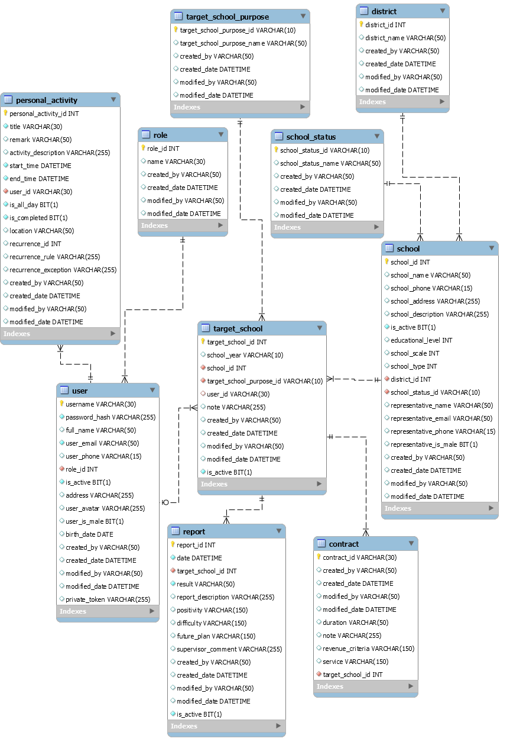

Figure 72. Database Diagram

#### school

|  |  |  |  |  |  |  |  |
| --- | --- | --- | --- | --- | --- | --- | --- |
| **#** | **Field name** | **Type** | **Size** | **Unique** | **Not Null** | **PK/FK** | **Notes** |
| 1 | school_id | int |  | X | X | X |  |
| 2 | school_name | varchar | 50 |  | X |  |  |
| 3 | school_phone | varchar | 15 |  |  |  |  |
| 4 | school_address | varchar | 255 | X | X |  |  |
| 5 | school_description | varchar | 255 |  |  |  |  |
| 6 | is_active | bit | 1 |  | X |  | Use for soft deleting |
| 7 | education_level | int |  |  | X |  |  |
| 8 | school_scale | int |  |  | X |  |  |
| 9 | school_type | int |  |  | X |  |  |
| 10 | district_id | int |  |  | X | X |  |
| 11 | school_status_id | varchar | 10 |  | X | X |  |
| 12 | representative_name | varchar | 50 |  |  |  |  |
| 13 | representative_email | varchar | 50 |  |  |  |  |
| 14 | representative_phone | varchar | 15 |  |  |  |  |
| 15 | representative_is_male | bit | 1 |  |  |  |  |
| 16 | created_by | varchar | 50 |  |  |  | Use for auditing |
| 17 | created_date | datetime |  |  |  |  | Use for auditing |
| 18 | modified_by | varchar | 50 |  |  |  | Use for auditing |
| 19 | modified_date | datetime |  |  |  |  | Use for auditing |

Table 90. Description for table "school"

#### district

|  |  |  |  |  |  |  |  |
| --- | --- | --- | --- | --- | --- | --- | --- |
| **#** | **Field name** | **Type** | **Size** | **Unique** | **Not Null** | **PK/FK** | **Notes** |
| 1 | district_id | int |  | X | X | X |  |
| 2 | district_name | varchar | 50 |  | X |  |  |
| 3 | created_by | varchar | 50 |  |  |  | Use for auditing |
| 4 | created_date | datetime |  |  |  |  | Use for auditing |
| 5 | modified_by | varchar | 50 |  |  |  | Use for auditing |
| 6 | modified_date | datetime |  |  |  |  | Use for auditing |

Table 91. Description for table "district"

#### school_status

|  |  |  |  |  |  |  |  |
| --- | --- | --- | --- | --- | --- | --- | --- |
| **#** | **Field name** | **Type** | **Size** | **Unique** | **Not Null** | **PK/FK** | **Notes** |
| 1 | school_status_id | varchar | 10 | X | X | X |  |
| 2 | school_status_name | varchar | 50 |  | X |  |  |
| 3 | created_by | varchar | 50 |  |  |  | Use for auditing |
| 4 | created_date | datetime |  |  |  |  | Use for auditing |
| 5 | modified_by | varchar | 50 |  |  |  | Use for auditing |
| 6 | modified_date | datetime |  |  |  |  | Use for auditing |

Table 92. Description for table "school_status"

#### target_school

|  |  |  |  |  |  |  |  |
| --- | --- | --- | --- | --- | --- | --- | --- |
| **#** | **Field name** | **Type** | **Size** | **Unique** | **Not Null** | **PK/FK** | **Notes** |
| 1 | target_school_id | int |  | X | X | X |  |
| 2 | school_year | varchar | 10 |  | X |  |  |
| 3 | school_id | int |  |  | X | X |  |
| 4 | target_school_purpose_id | varchar | 10 |  | X | X |  |
| 5 | user_id | varchar | 30 |  |  | X |  |
| 6 | note | varchar | 255 |  |  |  |  |
| 7 | is_active | bit | 1 |  | X |  | Use for soft deleting |
| 8 | created_by | varchar | 50 |  |  |  | Use for auditing |
| 9 | created_date | datetime |  |  |  |  | Use for auditing |
| 10 | modified_by | varchar | 50 |  |  |  | Use for auditing |
| 11 | modified_date | datetime |  |  |  |  | Use for auditing |

Table 93. Description for table "target_school"

#### report

|  |  |  |  |  |  |  |  |
| --- | --- | --- | --- | --- | --- | --- | --- |
| **#** | **Field name** | **Type** | **Size** | **Unique** | **Not Null** | **PK/FK** | **Notes** |
| 1 | report_id | int |  | X | X | X |  |
| 2 | date | datetime |  |  | X |  |  |
| 3 | target_school_id | int |  |  | X | X |  |
| 4 | result | varchar | 50 |  | X |  |  |
| 5 | report_description | varchar | 255 |  |  |  |  |
| 6 | positivity | varchar | 150 |  |  |  |  |
| 7 | difficulty | varchar | 150 |  |  |  |  |
| 8 | future_plan | varchar | 150 |  |  |  |  |
| 9 | supervisor_comment | varchar | 255 |  |  |  |  |
| 10 | is_active | bit | 1 |  | X |  | Use for soft deleting |
| 11 | created_by | varchar | 50 |  |  |  | Use for auditing |
| 12 | created_date | datetime |  |  |  |  | Use for auditing |
| 13 | modified_by | varchar | 50 |  |  |  | Use for auditing |
| 14 | modified_date | datetime |  |  |  |  | Use for auditing |

Table 94. Description for table "report"

#### target_school_purpose

|  |  |  |  |  |  |  |  |
| --- | --- | --- | --- | --- | --- | --- | --- |
| **#** | **Field name** | **Type** | **Size** | **Unique** | **Not Null** | **PK/FK** | **Notes** |
| 1 | target_school_purpose_id | varchar | 10 | X | X | X |  |
| 2 | target_school_purpose_name | varchar | 50 |  | X |  |  |
| 3 | created_by | varchar | 50 |  |  |  | Use for auditing |
| 4 | created_date | datetime |  |  |  |  | Use for auditing |
| 5 | modified_by | varchar | 50 |  |  |  | Use for auditing |
| 6 | modified_date | datetime |  |  |  |  | Use for auditing |

Table 95. Description for table "target_school_purpose"

#### user

|  |  |  |  |  |  |  |  |
| --- | --- | --- | --- | --- | --- | --- | --- |
| **#** | **Field name** | **Type** | **Size** | **Unique** | **Not Null** | **PK/FK** | **Notes** |
| 1 | username | varchar | 30 | X | X | X |  |
| 2 | password_hash | varchar | 255 |  | X |  | Password is hashed by Bcript Hashing Algorithm. |
| 3 | full_name | varchar | 50 |  |  |  |  |
| 4 | user_email | varchar | 50 |  |  |  |  |
| 5 | user_phone | varchar | 15 |  |  |  |  |
| 6 | role_id | int |  |  | X | X |  |
| 7 | is_active | bit | 1 |  | X |  | Use for soft deleting or when the users quit job. |
| 8 | address | varchar | 255 |  |  |  |  |
| 9 | user_avatar | varchar | 255 |  |  |  | Presigned URL for retriving images from Firebase Storage. |
| 10 | user_is_male | bit | 1 |  | X |  |  |
| 11 | birth_date | date |  |  |  |  |  |
| 12 | private_token | varchar | 255 |  |  |  | This token is used to recovered the forgotten password. |
| 13 | created_by | varchar | 50 |  |  |  | Use for auditing |
| 14 | created_date | datetime |  |  |  |  | Use for auditing |
| 15 | modified_by | varchar | 50 |  |  |  | Use for auditing |
| 16 | modified_date | datetime |  |  |  |  | Use for auditing |

Table 96. Description for table "user"

#### role

|  |  |  |  |  |  |  |  |
| --- | --- | --- | --- | --- | --- | --- | --- |
| **#** | **Field name** | **Type** | **Size** | **Unique** | **Not Null** | **PK/FK** | **Notes** |
| 1 | role_id | int |  | X | X | X |  |
| 2 | name | varchar | 30 |  | X |  |  |
| 3 | created_by | varchar | 50 |  |  |  | Use for auditing |
| 4 | created_date | datetime |  |  |  |  | Use for auditing |
| 5 | modified_by | varchar | 50 |  |  |  | Use for auditing |
| 6 | modified_date | datetime |  |  |  |  | Use for auditing |

Table 97. Description for table "role"

#### personal_activity

|  |  |  |  |  |  |  |  |
| --- | --- | --- | --- | --- | --- | --- | --- |
| **#** | **Field name** | **Type** | **Size** | **Unique** | **Not Null** | **PK/FK** | **Notes** |
| 1 | personal_activity_id | int |  | X | X | X |  |
| 2 | title | varchar | 30 |  | X |  | Title of the to-do activity |
| 3 | remark | varchar | 50 |  |  |  | Result or remark of the activity |
| 4 | activity_description | varchar | 255 |  |  |  |  |
| 5 | start_time | datetime |  |  | X |  |  |
| 6 | end_time | datetime |  |  | X |  |  |
| 7 | user_id | varchar | 30 |  | X | X |  |
| 8 | is_all_day | bit | 1 |  | X |  | The duration of the personal activity, if it lasts for whole day or not |
| 9 | is_completed | bit | 1 |  | X |  | The status of the activity, whether it is completed or not |
| 10 | location | varchar | 50 |  |  |  | Location where this activity happens/will happen. |
| 11 | recurrence_id | int |  |  |  |  | An activity can occur one time or multiple time. If it occurs multiple time, this “recurrence_id” is to specify the series/family of that activity. |
| 12 | recurrence_rule | varchar | 255 |  |  |  | A series contains multiple same activities with the general rule for repeating after a period. |
| 13 | recurrence _exception | varchar | 255 |  |  |  | This list is used to store the “personal_activity_id” of an exception in the series. |
| 14 | created_by | varchar | 50 |  |  |  | Use for auditing |
| 15 | created_date | datetime |  |  |  |  | Use for auditing |
| 16 | modified_by | varchar | 50 |  |  |  | Use for auditing |
| 17 | modified_date | datetime |  |  |  |  | Use for auditing |

Table 98. Description for table "personal_activity"

#### contract

|  |  |  |  |  |  |  |  |
| --- | --- | --- | --- | --- | --- | --- | --- |
| **#** | **Field name** | **Type** | **Size** | **Unique** | **Not Null** | **PK/FK** | **Notes** |
| 1 | contract_id | varchar | 30 | X | X | X |  |
| 2 | duration | varchar | 50 |  | X |  |  |
| 3 | note | varchar | 255 |  |  |  |  |
| 4 | revenue_criteria | varchar | 150 |  |  |  | Criteria of revenue and expenditure |
| 5 | service | varchar | 150 |  | X |  | Services/Programs that Major colaborate with the target school. |
| 6 | target_school_id | int |  |  | X |  |  |
| 7 | created_by | varchar | 50 |  |  |  | Use for auditing |
| 8 | created_date | datetime |  |  |  |  | Use for auditing |
| 9 | modified_by | varchar | 50 |  |  |  | Use for auditing |
| 10 | modified_date | datetime |  |  |  |  | Use for auditing |

Table 99. Description for table "contract"

### 5.2 Data File Design

We use firebase to store images.

|  |  |  |  |
| --- | --- | --- | --- |
| **#** | **File Name** | **Type** | **Notes** |
| 1 | avatars | JPG, JPEG, PNG | The images are used for user avatar. |
| 2 | Import_Sample.xlsx | xlsx | The sample sheet for user import guidance. |

Table 100. Data File Design

# V. Software Testing Documentation

## 1. Overall Description

### 1.1 Test Model

Based on the user requirements, team resources, and project conditions, our team has come up with using the prototype model as a software development model. In this model, a prototype is built, tested, and reworked until it is accepted by the user.

Figure 73 Prototype model

References: <https://www.geeksforgeeks.org/software-engineering-prototyping-model/>

### 1.2 Testing Levels

|  |  |
| --- | --- |
| **Testing Level** | **Description** |
| Unit Testing | Checks the software modules are fit for use |
| Integration Testing | Checks the integrated logic of the software module group |
| System Testing | Checks the whole system if it works as expected or not |
| Acceptance Testing | Checks the software if the user requirements are met or not |

Table 101. Testing Levels

### 1.3 Testing Types

|  |  |
| --- | --- |
| **Testing types** | **Description** |
| Functional Testing | * Unit Testing * Integration Testing * System Testing * Interface Testing * Regression Testing * Beta Testing |
| Non-functional Testing | * Performance Testing |

Table 102. Testing Types

## 2. Test Plan

### 2.1 Test Stages

|  |  |  |  |  |
| --- | --- | --- | --- | --- |
| **Type of Test** | **Stage of Test** | | | |
| ***Unit*** | ***Integration*** | ***System*** | ***Acceptance*** |
| Interface Testing | X |  | X |  |
| Performance Testing |  | X |  |  |
| Regression Testing | X | X |  |  |
| Beta Testing |  |  |  | X |

Table 103. Test Stages

### 2.2 Resources

#### Human Resources

|  |  |  |
| --- | --- | --- |
| **Worker/Doer** | **Role** | **Specific Responsibilities/Comments** |
| Phạm Thị Ngọc Hà | Leader | * Functional Testing * Non-functional Testing |
| Lê Gia Nguyên | Member | * Functional Testing * Non-functional Testing |
| Nguyễn Hoàng Gia | Member | * Functional Testing * Non-functional Testing |

Table 104. Human Resources

#### Environment

|  |  |  |  |
| --- | --- | --- | --- |
| **Purpose** | **Tool** | **Provider** | **Version** |
| Unit Testing | Postman | Postman, Inc | 8.2.1 |
| Unit Testing  Integration Testing  System Testing  Interface Testing  Regression Testing  Performance Testing | Chrome | Google LLC | 89 |

Table 105. Environment

### 2.3 Test Milestones

|  |  |  |  |
| --- | --- | --- | --- |
| **Milestone Task** | **Effort (md)** | **Start Date** | **End Date** |
| Setup the environment | 2 | 09/04/2021 | 09/04/2021 |
| Admin role function unit test | 2 | 09/04/2021 | 09/04/2021 |
| Admin role integration test | 3 | 09/04/2021 | 09/04/2021 |
| Admin role interface test | 2 | 09/04/2021 | 09/04/2021 |
| Salesman role function unit test | 4 | 09/04/2021 | 09/04/2021 |
| Salesman role integration test | 5 | 09/04/2021 | 09/04/2021 |
| Salesman role interface test | 4 | 09/04/2021 | 09/04/2021 |
| Sales manager role function unit test | 4 | 10/04/2021 | 10/04/2021 |
| Sales manager role integration test | 5 | 10/04/2021 | 10/04/2021 |
| Sales manager role interface test | 4 | 10/04/2021 | 10/04/2021 |
| Admin role regression test | 3 | 11/042021 | 11/042021 |
| Admin role performance test | 3 | 11/042021 | 11/042021 |
| Salesman role regression test | 5 |  |  |
| Salesman role performance test | 3 |  |  |
| Sales manager role regression test | 5 |  |  |
| Sales manager role performance test | 3 |  |  |
| Sales supervisor role function unit test | 3 |  |  |
| Sales supervisor role integration test | 3 |  |  |
| Sales supervisor role interface test | 3 |  |  |
| Sales supervisor role regression test | 4 |  |  |
| Sales supervisor role performance test | 3 |  |  |
| System test | 7 |  |  |
| Beta test | 10 |  |  |

Table 106. Test Milestones

### 2.4 Deliverables

|  |  |  |
| --- | --- | --- |
| No | Deliverables | Due Date |
| 1 | Report5_Unit Test Case | 12/04/2021 |
| 2 | Report5_ Test Case Document | 13/04/2021 |

Table 107. Deliverables

## 3. Test Cases

|  |  |
| --- | --- |
| **No** | **Filename** |
| 1 | [Report5_Unit Test Case.xls](Report5_Unit%20Test%20Case.xls) |
| 2 | [Report5_Test Case Document.xls](Report5_Test%20Case%20Document.xlsx) |

Table 108. Test Cases

## 4. Test Reports

|  |  |
| --- | --- |
| **No** | **Filename** |
| 1 | [Report5_Unit Test Case.xls](Report5_Unit%20Test%20Case.xls) |

Table 109. Test Reports

# VI. Release Package & User Guides

## 1. Deliverable Package

### 1.1 Source codes & documents

| **No.** | **Items** | **Sub-Items** | **Type** | **Version** |
| --- | --- | --- | --- | --- |
| ***Code Package*** | | | | |
| 1 | Web Apps |  | New | 1.0.0 |
| 2 | API Services |  | New | 1.0.0 |
| ***Database*** | | | | |
| 1 | Tables | contract.sql | New | 1.0.0 |
| district.sql | New | 1.0.0 |
| personal_activity.sql | New | 1.0.0 |
| report.sql | New | 1.0.0 |
| role.sql | New | 1.0.0 |
| school.sql | New | 1.0.0 |
| school_status.sql | New | 1.0.0 |
| target_school.sql | New | 1.0.0 |
| target_school_purpose.sql | New | 1.0.0 |
| user.sql | New | 1.0.0 |
| ***Documents*** | | | | |
| 1 | Introduction | Report1_Project Introduction.docx | New | 1.0.0 |
| 2 | Management Plan | Report2_Project Management Plan.docx | New | 1.0.0 |
| 3 | Requirement | Report3_Software Requirement Specification.docx | New | 1.0.0 |
| 4 | Design | Report4_Software Design Document.docx | New | 1.0.0 |
| 5 | Testing | Report5_Test Documentation.docx | New | 1.0.0 |
| Report5_Test Case Document.docx | New | 1.0.0 |
| Report5_Unit Test Case.docx | New | 1.0.0 |
| 6 | User Guides | Report6_Software User Guides.docx | New | 1.0.0 |
| 7 | Final | Report7_Final Project Report.docx | New | 1.0.0 |

Table 110. Source codes & documents

### 1.2 Known Issues, Limitations & Restrictions

* The current system does not provide a mobile app version for the user.
* The current system does not support communication channel with customers.
* The web application responsive interface has not stable yet.
* The interface still lacks consistency, may or may not cause uncomfortable for the user.
* The current application only supports English default.
* The system lacks testing, which leads to application performance or bugs that may cause during implementation.
* During the lack of team resources, some main features of the application have not been implemented.

## 2. Installation Guides

### System Requirements

#### 2.1.1 Hardware Requirements

* Scince this system is a web application, all the devices using the system must run over the Internet.
* Our system is deployed on the server, which the minimum requirements services to run in the following:

For Web App

|  |  |
| --- | --- |
| **Hardware** | **Minimum Requirements** |
| vCPU | 1 |
| Operation System | Linux Server/Window server |
| Memory (GiB) | 1GiB |

Table 111. <Installation guides> Hardware requirements for Web App

For API Services

|  |  |
| --- | --- |
| **Hardware** | **Minimum Requirements** |
| vCPU | 1 |
| Operation System | Linux Server/Window server |
| Memory | 1GiB |

Table 112. <Installation guides> Hardware requirements for API service

For Database

|  |  |
| --- | --- |
| **Hardware** | **Minimum Requirements** |
| vCPU | 1 |
| Operation System | Linux server/Window sẻver |
| Computer Memory | 1GiB |

Table 113. <Installation guides> Hardware requirements for Database

#### 2.1.2 Software Requirements

This web application works with: Chrome (version 52 or above), Firefox (version 51 or above), Edge (version 14 or above), Safari (version 10 or above), or Opera (version 38 or above) browser.

### 2.2 Setup Files

N/A

### 2.3 Installation Instruction

N/A

## 3. User Manual

### 3.1 Terms and definitions

* This system is built for Major Education with a project code SMSME, which stands for Sales Management System for Major Education.
* This system is an enterprise application, with the license rules and terms of use belong to Major Education.

### 3.2 System requirements

#### 3.2.1 Hardware Requirements

* Scince this system is a web application, all the devices using the system must run over the Internet.
* Our system is deployed on the server, which the minimum requirements services to run in the following:

For Web App

|  |  |
| --- | --- |
| **Hardware** | **Minimum Requirements** |
| vCPU | 1 |
| Operation System | Linux Server/Window server |
| Memory (GiB) | 1GiB |

Table 114. <User Manual> Hardware requirements for Web App

For API Services

|  |  |
| --- | --- |
| **Hardware** | **Minimum Requirements** |
| vCPU | 1 |
| Operation System | Linux Server/Window server |
| Memory (GiB) | 1GiB |

Table 115. <User Manual> Hardware requirements for API Services

For Database

|  |  |
| --- | --- |
| **Hardware** | **Minimum Requirements** |
| vCPU | 1 |
| Operation System | Linux server/Window sẻver |
| Memory (GiB) | 1GiB |

Table 116. <User Manual> Hardware requirements for Database

#### 3.2.2 Software Requirements

This web application works with: Chrome (version 52 or above), Firefox (version 51 or above), Edge (version 14 or above), Safari (version 10 or above), or Opera (version 38 or above) browser.

### 3.3 Application Usage

#### 3.3.1 Overview

The target users that SMSME mainly aims to are salesmen and sales managers of the Sales Department of Major Education.

For salesmen, this software would help them manage their work-plan as well as their tasks easier and more visually, submit daily reports more directly and they can also monitor other salesmen’s works.

For sales managers, they would not have to collect and analyze all salesmen’s reports manually. Now they can supervise salesmen or search for reports more easily. Moreover, they can see the overall picture of the company's business process, including what schools are lead or customers, who are the most effective salesmen,…

#### 3.3.2 Accounts

Purpose

* The admin manages user accounts

Functions

* View list of accounts
* View account’s details
* Search accounts
* Create accounts
* Edit account’s information

User interface(s)

Figure 74. List of Accounts

Figure 75. Account’s details

#### 3.3.3 Schools

Purpose

* The admin manages schools info
* The sales manager edits schools info
* The sales supervisor edits schools info
* The salesman edits schools info

Functions

* View list of schools
* View school’s details
* Search schools
* Create schools
* Edit school’s information

User interface(s)

Figure 76. List of Schools

Figure 77. School’s details

#### 3.3.4 Target schools

Purpose

* The sales manager manages target schools
* The sales supervisor manages target schools
* The salesman view assigned of target schools

Functions

* View list of target shools
* View target school’s details
* Search target schools
* Create target schools
* Edit target school’s information
* Assign salesmen to target schools
* Remove target schools

User interface(s)

Figure 78 Target Schools list

#### 3.3.5 Reports

Purpose

* The sales manager manages personal daily reports
* The sales supervisor manages personal daily reports
* The salesman manages personal daily reports
* The sales manager comments on salesman’s report
* The sales department monitors their reports

Functions

* View list of reports
* View report’s details
* Search reports
* Create reports
* Edit report's information
* Comment reports
* Remove reports

User interface(s)

#### 3.3.6. Profiles

Purpose

* The user edits personal profile

Functions

* View profile
* Edit profile

User interface(s)

Figure 79 Profile

#### 3.3.7 Workplans

Purpose

* The user manages personal workplans

Functions

* View workplans
* View personal activities details
* Create personal activities
* Edit personal activities
* Remove personal activities

User interface(s)

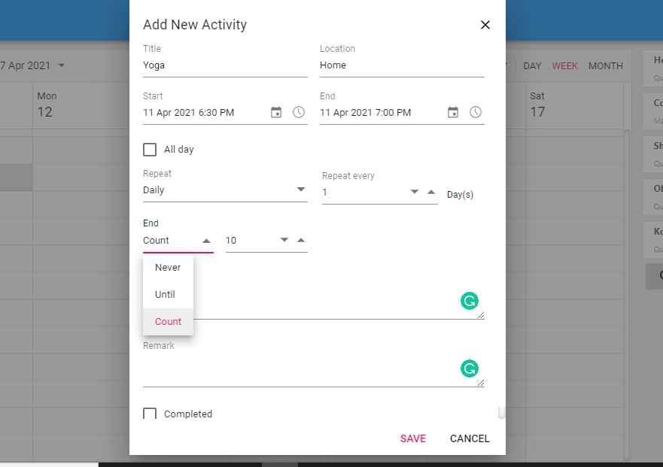

Figure 80 Add New Daily Activity

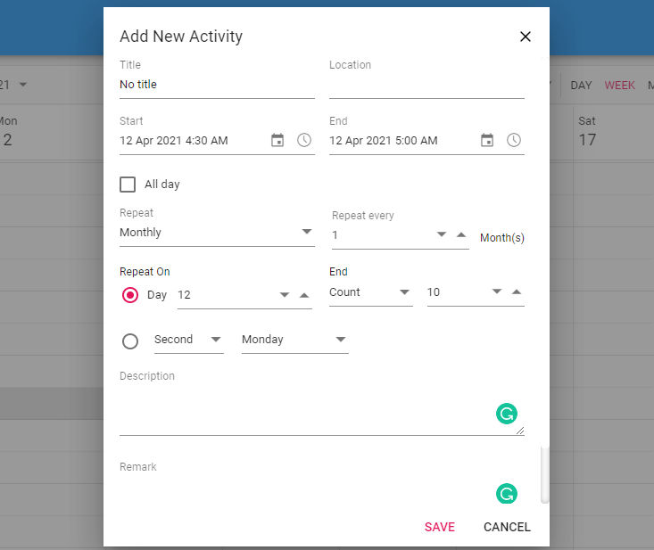

Figure 81 Add New Monthly Activity

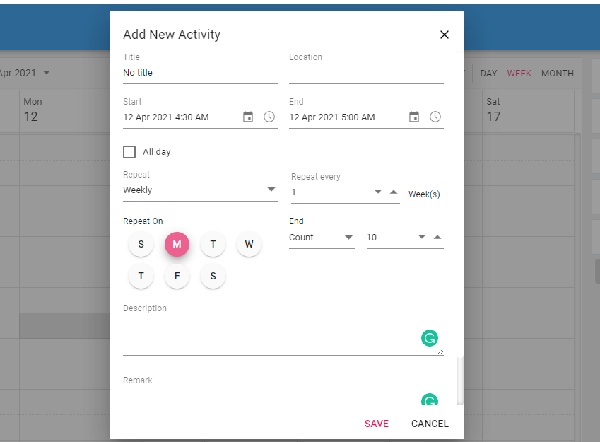

Figure 82 Add New Weekly Activity

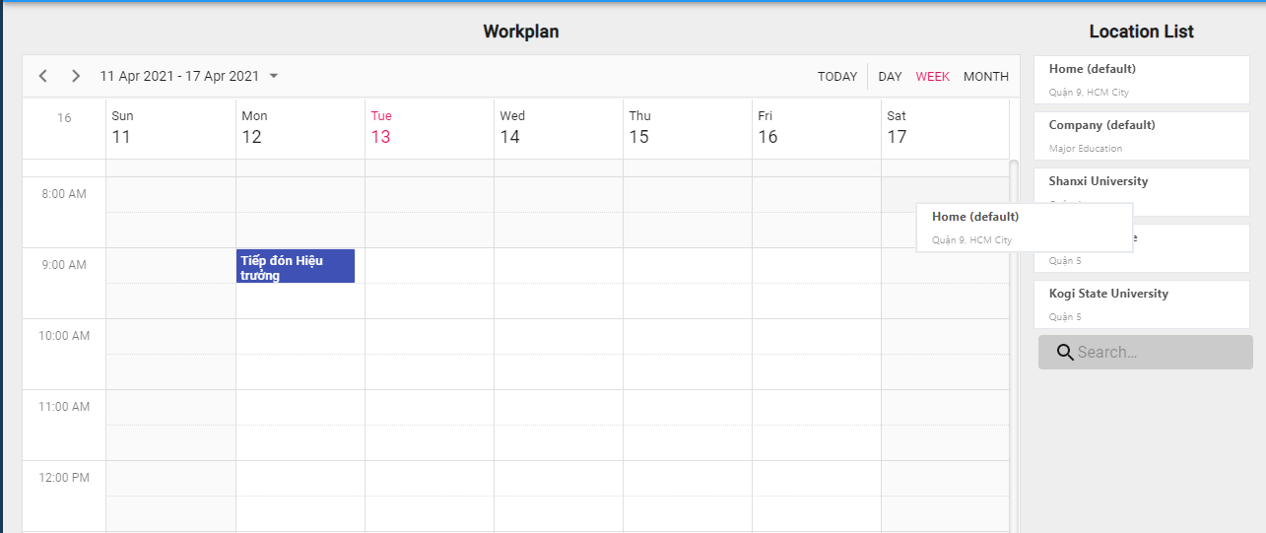

Figure 83 Drag Location Card to Add new

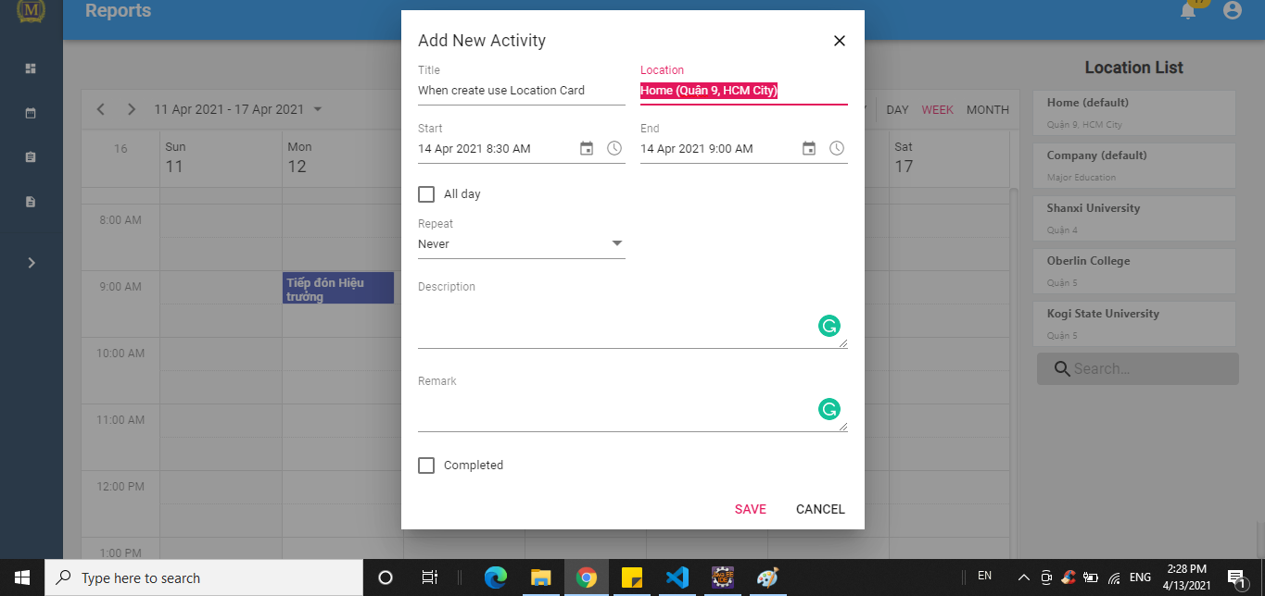

Figure 84 Add New Activity By Draging Location Card

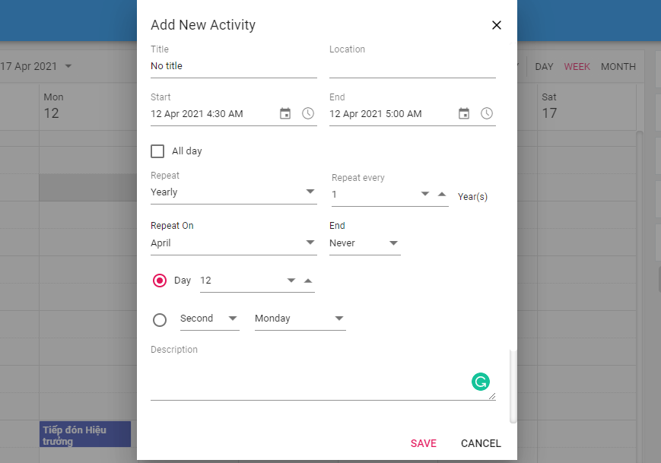

Figure 85 Add New Yearly Activity

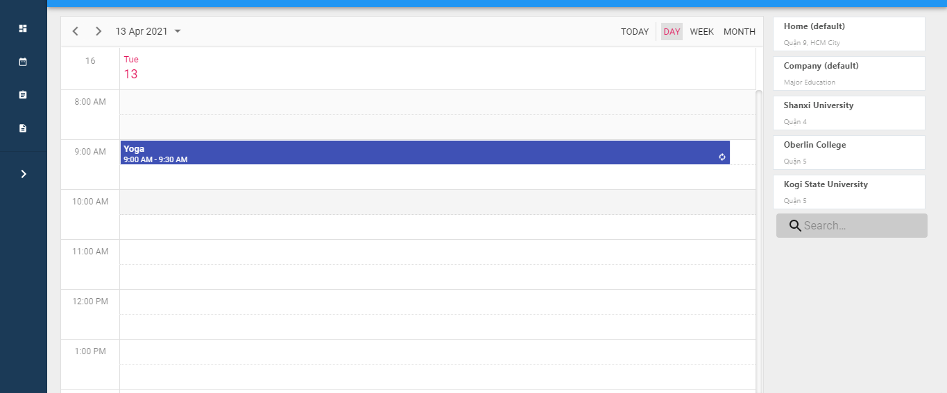

Figure 86 Day view

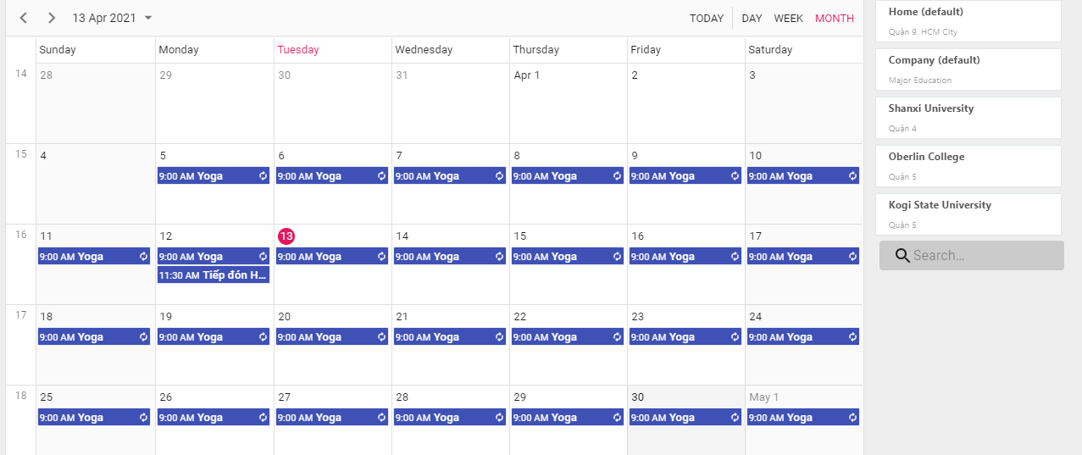

Figure 87 Monthly view

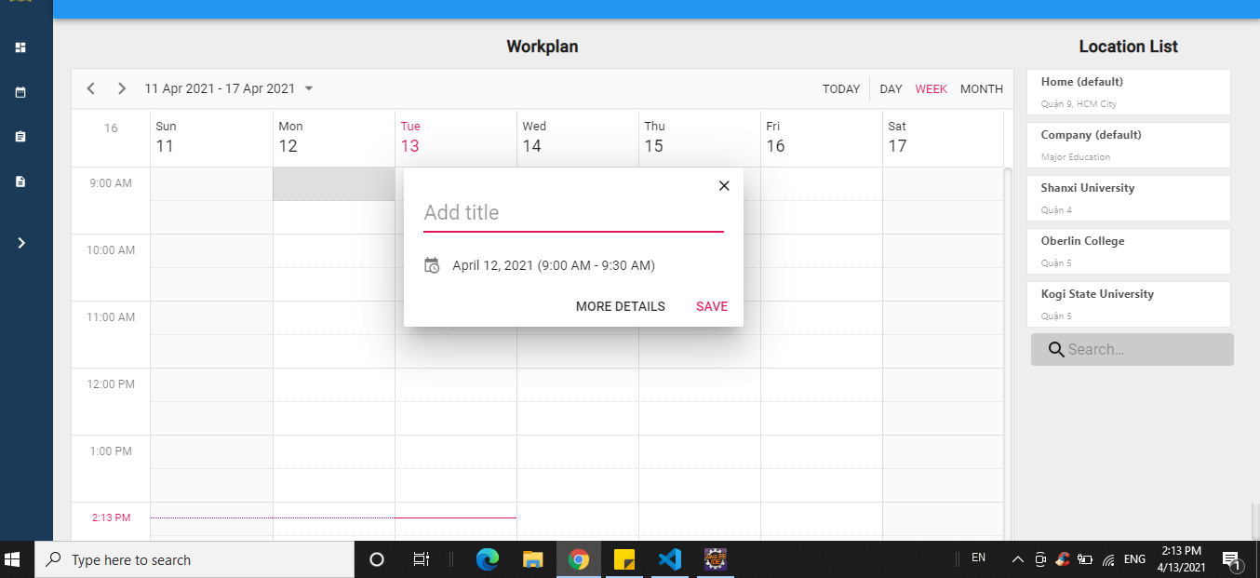

Figure 88 Quick Add Form

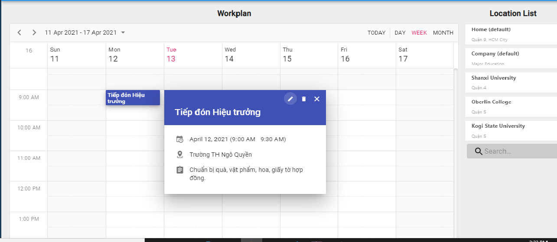

Figure 89 Quick Details

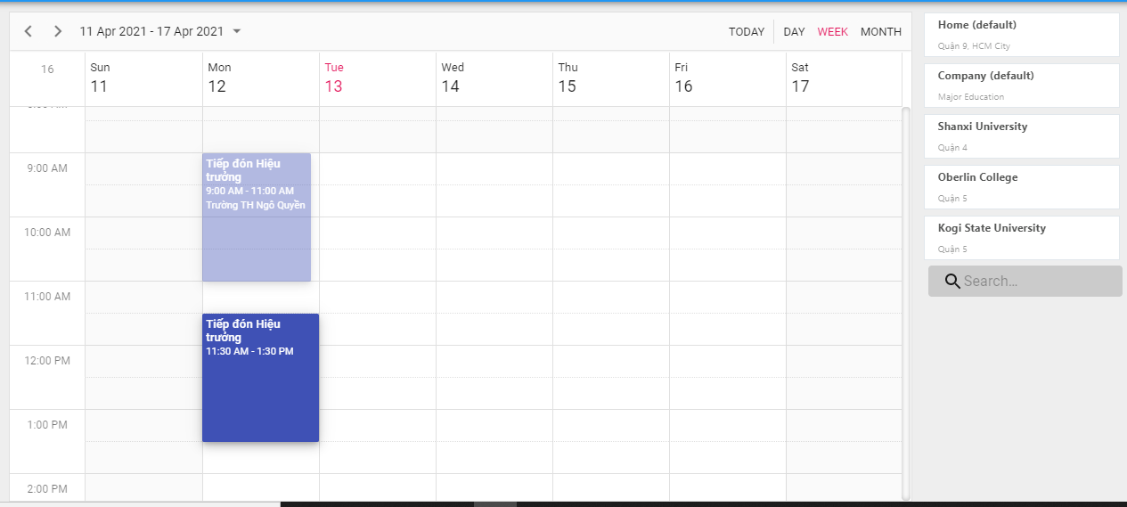

Figure 90 Edit By Drag Activity

#### 3.3.8 Dashboards

Purpose

* The sales department tracks their work process

Functions

* View dashboards

User interface(s)

Figure 91 Dashboards

#### 3.3.9 Contracts

Purpose

* The sales manager manages contracts ?
* The salesman tracks assigned contarcts

Functions

* View list of contracts ?
* View contract’s details
* Search contracts ?
* Create contracts ?
* Edit contacrts’s information ?

User interface(s)

#### 3.3.10 Logins

Purpose

* The unauthorized user logins the system
* The user retrieve their password

Functions

* Login with username and password
* Forgot password

User interface(s)

Figure 92 Login

#### 3.3.11 Logout

Purpose

* The authorized user logouts the system

Functions

* Logout

User interface(s)

Figure 93 Log out

### 3.4 Troubleshooting

#### 3.4.1 Web app layout broke during cross-device use

Problems:

* The application responsive interface has not supported for all devices

Workaround:

* Refresh the web app page
* Contacts the system developers for more supports

#### 3.4.2 Avatar or images loading time is long

Problems:

* The Internet connection is slow or unstable

Workaround:

* Refresh the web app page
* Connect with a better Internet connection

#### 3.4.3 Data record loading time is long

Problems:

* The Internet connection is slow or unstable

Workaround:

* Refresh the web app page
* Connect with a better Internet connection

## ４．ユーザーマニュアル

### 4.1　用語と定義

この販売管理システムはMajorEducationのため、開発されたものですから、すべての利用規約はそれらに属している。

### 4.2　システム要件

#### 4.2.1 　ハードウェア要件

* このシステムはWebアプリケーションですから、システムを使用されるとき、インターネットで接続する必要がある。
* 私たちのシステムはサーバーにデプロイされており、実行するための最小要件サービスは次のとおりです。

Webアプリの場合

|  |  |
| --- | --- |
| **ハードウェア** | **最小要件** |
| vCPU | 1 |
| オペレーションシステム | Linux Server/Window server |
| メモリー(GiB) | 1GiB |

Table 117. 「システム要件」 Web アプリの場合

API サービスの場合

|  |  |
| --- | --- |
| **Hardware** | **最小要件** |
| vCPU | 1 |
| オペレーションシステム | Linux Server/Window server |
| メモリー(GiB) | 1GiB |

Table 118. 「システム要件」 API サービスの場合

Databaseの場合

|  |  |
| --- | --- |
| **Hardware** | **最小要件** |
| vCPU | 1 |
| オペレーションシステム | Linux server/Window sẻver |
| メモリー(GiB) | 1GiB |

Table 119. 「システム要件」 Database の場合

#### 4.2.2　ソフトウェア要件

このWebアプリケーションは、Chrome（バージョン52以上）、Firefox（バージョン51以上）、Edge（バージョン14以上）、Safari（バージョン10以上）、またはOpera（バージョン38以上）ブラウザーで動作する。

### 4.3　アプリケーションの使用

#### 4.3.1　概要

この販売管理システムの主にユーザーはMajorEducationの販売部門です。

#### 4.3.2　アカウント

目標

* ユーザーアカウントを管理する。

機能

* アカウントのリストの表示
* アカウントの詳細の表示
* アカウントの検索
* アカウントの作成
* アカウントの情報の編集

ユーザーインターフェース

Figure 94アカウントリスト

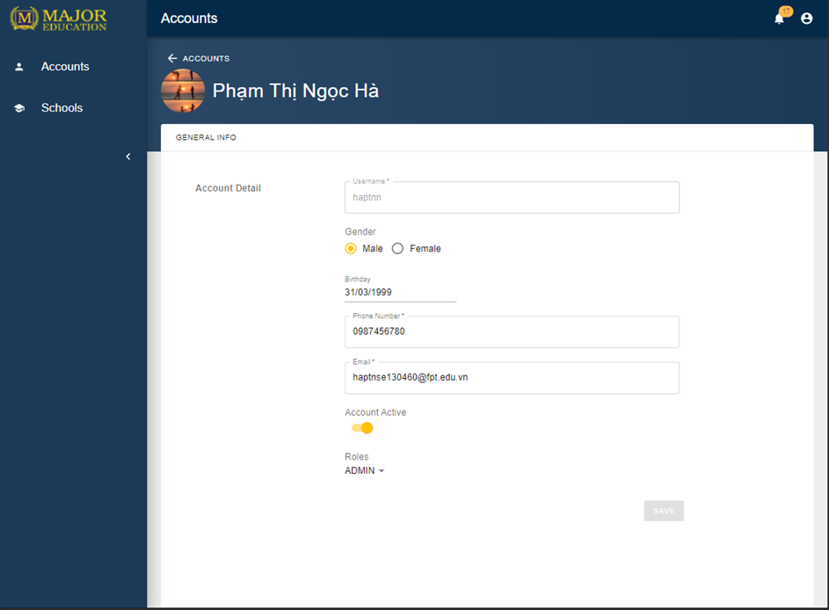

Figure 95アカウント詳細

#### 4.3.3　スクール

目標

* スクールを管理する。

機能

* スクールのリストの表示
* スクールの詳細の表示
* スクールの検索
* スクールの作成
* スクールの情報の編集

ユーザーインターフェース

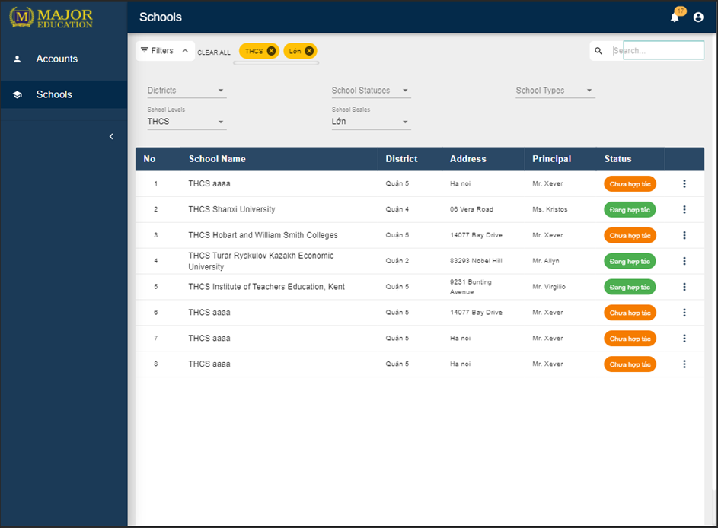

Figure 96スクールリスト

Figure 97スクールの詳細

#### 4.3.4　ターゲットスクール

目標

* ターゲットスクールを管理する。

機能

* ターゲットスクールのリストの表示
* ターゲットスクールの詳細の表示
* ターゲットスクールの検索
* ターゲットスクールの作成
* ターゲットスクール情報の編集
* ターゲットスクールにセールスマンの割当
* ターゲットスクールの削除

ユーザーインターフェース

Figure 98ターゲットスクールリスト

#### 4.3.5　レポート

目標

* レポートを管理する。

機能

* レポートのリストの表示
* レポートの詳細の表示
* レポートの検索
* レポートの作成
* レポートの情報の編集
* コメントレポート
* レポートの削除

ユーザーインターフェース

#### 4.3.6　プロフィール

目標

* プロフィールを管理する。

機能

* プロフィールの表示
* プロファイルの編集

ユーザーインターフェース

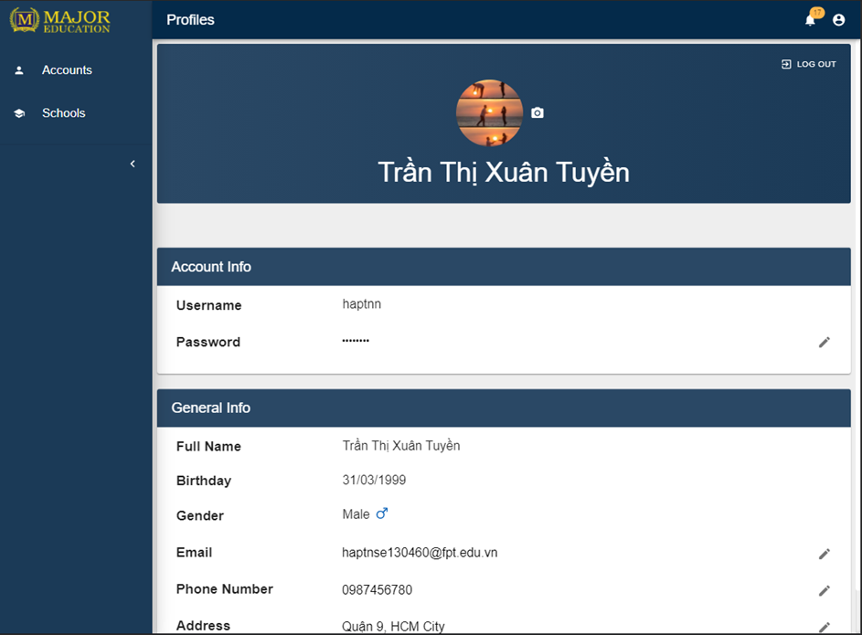

Figure 99プロフィール

#### 4.3.7　作業計画

目標

* 作業計画を管理する。

機能

* 作業計画の表示
* 個人的な活動の詳細の表示
* 個人的な活動の作成
* 個人的な活動の編集
* 個人的な活動の削除

ユーザーインターフェース



Figure 100デイビュー



Figure 101月表示



Figure 102 クイック追加



Figure 103 活動の詳細

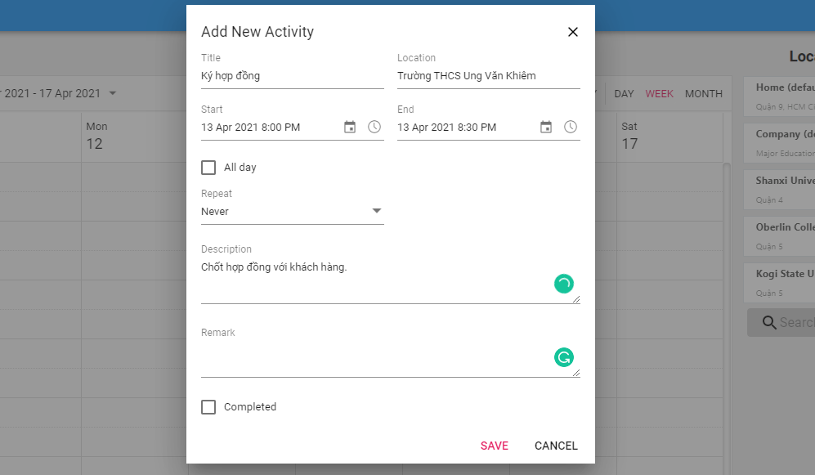

Figure 104 詳細追加



Figure 105 ドラッグして編集

#### 4.3.8　ダッシュボード

目標

* 営業部門は営業プロセスを追跡する。

機能

* ダッシュボードの表示

ユーザーインターフェース

Figure 106ダッシュボード

#### 4.3.9　契約

目標

* 契約を管理する。

機能

* 契約のリストの表示
* 契約の詳細の表示
* 契約の検索
* 契約の作成
* 契約の情報の編集

ユーザーインターフェース

#### 4.3.10　ログイン

目標

* 許可されていないユーザーがシステムにログインする。
* ユーザーのパスワードをリセットしする。

機能

* ユーザー名とパスワードでログイン
* パスワードリマインダー

ユーザーインターフェース

Figure 107ログイン

#### 4.3.11　ログアウト

目標

* 許可されたユーザーがシステムからログアウトする。

機能

* ログアウト

ユーザーインターフェース

Figure 108ログアウト

### 4.4　トラブルシューティング

#### 4.4.1　Webアプリ画面レイアウトが崩れる

問題

* アプリケーションレスポンシブUIは、すべてのデバイスでまだサポートされていないことです。

解決

* Webのページをリフレッシュしてください。
* その他のサポートについては、システム開発者に連絡してください。

#### 4.4.2　画像の読み込み時間が遅い

問題

* インターネット接続が遅い。

解決

* Webのページをリフレッシュしてください。
* もっと良いインターネットに接続してください。

#### 4.4.3　テーブルデータの読み込み時間が遅い

問題

* インターネット接続が遅い。

解決

* Webのページをリフレッシュしてください。
* もっと良いインターネットに接続してください。

# VII. Appendix

## 1. Glossary [Optional]

*[Place all definitions or abbreviation used in this document]*

## 2. References [Optional]

*[Place all referenced materials used in this document]*

## 3. Others [Optional]

*[Provide any other information here…]*

1. “MOU (*Memorandum of understanding)”* means “a document that describes the broad outlines of an agreement that two or more parties have reached”.

   Kenton, W., 2021. *Memorandum of Understanding (MOU): What You Need to Know*. [online] Investopedia. Available at: <https://www.investopedia.com/terms/m/mou.asp>.